# Vehicle Standards Information Sheet

#### Tyre Outer Diameter for Alternative Tyres on Light Vehicles

May 2025

Vehicle Standards Bulletin 14 (VSB-14) and the Queensland Road Vehicle Modification Handbook (QRVMH) outline the requirements for fitting alternative sized tyres on light vehicles registered in Queensland. These alternative size tyres differ from, but are related to, the tyre size specified by the Original Vehicle Manufacturer (OVM) and indicated on the original tyre placard. The purpose of this Vehicle Standards Information Sheet (VSI) is to explain how to determine the outer diameter of acceptable alternative tyres sizes that can be fitted to light vehicles.

**To Determine the Base Tyre Sizes**

A vehicle’s base tyre sizes can be determined by:

* viewing the tyre placard fitted by the OVM;
* viewing the specifications listed in the Vehicle Owner’s Manual; or
* obtaining specifications directly from the vehicle manufacturer.

Only tyre sizes fitted for the Australian market are permitted to be used as the base tyre size. This means that, if a larger tyre is fitted in a country other than Australia, that tyre size cannot be used as the base size.

**Locating Tyre Outer Diameter**

The acceptable tyre outer diameter shall be sourced from the following:

For passenger car tyres:

* 1. The [*Tyre and Rim Association of Australia Standards Manual*](https://tyreandrim.org.au/) (Standards Manual) may be used. Only the ‘Design New Tyre Overall Diameter’ can be used, the ‘Maximum Grown Overall Diameter’ must not be used; or
  2. The tyre outer diameter may be calculated as specified in UN Regulation no. 30 and may also be sourced from the tables provided in the annex to that regulation.

For light truck tyres:

* 1. The tyre outer diameter should be calculated as specified in UN Regulation no. 54 and can also be sourced from the tables provided in the annex to that regulation.

As the diameters in the UN Regulation and annex are generally identical to the relevant ‘Design New Tyre Overall Diameters’ within the Standards Manual, the Standards Manual can also be relied upon. However, only the ‘Design New Tyre Overall Diameter’ can be used, the ‘Maximum Grown Overall Diameter’ must not be used.

**Example - Locating the correct tyre diameter in the *Standards Manual***

1. In this example, we have a base tyre size of 265/75R16.
2. Turn to the relevant page in the Standards Manualto locate the table that provides tyre dimensions for the base tyre size of 265/75R16.
3. In this table, find the ‘Design New Tyre Overall Diameter,’ either for highway tread or traction tread depending on the tyre type. This is the correct diameter to use.

Note: Do not use the ‘Maximum Grown Overall Diameter.’ These diameters are provided only as design references for tyre and vehicle manufactures to ensure adequate clearances.

1. 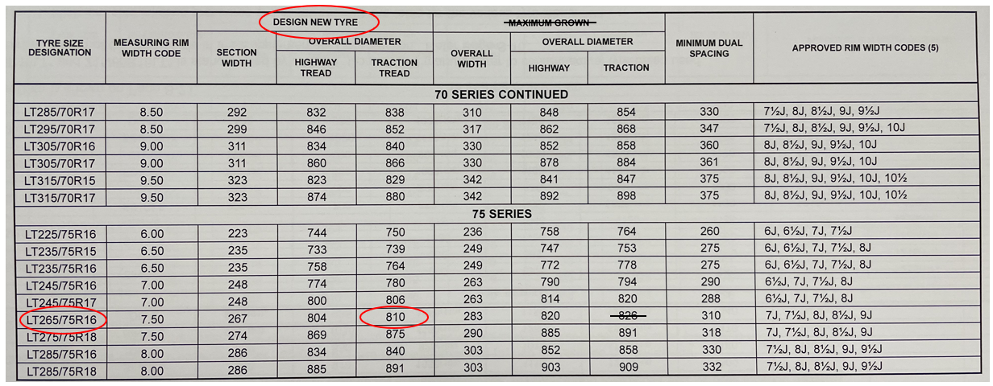In this example, the base tyre has a diameter of 810mm for traction tread (see extract from the Standards Manual below).
2. In this example, we have utilised the maximum allowable 50mm increase as permitted under modification codes LS9 and LS10. Consequently, when selecting alternative tyres, only those tyres with an overall diameter of 860mm or less can be chosen.

**Further Information**

[Transport Operations (Road Use Management—Vehicle Standards and Safety) Regulation 2021](https://www.legislation.qld.gov.au/view/whole/html/inforce/current/sl-2021-0114)

National Code of Practice for Light Vehicle Construction and Modification (NCOP) - [Section LS - Suspension & Steering](https://www.infrastructure.gov.au/sites/default/files/migrated/vehicles/vehicle_regulation/bulletin/files/NCOP11_Section_LS_Tyres_Suspension_Steering_Nov_2015_v4.pdf)

[Australian Design Rule 42/04](https://www.legislation.gov.au/F2018L01514/latest/text)

United Nations Economic Commission for Europe (UNECE) - [Regulation No 54 of the Economic Commission for Europe of the United Nations (UNECE) — Uniform provisions concerning the approval of pneumatic tyres for commercial vehicles and their trailers - Publications Office of the EU](https://op.europa.eu/en/publication-detail/-/publication/018ac3d5-ac64-4d65-89f6-47ca8fa1b4ae/language-en)

United Nations Economic Commission for Europe (UNECE) - [Regulation No 30 of the Economic Commission for Europe of the United Nations (UN/ECE) — Uniform provisions concerning the approval of pneumatic tyres for motor vehicles and their trailers - Publications Office of the EU](https://op.europa.eu/en/publication-detail/-/publication/fbec46cd-c715-44ef-a865-50084b8f2a95)

For more information about this VSI, please email [vehiclestandards@tmr.qld.gov.au](mailto:vehiclestandards@tmr.qld.gov.au).