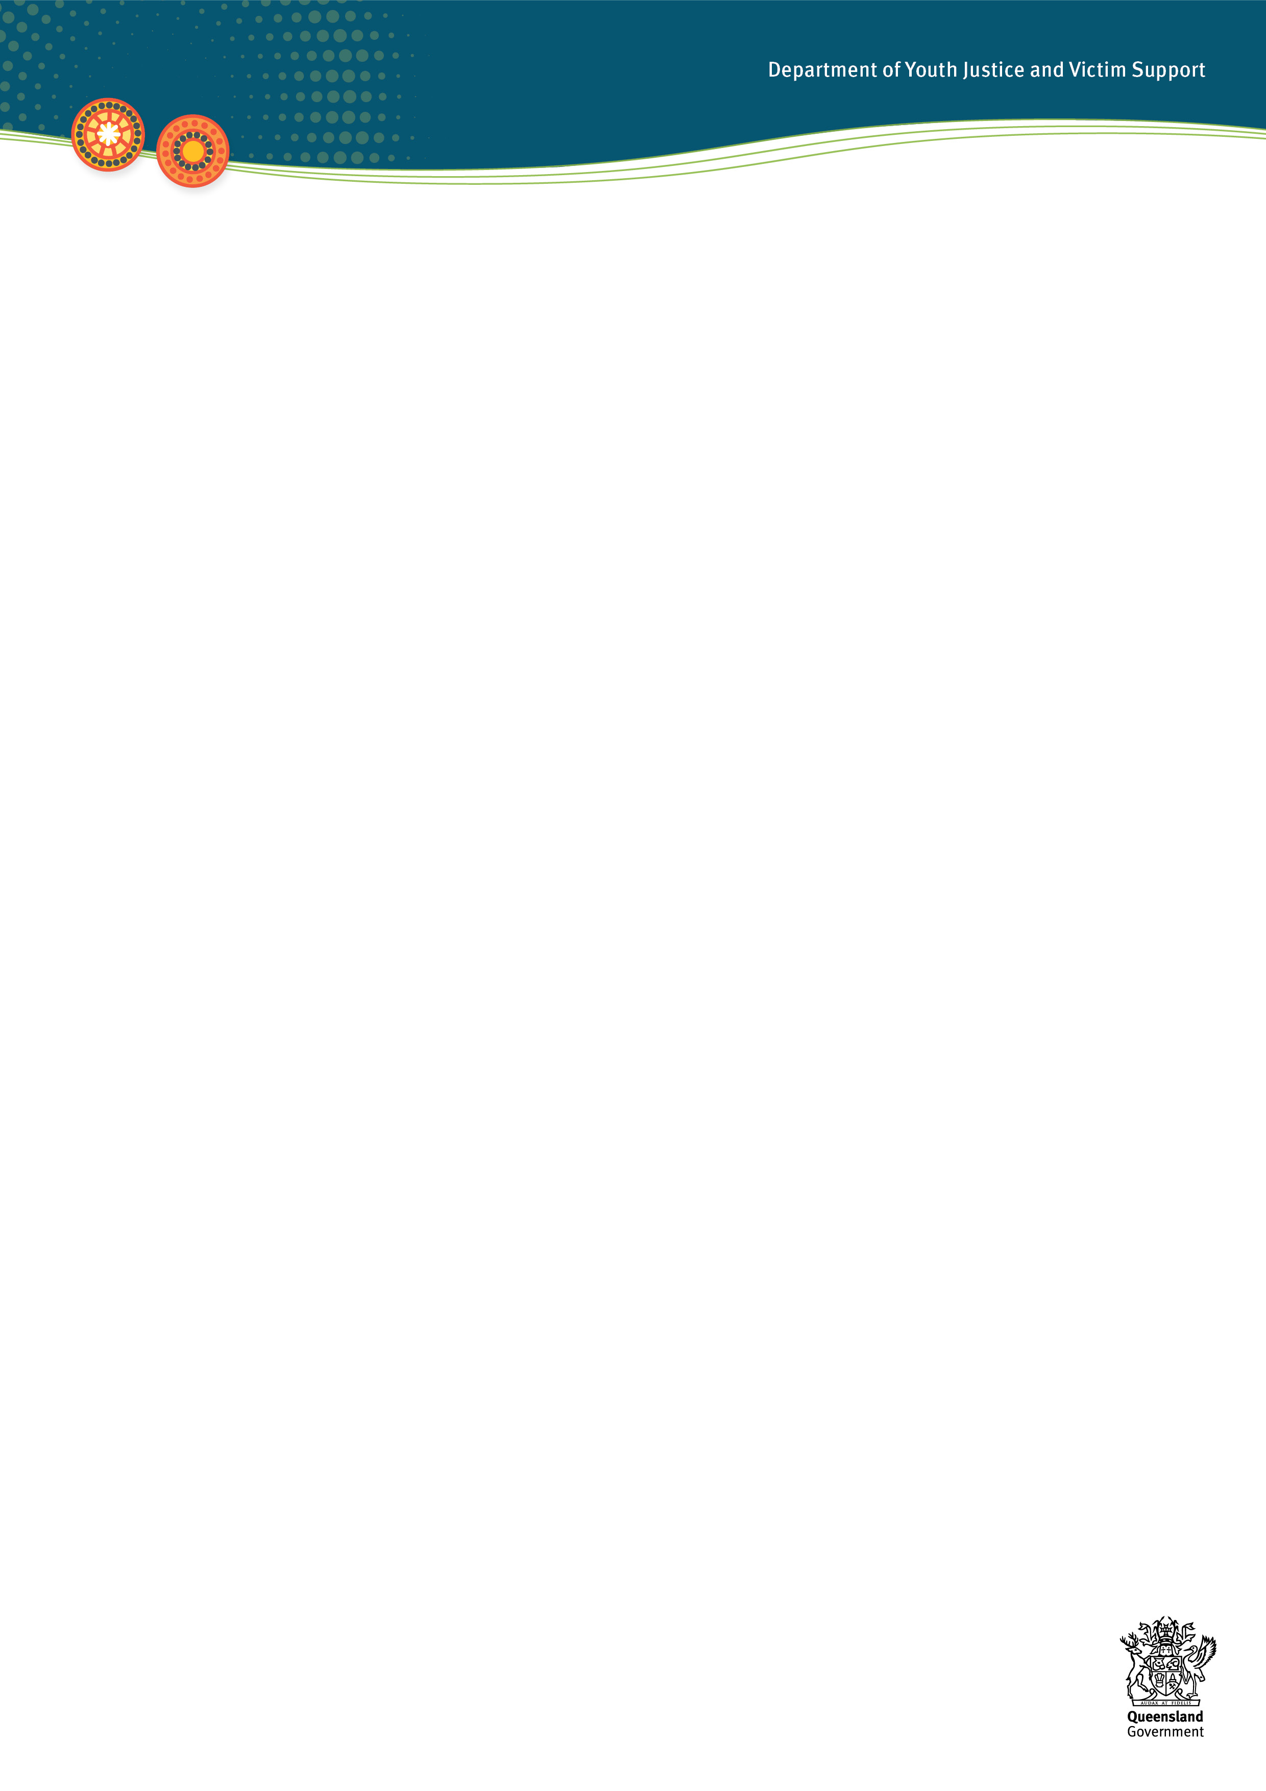***Adult Crime, Adult Time Sentencing Scheme***

Current as at 23 May 2025

The Adult Crime, Adult Time sentencing scheme makes children liable to the same maximum, minimum and mandatory penalties as apply to adults for the same offence, for certain prescribed offences.

The provisions are found in section 175A of the *Youth Justice Act 1992* (YJ Act).

The Adult Crime, Adult Time sentencing scheme was first introduced by the *Making Queensland Safer Act 2024*, with further offences (‘tranche 2’) added by the *Making Queensland Safer (Adult Crime, Adult Time) Amendment Act 2025*.

## **The offences**

The offences prescribed under section 175A as Adult Time, Adult Crime, and their relevant commencement dates , can be found in appendix 1.

Tranche 1 of Adult Crime, Adult Time commenced on 13 December 2024. A child is liable to Adult Crime, Adult Time penalties for those 13 prescribed offences where they were committed ***on or after 13 December 2024.***

Tranche 2 commenced on 23 May 2025. A child is liable to Adult Crime, Adult Time penalties for those 20 prescribed offences where they were committed ***on or after 23 May 2025.***

## **Changes to sentencing options**

As well as adopting adult maximum, minimum and mandatory penalties, the Adult Crime, Adult Time amendments:

* extended the maximum duration of a probation order to three years for all courts for the prescribed offences
* extended the maximum period of detention a Childrens Court magistrate can impose for those offences to three years
* removed restorative justice orders as a sentencing option for children for those offences.

Other referral pathways to restorative justice remain available, including police referrals, court diversion referrals, and pre-sentence referrals.

In summary, the applicable mandatory and minimum penalties are:

* mandatory life detention with a minimum non-parole period of 20 years for murder (or 25 years for murder of a police officer, or 30 years for murder of more than one person or by a person with a previous murder conviction)
* if a child is sentenced to life detention (for a life offence other than murder), a minimum non-parole period of 15 years
* if a child is sentenced to serve a period of detention for unlawful striking causing death, unless a conditional release order is made, the child must serve the lesser of 80 per cent of the sentence or 15 years
* detention must form whole or part of the punishment for dangerous operation of a vehicle with a circumstance of aggravation under section 328A(3) of the Criminal Code
* if a child is sentenced for an offence of grievous bodily harm, serious assault (in certain circumstances) or wounding, and the offence was committed in a public place and while adversely affected by an intoxicating substance, they must be sentenced to a community service order, in addition to any other order the court imposes. Consistent with the position for adults, there is no requirement for the child to consent to the community service order.

The following provisions of the YJ Act will continue to apply to children found guilty of a prescribed offence:

* the types of sentencing orders available, such as probation, community service, and detention (excluding restorative justice orders as a sentencing option)
* the YJ Act sentencing principles
* the provisions providing for serious repeat offender declarations
* the provisions providing for the making of a restitution or compensation order
* the requirement to consider a pre-sentence report before making a detention order
* the power, when making a detention order, to make a conditional release order
* the considerations for the court in deciding whether to record a conviction.

Previously, if the court ordered that a child serve a period of detention, the earliest that a supervised release order (the youth justice equivalent of parole) could be made was after the child had served 50 per cent of the period of detention. The amendments provide that this does not apply when sentencing a child for a prescribed offence. This means the sentencing court can set the date for the supervised release order at any point during the period of detention (other than when a mandatory non-parole period applies). This is consistent with the arrangements for parole when sentencing adults.

**Further support**

If you would like any further information, contact Youth Justice Strategy and Performance at [osed_spc@youthjustice.qld.gov.au](mailto:osed_spc@youthjustice.qld.gov.au).

**Appendix 1**

**Current as at 23 May 2025**

**Adult Crime, Adult Time offences and commencement dates**

| **OFFENCE** | | **COMMENCEMENT** |
| --- | --- | --- |
| **Section**  **(all Criminal Code, except where indicated)** | **Offence** |
| s.69 | Going armed so as to cause fear | 23 May 2025 |
| s. 75 | Threatening violence | 23 May 2025 |
| s.302, s.305 | Murder | 13 December 2024 |
| s.303, s.310 | Manslaughter | 13 December 2024 |
| s.306 | Attempt to murder | 23 May 2025 |
| s.307 | Accessory after the fact to murder | 23 May 2025 |
| s.313(2) | Assaulting a pregnant person and killing, or doing GBH to, or transmitting a serious disease to the unborn child | 23 May 2025 |
| s.314A | Unlawful striking causing death | 13 December 2024 |
| s.317 | Acts intended to cause GBH and other malicious acts | 13 December 2024 |
| s.320 | GBH | 13 December 2024 |
| s.320A | Torture | 23 May 2025 |
| s.323 | Wounding | 13 December 2024 |
| s.328A | Dangerous operation of a motor vehicle | 13 December 2024 |
| s.328C | Damaging emergency vehicle when operating motor vehicle | 23 May 2025 |
| s.328D | Endangering police officer when driving motor vehicle | 23 May 2025 |
| s.340 | Serious assaults | 13 December 2024 |
| s.349 | Rape | 23 May 2025 |
| s.350 | Attempt to commit rape | 23 May 2025 |
| s.351 | Assault with intent to commit rape | 23 May 2025 |
| s.352 | Sexual assault, if the circumstance in subsection (2) (involving any part of the mouth) or (3) (while armed, in company, or involving penetration) applies | 23 May 2025 |
| s.354 | Kidnapping | 23 May 2025 |
| s.354A | Kidnapping for ransom | 23 May 2025 |
| s.355 | Deprivation of liberty | 23 May 2025 |
| s.398 | Stealing, if item 12 (a vehicle) or 14 (a firearm for use in another indictable offence) applies | 23 May 2025 |
| s.408A | Unlawful use or possession of a motor vehicle, aircraft, or vessels | 13 December 2024 |
| s.409 | Robbery | 13 December 2024 |
| s.412 | Attempted robbery, if the circumstances in subsection (2) (armed or in company) or (3) (armed with violence) applies | 23 May 2025 |
| s.419 | Burglary | 13 December 2024 |
| s.421 | Entering or being in premises and committing indictable offences | 13 December 2024 |
| s.427 | Unlawful entry of a vehicle for committing an indictable offence | 13 December 2024 |
| s.461 | Arson | 23 May 2025 |
| s.462 | Endangering particular property by fire | 23 May 2025 |
| *Drugs Misuse Act 1986*  s.5 | Trafficking in dangerous drugs | 23 May 2025 |