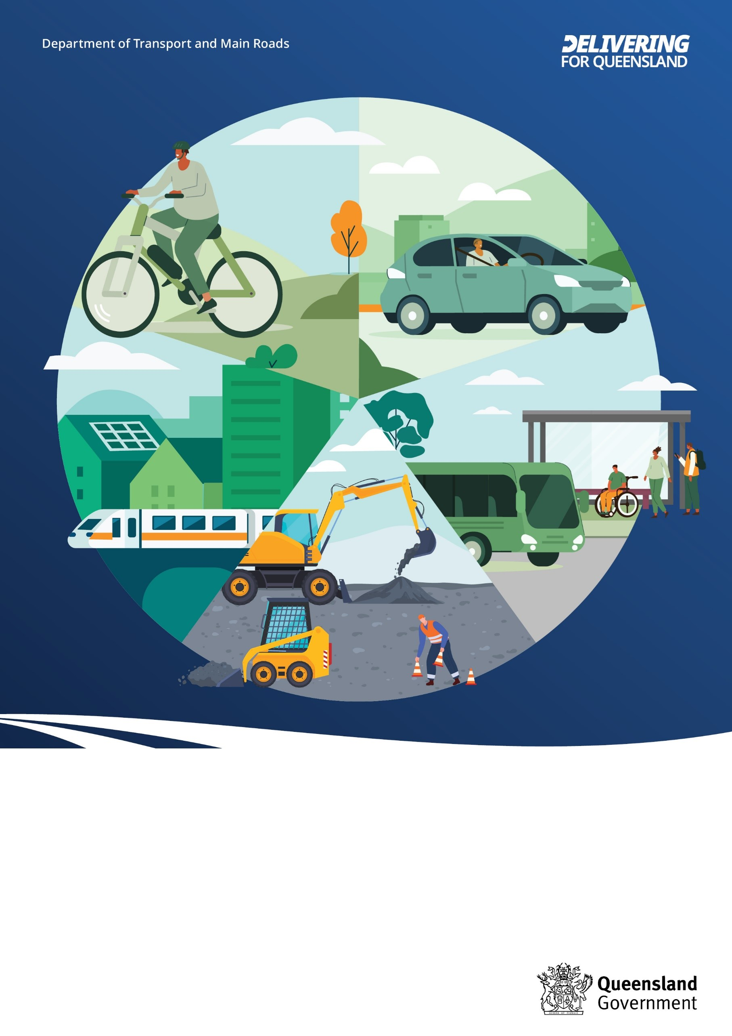
Queensland Transport and Roads Investment Program

2025–26 to 2028–29

About this document
The Queensland Transport and Roads Investment Program (QTRIP) outlines current and planned transport and road infrastructure investments for delivery over the next four years. The QTRIP is updated and published annually. This document is available online: www.publications.qld.gov.au.
Translating and interpreting assistance
The Queensland Government is committed to providing accessible services to Queenslanders from all cultural and linguistic backgrounds. If you have difficulty understanding this publication and need a translator, please call the Translating and Interpreting Service (TIS National) on 13 14 50 and ask them to telephone the Queensland Government (Department of Transport and Main Roads) on 13 74 68.
Accessibility
The Department of Transport and Main Roads is committed to leading the delivery of accessible and inclusive transport products, services, information and infrastructure. The content of this document can also be viewed in HTML format at www.tmr.qld.gov.au/qtriponline.
Copyright
This publication is protected by the Copyright Act 1968. © The State of Queensland, 2025.
Disclaimer
While every care has been taken in preparing this publication, to the extent permitted by law, the State of Queensland accepts no responsibility and disclaims all liability (including without limitation, liability in negligence) for all expenses, losses (including direct and indirect loss), damages and costs incurred as a result of decisions or actions taken as a result of any data, information, statement or advice, expressed or implied, contained within. To the best of our knowledge, the content was correct at the time of publishing.
Follow us
- https://www.linkedin.com/company/tmrqld
- www.facebook.com/TMRQld/
- https://twitter.com/TMRQld
- https://instagram.com/TMRQld
Contents
Minister’s Foreword 6
Director-General’s Foreword 8
Introduction 11
Overview 12
Strategic intent 13
Fast Facts 14
Total investment 15
Investment by entity 15
Investment by mode 15
Investment by funding source 16
QTRIP highlights 16
Investment by region/district 17
South Coast 18
Key facts 18
Contact details 19
South Coast 21
Planned investments 21
Contractually committed investments 26
Metropolitan 30
Key facts 30
Contact details 31
Metropolitan 33
Planned investments 33
Contractually committed investments 37
North Coast 42
Key facts 42
Contact details 43
North Coast 45
Planned investments 45
Contractually committed investments 49
Wide Bay Burnett 52
Key facts 52
Contact details 53
Wide Bay Burnett 55
Planned investments 55
Contractually committed investments 57
Darling Downs 60
Key facts 60
Contact details 61
Darling Downs 63
Planned investments 63
Contractually committed investments 65
South West 68
Key facts 68
Contact details 69
South West 71
Planned investments 71
Contractually committed investments 71
Fitzroy 73
Key facts 73
Contact details 74
Fitzroy 76
Planned investments 76
Contractually committed investments 78
Central West 80
Key facts 80
Contact details 81
Central West 83
Planned investments 83
Contractually committed investments 83
Mackay Whitsunday 85
Key facts 85
Contact details 86
Mackay Whitsunday 88
Planned investments 88
Contractually committed investments 90
Northern 92
Key facts 92
Contact details 93
Northern 95
Planned investments 95
Contractually committed investments 96
North West 99
Key facts 99
Contact details 100
North West 102
Planned investments 102
Contractually committed investments 103
Far North 105
Key facts 105
Contact details 106
Far North 108
Planned investments 108
Contractually committed investments 111
Statewide 116
Statewide 117
Planned investments 117
Contractually committed investments 120
References 123
Key Terms 123
Notes for Fast Facts 129
Notes for Map Pages 129

Minister’s Foreword
The State Government is delivering for Queensland.
The $41.7 billion Queensland Transport and Roads Investment Program (QTRIP) 2025–26 to 2028–29 outlines the transport infrastructure program that is being delivered to respond to population growth and cater for the significant transport demand that we will see during the 2032 Olympic and Paralympic Games.
We want Queenslanders to be able to get home sooner. This needs a network that is reliable, efficient, productive, and safe.
But we can’t do it alone. It’s important to acknowledge the State’s partnership with the Federal Government as well as local governments across Queensland as we build the infrastructure needed for a growing state.
Both QTRIP and the State Budget reflect the Government’s commitment to work with all Queenslanders, no matter where they live, to cater for the transport needs of our communities. We will invest in communities that have been ignored for too long.
Initiatives such as Country Road Connect will help seal vital transport links to provide greater resilience during times of natural disasters.
The Federal and State Government’s $9 billion Bruce Highway Targeted Safety Program has already begun work on many projects along the Bruce Highway. The Program will deliver wide centre line treatments, intersection upgrades, improved rest areas and overtaking lanes on priority sections of the highway north of Gympie to improve safety and reduce the time this vital link is closed due to accidents.
Work is also continuing for major projects along the highway such as the Rockhampton Ring Road and Tiaro Bypass to improve productivity, increase safety and improve flood immunity.
The Government is committed to make public transport more affordable, frequent, reliable, and safe. QTRIP includes funding for projects such as Logan and Gold Coast Faster Rail and the Wave stage 1. These two projects will deliver major upgrades for the rail network connecting the Sunshine Coast, Brisbane, and the Gold Coast. This QTRIP will also include funding for a number of projects that were commitments of the new Government to the people of Queensland at the last election. Along with these funding commitments comes a commitment to ensure every dollar of taxpayers’ money is spent wisely. When projects aren’t delivered on time and on budget it means that other worthy projects need to get delayed or cancelled.
This year’s QTRIP will focus on value for money to ensure more can be done with existing resources. Prior QTRIP publications have displayed budgets for all projects, an approach which influences the market’s response to projects. Ultimately, these budget disclosures lead to reduced competition, weaker innovation, and poorer value for money.
This year, the new QTRIP layout categorises investments by ‘Planned Investments’ or ‘Contractually Committed Investments’, with budgets only displayed for investments that have achieved contract award. This new format continues to provide useful information to support the industry, maintains transparency for all users of the document, and delivers improved competition and value for money by not publishing project budgets for Planned Investments.
Queensland is a great state with huge opportunities. This program aims to deliver the transport network that facilitates and maximises these opportunities and ensure that all Queenslanders, no matter where they live, benefit from investment in their communities.
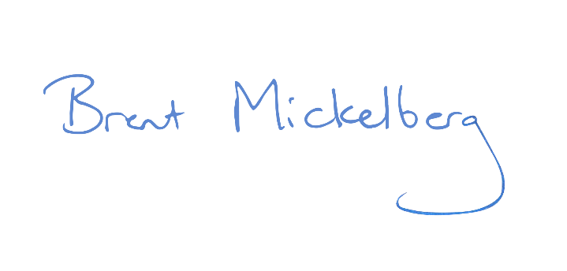



Honourable Brent Mickelberg MP
Minister for Transport and Main Roads

Director-General’s Foreword
The QTRIP 2025–26 to 2028–29 continues to deliver on our vision of connecting communities in a sustainable, thriving and inclusive Queensland.
Outlining a $41.7 billion investment over the next four years into Queensland’s road and transport infrastructure across local, state and national networks, the QTRIP reflects the Queensland Government’s dedication to building resilient infrastructure that meets the needs of our growing population.
The development of QTRIP is supported by strategic direction-setting documents, such as the State Infrastructure Strategy 2022–2042, the Queensland Transport Strategy, the Transport Coordination Plan (TCP) 2017–2027 and our TMR Strategic Plan 2023–2027, all of which provide direction on key focus areas and priorities required to deliver the transport system vision. It is also supported by other transport strategies and plans, such as Regional Transport Plans, which guide infrastructure planning and investment.
The QTRIP 2025–26 to 2028–29 showcases our strong commitment to building resilience through the Natural Disaster Program, delivered in partnership with the Australian Government via the Queensland Reconstruction Authority. At TMR, we take pride in reacting quickly when Queensland faces severe and unprecedented events. Our proactive and coordinated efforts ensure communities and industries stay connected, moving, and safe, reinforcing our dedication to supporting Queenslanders when it matters most.
Safe and reliable roads are the backbone of Queensland’s rural and regional communities, driving industry growth and connecting people to vital services and opportunities. Thanks to a strong partnership with the Australian Government, we are delivering transformative infrastructure projects that will shape the future of our state. Early works are continuing on the $1 billion Inland Freight Route between Charters Towers and Mungindi, as well as the $500 million Queensland Beef Corridors, ensuring better connectivity for freight and industry. Construction is also well underway on the $1.98 billion Rockhampton Ring Road, a project set to enhance safety and efficiency for road users. Meanwhile, the Bruce Highway Gympie Bypass (Cooroy to Curra Section D) is now complete, unlocking safer and faster travel along this critical corridor.

The Roads and Transport Alliance is continuing its partnership with local governments, with an allocation of $75.95 million in 2025–26 for the Transport Infrastructure Development Scheme. This scheme provides essential funding to local governments to support infrastructure upgrades across Queensland's road and transport networks.
Rail infrastructure continues to be a priority with works progressing on several priority projects to reduce congestion and support increasing customer demand. Building on the continued success of 50 Cent Fares, investments will ease the cost of living and focus on delivering better journeys with more frequent and faster services and easier access to more locations with new and upgraded stations to support connections between home, work, and essential services. Many of these investments will also support accelerated housing supply and ensure we are well positioned to meet the challenges of hosting the Olympic and Paralympic Games in 2032. Key investments include:
- Logan and Gold Coast Faster Rail
- The Wave (Stage 1)
- The Wave (Stage 2 and 3), planning and market readiness
- European Train Control Signalling System
Cost pressures remain a challenge for TMR, exacerbated by delays in procurement, labour shortages, and market capacity limitations. These factors pose risks to both overall project costs and delivery timelines.
In response to these challenges, TMR continues to implement targeted initiatives to manage cost-related risks effectively. Additionally, the Queensland Government is addressing these pressures through a range of cost certainty initiatives including:
- improving design quality and correctness
- targeted earlier investigations to manage risk exposure through design and delivery
- improving business case and pre-tender estimates, including independent reviews
- addressing uncertainty with appropriate estimate allowances and contingency
- value engineering projects to ensure whole-of-life benefits are maximised and ‘nice to have’ scope elements are identified without compromising whole-of-life operational costs

- early industry and partner engagement (resetting expectations) and collaborative risk management, improved decisions on risk sharing and contract choice.
Many of these projects will ensure we are well positioned to meet the challenges of hosting the 2032 Olympic and Paralympic Games, as identified within the 2032 Delivery Plan. This includes major new public transport connections from the Sunshine Coast through to the Gold Coast, and a generational investment into road connections, including improving safety and accessibility on the Bruce Highway and improving safety and reliability on the M1 Pacific Motorway.
The delivery of this four-year program within QTRIP 2025–26 to 2028–29 would not be possible without the collaboration and dedication of our partners, including local governments, industry stakeholders, and the broader community. We cannot achieve this alone and partnering with industry in shaping this program and ensuring its successful implementation is essential.
We have an ambitious journey ahead of us and I encourage all Queenslanders to explore the projects and initiatives outlined in QTRIP 2025–26 to 2028–29 as we work towards a brighter, more connected Queensland. Together, we are building a transport network that will serve our state for generations to come.





Sally Stannard
Director-General
Department of Transport and Main Roads


Introduction

Overview
Department of Transport and Main Roads (TMR) designs, delivers and maintains transport infrastructure to connect communities in a sustainable, thriving and inclusive Queensland.
As well as meeting the statutory requirements set out in the Transport Infrastructure Act 1994, the Queensland Transport and Roads Investment Program (QTRIP) provides transparency to the community, industry, government and organisations about current and planned investment. QTRIP investment spans road, rail, maritime, public transport and active transport infrastructure on freight, commuter and recreational networks and includes TMR’s infrastructure investment as well as capital programs for Queensland Rail and Gold Coast Waterways Authority.
QTRIP is developed in accordance with funding allocations identified by the Australian Government and Queensland Government in their annual budgets, which align to both governments’ policy objectives.

Strategic intent
National and state government policy objectives and agendas guide and shape the QTRIP’s strategic intent. Various Queensland Government strategies and plans establish high-level transport objectives and strategic outcomes for the development of the QTRIP as outlined in Figure 1.
Figure 1: QTRIP guiding strategies and plans
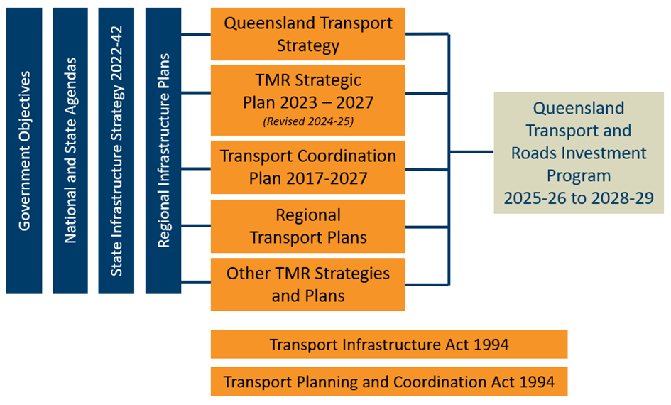

DRAFT v0.6.2 (as at 3 June 2024)


Fast Facts

Total investment
 $41.7 billion
 25,000 Jobs supported

Investment by entity
 $36.4 billion Transport and Main Roads
 $5.3 billion Queensland Rail
 $21 million Gold Coast Waterways Authority

Investment by mode
 $25.5 billion Roads
 $15.3 billion Railways
 $227 million Bus infrastructure
 $288 million Active transport
$262 million Maritime
 $134 million Multimodal and other infrastructure

Investment by funding source
$29.2 billion Queensland Government/other funding
 $12.5 billion Australian Government

QTRIP highlights
 $5.6 billion Maintenance of the network
 $1.7 billion Targeted road safety initiatives
$9 billion Bruce Highway Targeted Safety Program
$5.75 billion Logan and Gold Coast Faster Rail
$4.869 billion Queensland Train Manufacturing Program
$3.5 billion Coomera Connector (Stage 1), Coomera to Nerang
$1.98 billion Rockhampton Ring Road
 $1 billion Inland Freight Route funding commitment
$500 million Queensland Beef Corridors funding commitment
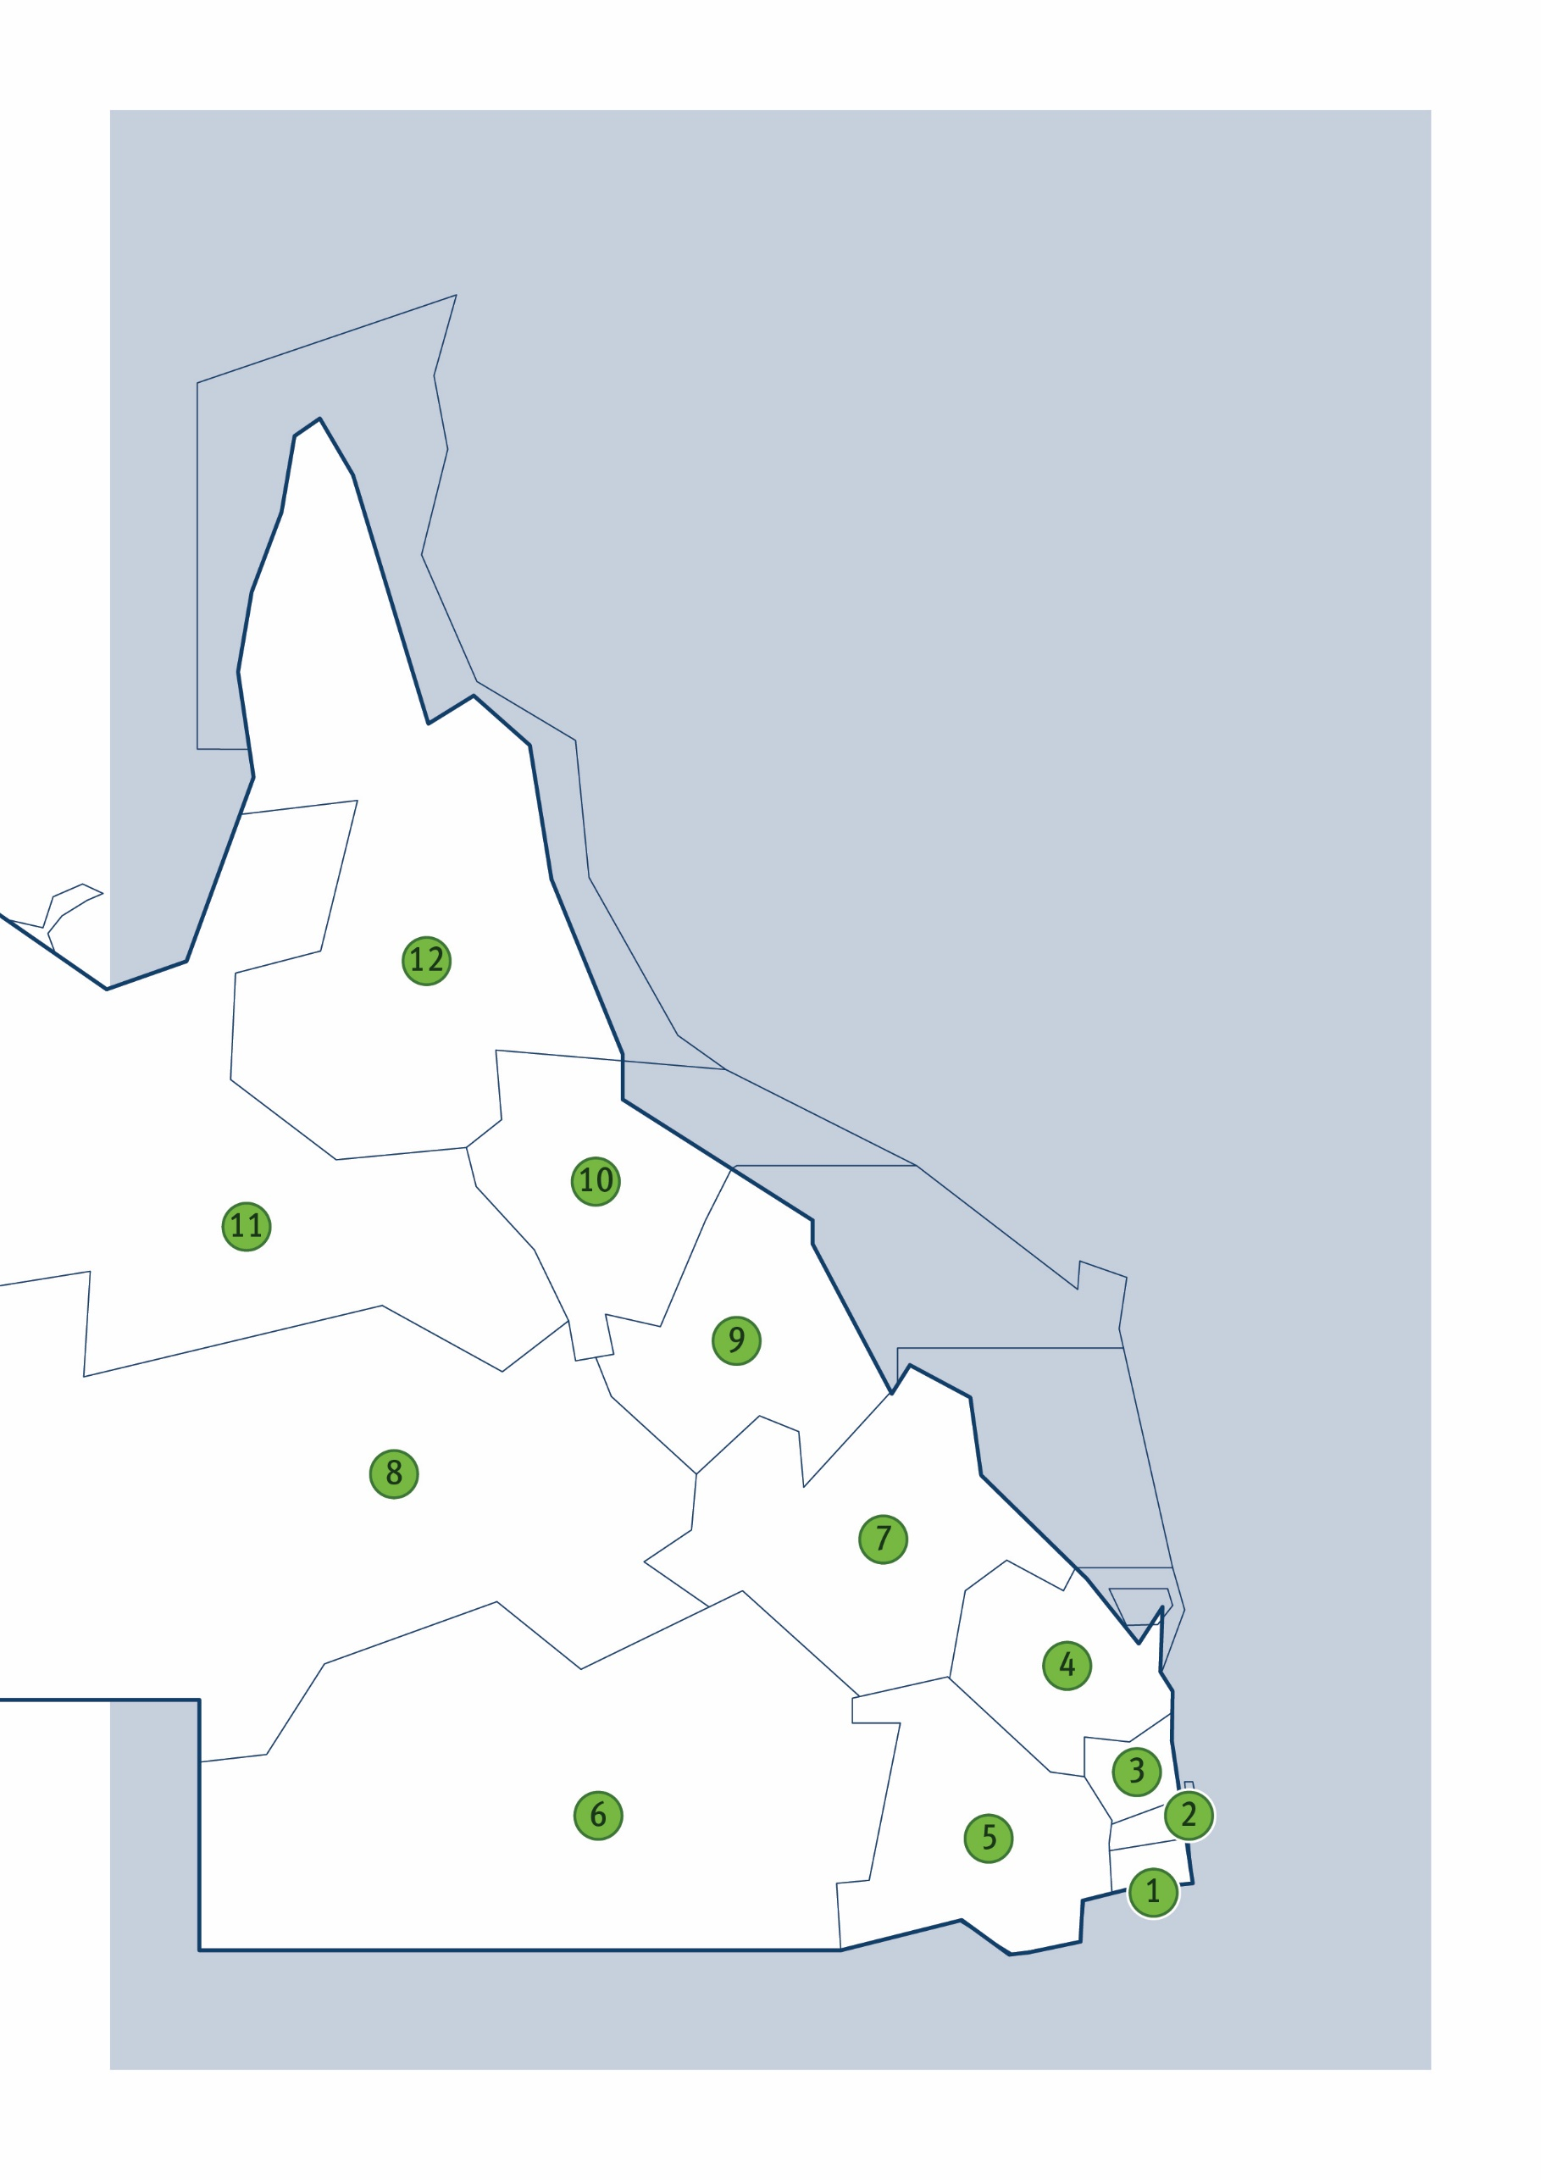

Investment by region/district
- South Coast $4.8 billion
- Metropolitan $4.7 billion
- North Coast $7.2 billion
- Wide Bay Burnett $1.1 billion
- Darling Downs $736 million
- South West $325 million
- Fitzroy $2.1 billion
- Central West $396 million
- Mackay Whitsunday $1.1 billion
- Northern $810 million
- North West $474 million
- Far North $1.9 billion

South Coast

Key facts
6,535 km² Area covered by location 1
 19.95% Population of Queensland 1

868 km Other state-controlled road network
179 km National Land Transport Network 2
88 km National rail network 2

Contact details

Office: Nerang
Address: 36–38 Cotton Street | Nerang | Qld 4211
Postal: PO Box 442 | Nerang | Qld 4211
Phone: (07) 5563 6600
Email: southcoast@tmr.qld.gov.au

See Reference section (Notes for Map Pages)
for further details.

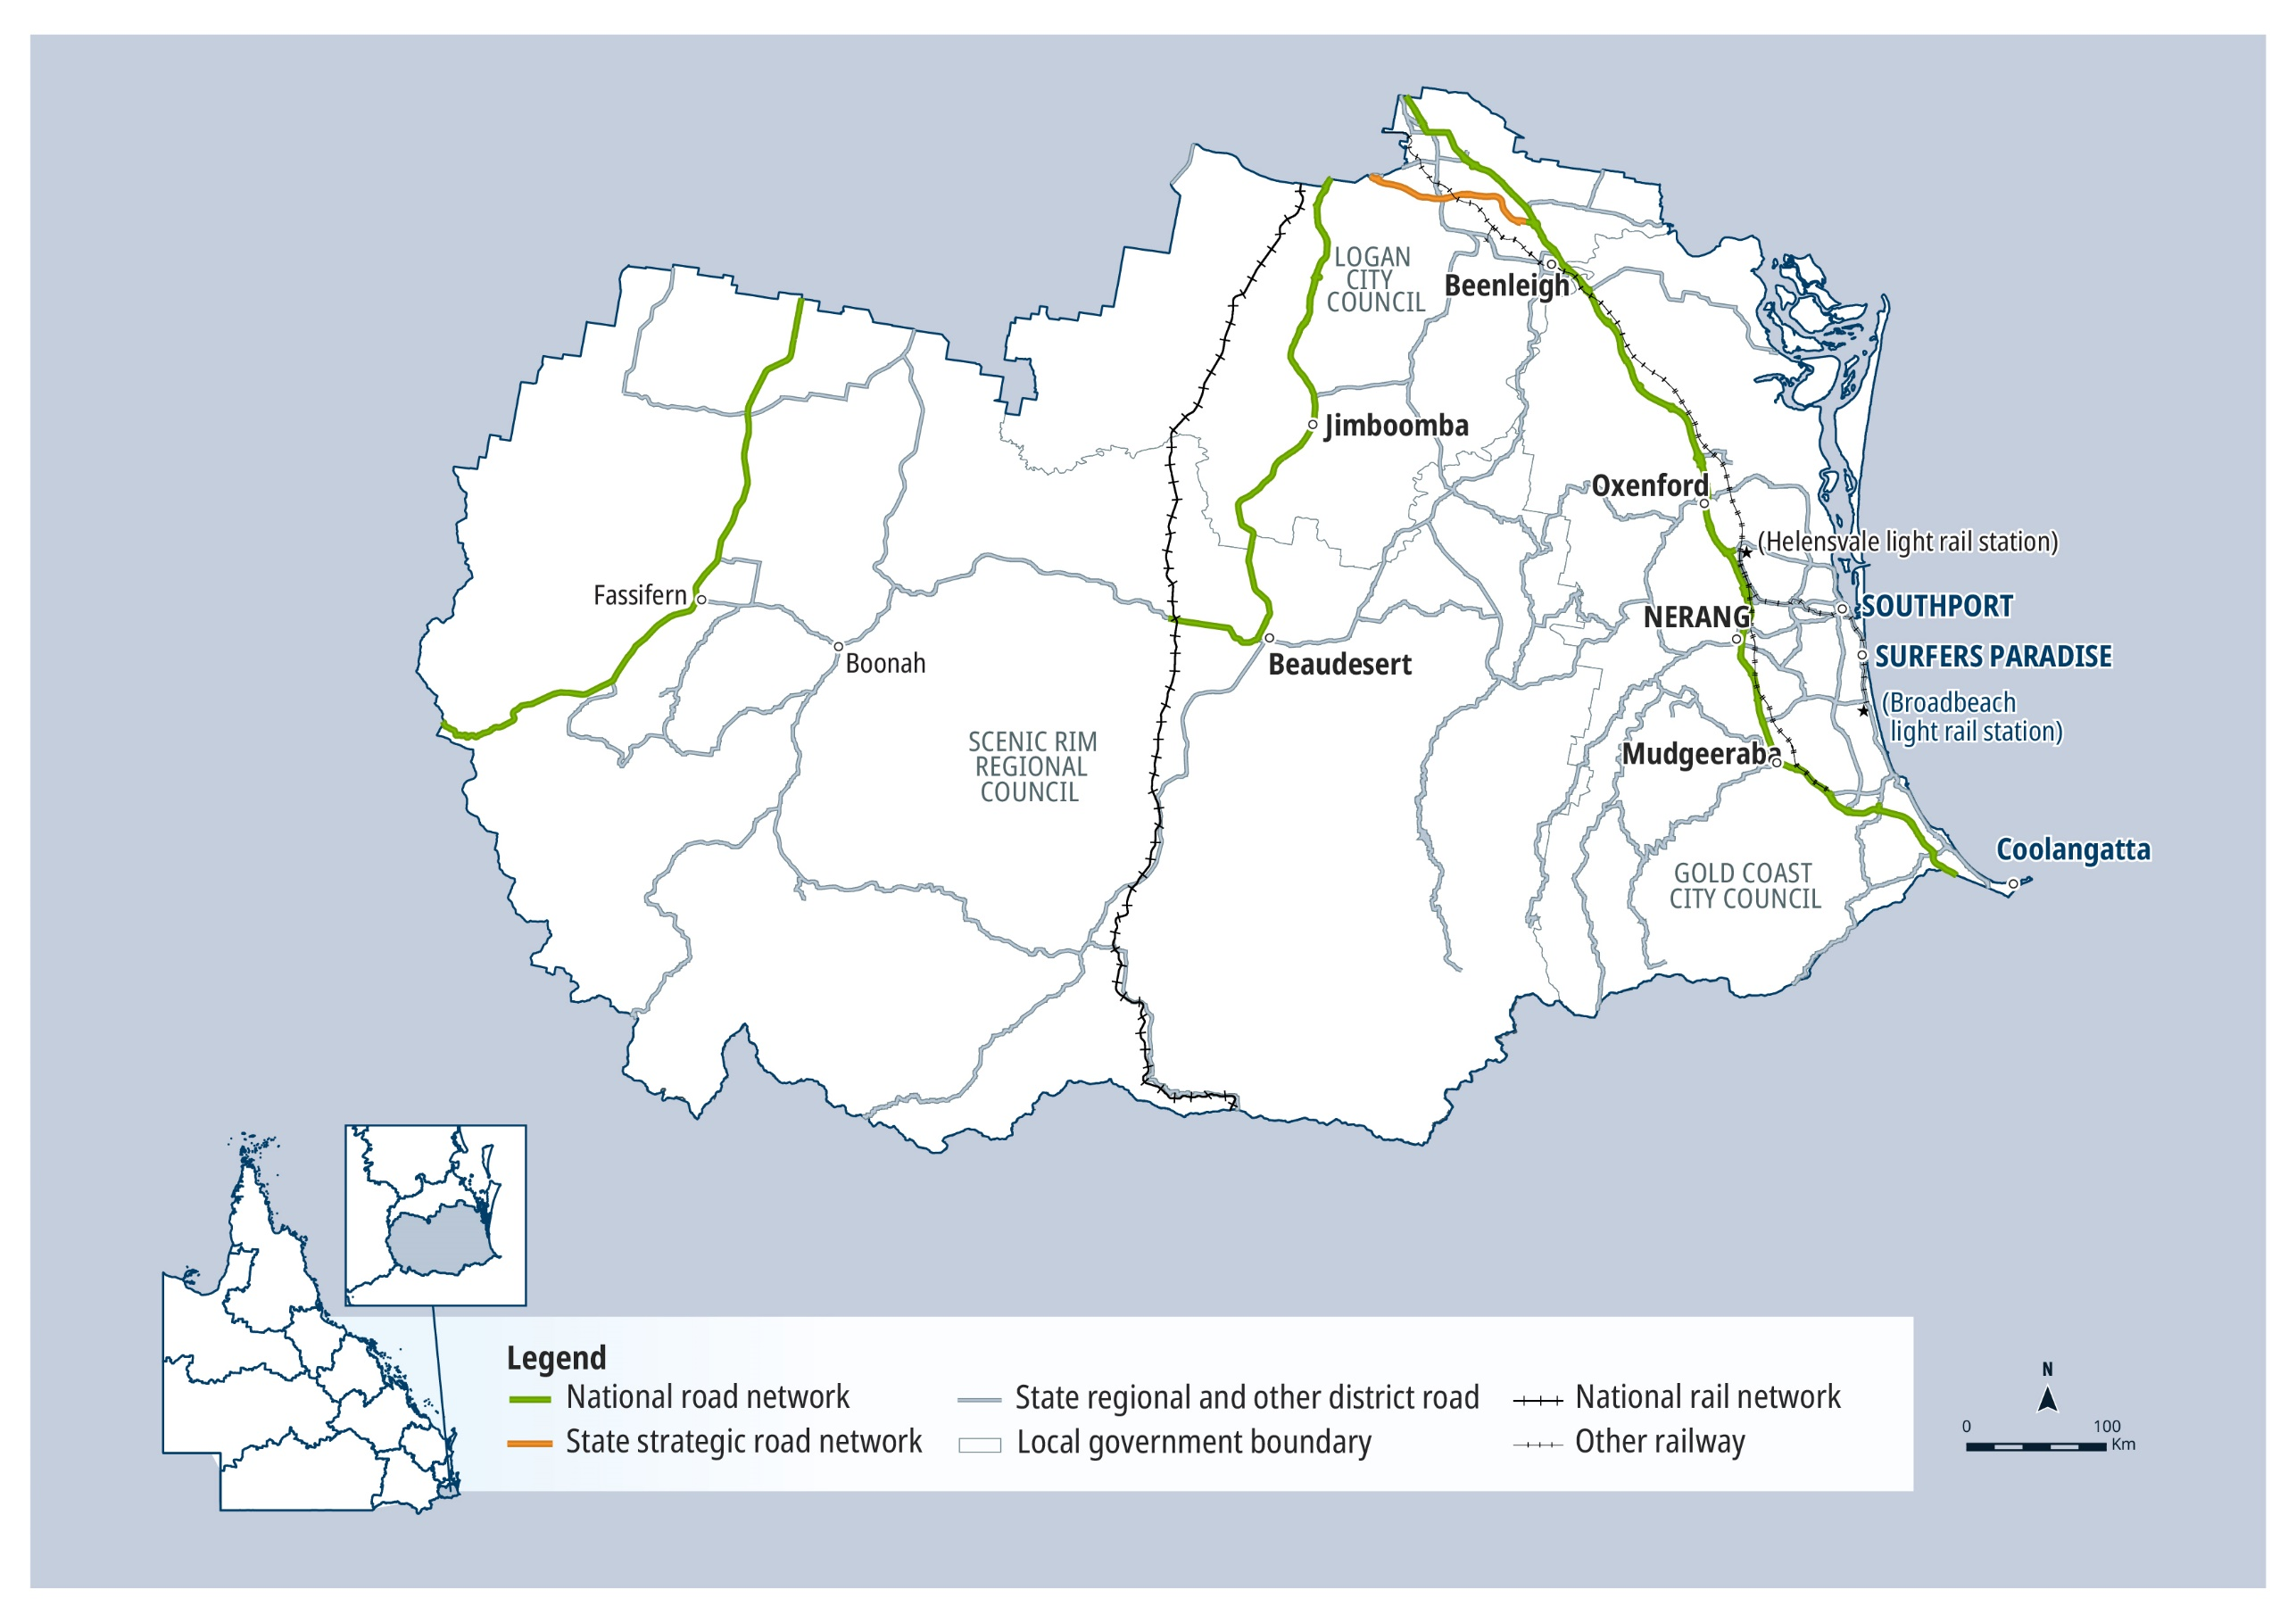

QTRIP 2025-26 to 2028-29

South Coast

Planned investments

Projects: $1 billion plus
AG = Australian Government funding, QG = Queensland Government funding, Local/Other = Local Government or other funding partners.

Investment ID | Project title | AG | QG | Local/ Other | Planning | Procurement | Construction Start | Notes
2543934 | Pacific Motorway, Daisy Hill to Logan Motorway, funding allocation | ● | ● |  | Underway | - | -

Projects: Up to $250 million
AG = Australian Government funding, QG = Queensland Government funding, Local/Other = Local Government or other funding partners.

Investment ID | Project title | AG | QG | Local/ Other | Planning | Procurement | Construction Start | Notes
2612588 | Beaudesert - Beenleigh Road and Mundoolun Connection Road intersection, improve safety |  | ● |  | ✔ | Mid 2025 | Late 2025
2613290 | Beaudesert - Beenleigh Road and Mundoolun Road, improve intersection |  | ● |  | ✔ | Mid 2025 | Early 2026 | Safer Roads Sooner Program
3440401 | Beaudesert - Beenleigh Road, 2024 Disaster Recovery Funding Arrangements reconstruction works | ● | ● |  | - | - | - | Funding administered by the Queensland Reconstruction Authority.
3515374 | Beaudesert - Beenleigh Road, Bannockburn Road and Belivah Road intersection (Windaroo), install traffic signals |  | ● |  | Underway | 2026-27 | 2026-27
1836448 | Beaudesert - Boonah Road (Coulson), improve safety |  | ● |  | ✔ | Early 2026 | Mid 2026 | Safer Roads Sooner Program
3516130 | Beaudesert - Boonah Road (Wyaralong Dam), install guardrail |  | ● |  | Underway | Mid 2026 | 2026-27 | Safer Roads Sooner Program
3617661 | Beaudesert – Boonah Road, install passing lanes, planning |  | ● |  | 2026-27 | - | -
3617706 | Beaudesert – Boonah Road, Teviot Brook Bridge (Coulson) replacement, planning |  | ● |  | 2026-27 | - | -
2612606 | Beaudesert - Nerang Road (Christie Street) and Lamington National Park Road (Kidston Street) (Canungra), pedestrian safety improvements |  | ● |  | Underway | - | -
3516004 | Beaudesert - Nerang Road (Witheren), undertake safety improvements |  | ● |  | Underway | Early 2026 | Mid 2026 | Safer Roads Sooner Program
2352626 | Beenleigh Connection Road and City Road (Beenleigh), upgrade intersection | ● | ● |  | Underway | 2026-27 | 2027-28 | The project has a business case, with scope, cost and timing subject to further project development and site investigations, and consideration.
3439786 | Boonah - Rathdowney Road, 2024 Disaster Recovery Funding Arrangements reconstruction works | ● | ● |  | Underway | Early 2026 | 2026-27 | Funding administered by the Queensland Reconstruction Authority.
2682739 | Brisbane - Beenleigh Road, Jacaranda Avenue to Chambers Flat Road, planning |  | ● |  | Underway | - | -
3048562 | Brisbane - Beenleigh Road (Kingston Road), Moss Street and Rudge Street (Woodridge), improve intersection |  | ● |  | Underway | - | -
3516083 | Brisbane - Beenleigh Road (Logan River Road) and Holmview Road (Holmview), improve intersection |  | ● |  | Underway | 2026-27 | 2026-27 | Safer Roads Sooner Program
2667114 | Brisbane - Beenleigh Road, improve safety |  | ● |  | Underway | Mid 2026 | 2026-27 | High Risk Roads Initiative
3055682 | Burleigh Connection Road and Varsity Lakes Train station, upgrade bus infrastructure |  | ● |  | ✔ | Late 2025 | Early 2026 | The project has a business case, with scope, cost and timing subject to further project development and site investigations, and consideration.
3646282 | Coomera Connector (Stage 2), Shipper Drive to Yawalpah Road, planning and design |  | ● |  | Early 2026 | - | -
3459628 | Coomera Town Centre, East-west Connectors and M1 interchange, planning |  | ● |  | Underway | - | - | Safer Roads, Better Transport Initiative
1776744 | Currumbin Creek Road and Bienvenue Drive, upgrade intersection | ● | ● |  | ✔ | Late 2025 | Early 2026 | Funding splits under negotiation with Australian Government.
3048531 | Currumbin Creek Road and Stewart Road (Currumbin), improve intersection |  | ● |  | Underway | Mid 2026 | 2026-27
3293956 | Currumbin Creek Road, culvert replacement, pre-construction |  | ● |  | ✔ | _ | - | This project represents planning and design costs only, with construction cost subject to confirmation.
3440315 | Gold Coast - Springbrook Road, 2024 Disaster Recovery Funding Arrangements reconstruction works | ● | ● |  | Underway | Early 2026 | 2026-27 | Funding administered by the Queensland Reconstruction Authority.
3545458 | Gold Coast Highway (Burleigh Heads), wildlife crossing, pre-construction |  | ● |  | Underway | - | - | This project represents planning and design costs only, with construction cost subject to confirmation.
3335959 | Goldmine Road Upgrade |  |  | ● | Underway | - | -
3048432 | Hope Island Road (Oxley Drive) and Sunbird Avenue (Paradise Point), improve intersection |  | ● |  | Underway | Early 2026 | 2026-27
3630404 | Hope Island Road, Jabiru Island Bridge upgrade, planning |  | ● |  | Mid 2025 | - | -
2612579 | Kalbar Connection Road (George Street) (Kalbar), improve pedestrian safety |  | ● |  | ✔ | ✔ | Early 2026
3439836 | Lamington National Park Road, 2024 Disaster Recovery Funding Arrangements reconstruction works | ● | ● |  | Underway | Early 2026 | 2026-27 | Funding administered by the Queensland Reconstruction Authority.
3049926 | Mount Cotton Road and Wuduru Road (Beenleigh), improve intersection |  | ● |  | ✔ | Late 2025 | Early 2026 | Safer Roads Sooner Program
3439548 | Mount Lindesay Highway (Beaudesert - Border), 2024 Disaster Recovery Funding Arrangements reconstruction works | ● | ● |  | Underway | Early 2026 | 2026-27 | Funding administered by the Queensland Reconstruction Authority.
1836396 | Mount Lindesay Highway (Beaudesert - Border), Palen Creek, improve safety |  | ● |  | Underway | Mid 2026 | 2026-27 | Safer Roads Sooner Program
3515509 | Mount Lindesay Highway (Brisbane - Beaudesert) and Millstream Road (Jimboomba), improve intersection |  | ● |  | Underway | Early 2026 | 2026-27 | Safer Roads Sooner Program
3538514 | Mount Lindesay Highway (Brisbane - Beaudesert), Jimboomba to Beaudesert, safety and capacity improvements, planning |  | ● |  | Underway | - | - | Safer Roads, Better Transport Initiative
2262546 | Mount Lindesay Highway (Brisbane - Beaudesert), Logan Motorway to Park Ridge Road, planning |  | ● |  | Underway | - | -
3516163 | Mundoolun Connection Road and Biddaddaba Road (Boyland), improve intersection |  | ● |  | Underway | 2026-27 | 2026-27 | Safer Roads Sooner Program
3048559 | Nerang - Broadbeach Road and Labrador - Carrara Road (Ross Street) intersection, upgrade pedestrian facilities |  | ● |  | Underway | - | -
3440367 | Nerang - Murwillumbah Road, 2024 Disaster Recovery Funding Arrangements reconstruction works | ● | ● |  | Underway | Early 2026 | 2026-27 | Funding administered by the Queensland Reconstruction Authority.
3113540 | Nerang to Broadbeach public transport route, business case |  | ● |  | Early 2026 | - | -
3050251 | Pacific Highway (Pacific Motorway), Main Street overpass (Beenleigh), undertake safety improvements |  | ● |  | ✔ | ✔ | Late 2025 | Safer Roads Sooner Program
3541961 | Pacific Motorway, Coomera Springs, install noise barriers |  | ● |  | Underway | - | - | The project is in the pre-business case stage, with scope, cost and timing subject to further planning and business case development, and consideration.
3541505 | Pacific Motorway, Exit 41, install noise barriers |  | ● |  | Underway | - | - | The project is in the pre-business case stage, with scope, cost and timing subject to further planning and business case development, and consideration.
3654207 | Pacific Motorway, Exit 45 (North) Ormeau, design and pre-construction |  | ● |  | Mid 2026 | - | -
1487103 | Salisbury to Beaudesert rail line, corridor protection | ● | ● |  | Late 2025 | - | - | Australian Government Major Projects Business Case Fund
3516005 | Southport - Burleigh Road (Bermuda Street), Q Super Centre access (Mermaid Waters), improve intersection |  | ● |  | Underway | 2026-27 | 2026-27 | Safer Roads Sooner Program
1882808 | Southport - Burleigh Road, Clear Island Waters to Burleigh Heads, planning |  | ● |  | Underway | - | -
1192281 | Southport - Burleigh Road and Markeri Street, upgrade intersection |  | ● |  | Underway | - | - | Project scope, cost and timing subject to further planning.
3048461 | Southport - Burleigh Road and Slayter Avenue, improve intersection |  | ● |  | Underway | 2026-27 | 2026-27
3049063 | Southport - Nerang Road and Ashmore Road (Ashmore), undertake safety improvements |  | ● |  | Underway | 2026-27 | 2026-27 | Safer Roads Sooner Program
3049817 | Southport - Nerang Road, Minnie Street and Anne Street (Southport), improve intersection |  | ● |  | ✔ | Early 2026 | Mid 2026 | Safer Roads Sooner Program
2613362 | Springwood Connection Road (Wembley Road) and Mayes Avenue, improve intersection |  | ● |  | ✔ | Late 2025 | Early 2026 | Safer Roads Sooner Program
2613366 | Tallebudgera Creek Road and Old Coach Road, improve intersection |  | ● |  | Underway | Late 2025 | Mid 2026 | Safer Roads Sooner Program
3440418 | Tamborine - Oxenford Road, 2024 Disaster Recovery Funding Arrangements reconstruction works | ● | ● |  | Underway | Mid 2026 | 2026-27 | Funding administered by the Queensland Reconstruction Authority.
3135496 | Tamborine - Oxenford Road, Regatta Avenue East to Gray Willow Boulevard, improve safety and capacity, planning |  | ● |  | Mid 2025 | - | -
3515562 | Tamborine Mountain Road (Tamborine), undertake safety improvements |  | ● |  | Underway | Early 2026 | 2026-27 | Safer Roads Sooner Program
3439763 | Tamborine Mountain Road, 2024 Disaster Recovery Funding Arrangements reconstruction works | ● | ● |  | Underway | Early 2026 | 2026-27 | Funding administered by the Queensland Reconstruction Authority.
3515461 | Tugun - Currumbin Road (Stewart Road) (Currumbin), undertake safety improvements |  | ● |  | Underway | Early 2026 | 2026-27 | Safer Roads Sooner Program
3050176 | Waterford - Tamborine Road (Logan Village), undertake safety improvements |  | ● |  | ✔ | Late 2025 | Early 2026 | Safer Roads Sooner Program
2688576 | Waterford - Tamborine Road, Stegemann Road to Logan Village, planning |  | ● |  | Underway | - | -

Contractually committed investments
AG = Australian Government funding, QG = Queensland Government funding, Local/Other = Local Government or other funding partners.
Investment ID | Project title | AG  ($’000’s) | QG  ($’000’s) | Local/ Other  ($’000’s) | Committed total budget ($’000’s) | Estimated expenditure to 30 June 2025 ($’000’s) | 2025-26 ($’000’s) | Post 2025-26 ($’000’s) | Notes
1776678 | Coomera Connector (Stage 1), Coomera to Nerang | 1,513,000 | 1,987,000 |  | 3,500,000 | 1,498,181 | 610,000 | 1,391,819 | Project subject to further negotiation with the Australian Government.
938148 | Gold Coast Light Rail (Stage 3), Broadbeach South to Burleigh Heads | 395,600 | 1,043,300 | 110,100 | 1,549,000 | 1,081,292 | 360,000 | 107,708 | This project is being delivered as a Public Private Partnership. Funding splits under negotiation with Australian Government.
852582 | Pacific Motorway, Varsity Lakes (Exit 85) to Tugun (Exit 95) upgrade | 750,000 | 750,000 |  | 1,500,000 | 1,282,082 | 100,000 | 117,918
2316082 | New Gold Coast Stations (Pimpama, Hope Island and Merrimac) |  | 500,000 |  | 500,000 | 361,534 | 138,466 |  | Includes an agreed contribution from Queensland Rail of $73 million.
B07079 | European Train Control System Level 2 upgrades, Beenleigh to Varsity Lakes |  | 339,000 |  | 339,000 | 52,900 | 166,900 | 119,200 | This project is being delivered by the Department of Transport and Main Roads.
1452806 | Cunningham Highway (Ipswich - Warwick), 2020 Disaster Recovery Funding Arrangements reconstruction works | 205,650 | 68,550 |  | 274,200 | 217,542 | 56,658 |  | Funding administered by the Queensland Reconstruction Authority.
B06695 | Queensland Train Manufacturing Program Enabling works |  | 246,900 |  | 246,900 | 30,838 | 54,926 | 161,136 | The Ormeau Mainline Connection Works and Ormeau Feeder Substation have been merged to form Queensland Train Manufacturing Program Enabling works.
1490266 | Loganlea train station relocation | 89,380 | 84,380 |  | 173,760 | 59,617 | 65,028 | 49,115 | Includes an agreed contribution from Queensland Rail.
1776871 | Mount Lindesay Highway (Brisbane - Beaudesert), Johanna Street to South Street (Jimboomba), duplication | 63,400 | 31,600 |  | 95,000 | 26,879 | 33,121 | 35,000
1748742 | Gold Coast Light Rail (Stage 4), Burleigh Heads to Coolangatta, planning |  | 15,000 | 15,000 | 30,000 | 10,770 | 5,300 | 4,600 | Gold Coast City Council contribution includes both financial and in-kind to a total $30 million planning.
GC6 | Spit Masterplan (Southport), northern end of Main Beach, implement spit masterplan (Gold Coast Waterways Authority) |  | 24,236 |  | 24,236 | 15,953 | 3,057 | 5,226 | This capital value makes up part of the overall $60 million Spit Master Plan works program being implemented by GCWA and other delivery entities.
709455 | Brisbane - Beenleigh Road, Kingston Road and Compton Road, upgrade intersection |  | 21,400 |  | 21,400 | 9,946 | 10,054 | 1,400
1489367 | Beaudesert - Beenleigh Road, Milne Street to Tallagandra Road, duplicate to four lanes | 10,000 | 10,000 |  | 20,000 | 8,206 | 10,794 | 1,000 | The project is in the post-business case stage, with project scope, cost and timing subject to confirmation following market engagement, and consideration. Funding splits under negotiation.
1621576 | Gold Coast Light Rail (Stage 3), Broadbeach South to Burleigh Heads, construct cycleway |  | 10,000 | 10,000 | 20,000 | 13,832 | 6,168
2023478 | Loganlea train station, upgrade park 'n' ride | 1,987 | 15,000 |  | 16,987 | 5,946 | 6,796 | 4,245
3006608 | Kerry Road (Kerry), realignment, strengthen and widen pavement | 5,000 |  | 4,601 | 9,601 |  | 5,000 |  | Australian Government Safer Local Roads and Infrastructure Program
3006565 | Hinchcliffe Drive (Kooralbyn), replace bridge | 5,000 |  | 3,097 | 8,097 | 2,000 | 3,000 |  | Australian Government Safer Local Roads and Infrastructure Program
2749642 | Stapylton - Jacobs Well Road, Christensen Road to Woolshed Road, planning |  | 4,000 |  | 4,000 | 2,600 |  | 1,400
2613343 | Nerang Connection Road (Ferry Street) and Nerang Street, improve intersection |  | 3,582 |  | 3,582 | 1,868 | 1,292 | 422 | Safer Roads Sooner Program
3333506 | Logan bus service growth infrastructure improvements |  | 2,500 |  | 2,500 | 500 | 700 | 1,300
2681768 | Beenleigh Connection Road, Main Street, Martens Road, M1 Exit 35, improve roundabout, planning |  | 2,000 |  | 2,000 | 500 | 1,000 | 500
2616650 | Bumstead Road and Julie Street, improve intersection | 2,000 |  |  | 2,000 | 490 | 1,510 |  | Australian Government Black Spot Program
2607288 | Hope Island Road, Harbour Quays Drive to Gold Coast Highway intersection, install pedestrian facilities |  | 1,985 |  | 1,985 | 543 | 942 | 500
3049818 | Hein Road (Buccan), Section A, undertake safety improvements | 1,950 |  |  | 1,950 | 975 | 975 |  | Australian Government Black Spot Program
3515012 | Mystery Road (Guanaba), undertake safety improvements | 1,900 |  |  | 1,900 |  | 1,900 |  | Australian Government Black Spot Program
3515011 | West Mount Cotton Road (Cornubia), undertake safety improvements | 1,850 |  |  | 1,850 |  |  | 1,850 | Australian Government Black Spot Program
3049819 | Hein Road, The Aspect to Stegemann Road (Buccan), Section B, undertake safety improvements | 1,740 |  |  | 1,740 | 870 | 870 |  | Australian Government Black Spot Program
3555799 | Gold Coast - Springbrook Road, Austinville, upgrade causeway, pre-construction |  | 1,500 |  | 1,500 | 375 | 375 | 750
2352560 | Pacific Motorway, Exit 45 (North) Ormeau, business case | 750 | 750 |  | 1,500 |  | 750 | 750
3514866 | Kooralbyn Road (Laravale), undertake safety improvements | 1,495 |  |  | 1,495 |  | 500 | 995 | Australian Government Black Spot Program
3049816 | Mundoolun Road (Mundoolun), undertake safety improvements | 1,480 |  |  | 1,480 | 740 | 740 |  | Australian Government Black Spot Program
3518059 | Camp Creek Road (Glenapp), upgrade level crossing | 1,250 |  |  | 1,250 | 250 | 1,000 |  | Australian Government Regional Level Crossing Upgrade Fund
2613152 | Springwood Connection Road (Wembley Road) and Ewing Road, improve intersection |  | 1,200 |  | 1,200 | 417 | 411 | 373 | Safer Roads Sooner Program
2613354 | Springwood Connection Road (Wembley Road), Railway Parade and Jacaranda Avenue, improve intersection |  | 1,200 |  | 1,200 | 454 | 382 | 364 | Safer Roads Sooner Program
3515041 | Kokoda Street and York Street intersection (Beenleigh), improve intersection | 1,080 |  |  | 1,080 |  | 20 | 1,060 | Australian Government Black Spot Program
2613242 | Gold Coast - Springbrook Road (Railway Street), Mudgeeraba, install pedestrian facilities |  | 1,000 |  | 1,000 | 163 | 737 | 100

South Coast
2025–26 FY total investment: $2 billion
2026–27 FY total investment: $1.5 billion
2027–28 to 2028–29 FY total investment: $1.3 billion
South Coast total investment over four years (2025–26 to 2028–29): $4.8 billion ⁵

Metropolitan

Key facts
2,974 km² Area covered by location 1
31.89% Population of Queensland 1
437 km Other state-controlled road network
90 km National Land Transport Network 2
88 km National rail network 2


Contact details

Office: Brisbane
Address: 313 Adelaide Street | Brisbane | Qld 4000
Postal: PO Box 70 | Brisbane | Qld 4000
Phone: (07) 3066 4222
Email: metropolitanregion@tmr.qld.gov.au

See Reference section (Notes for Map Pages)
for further details.

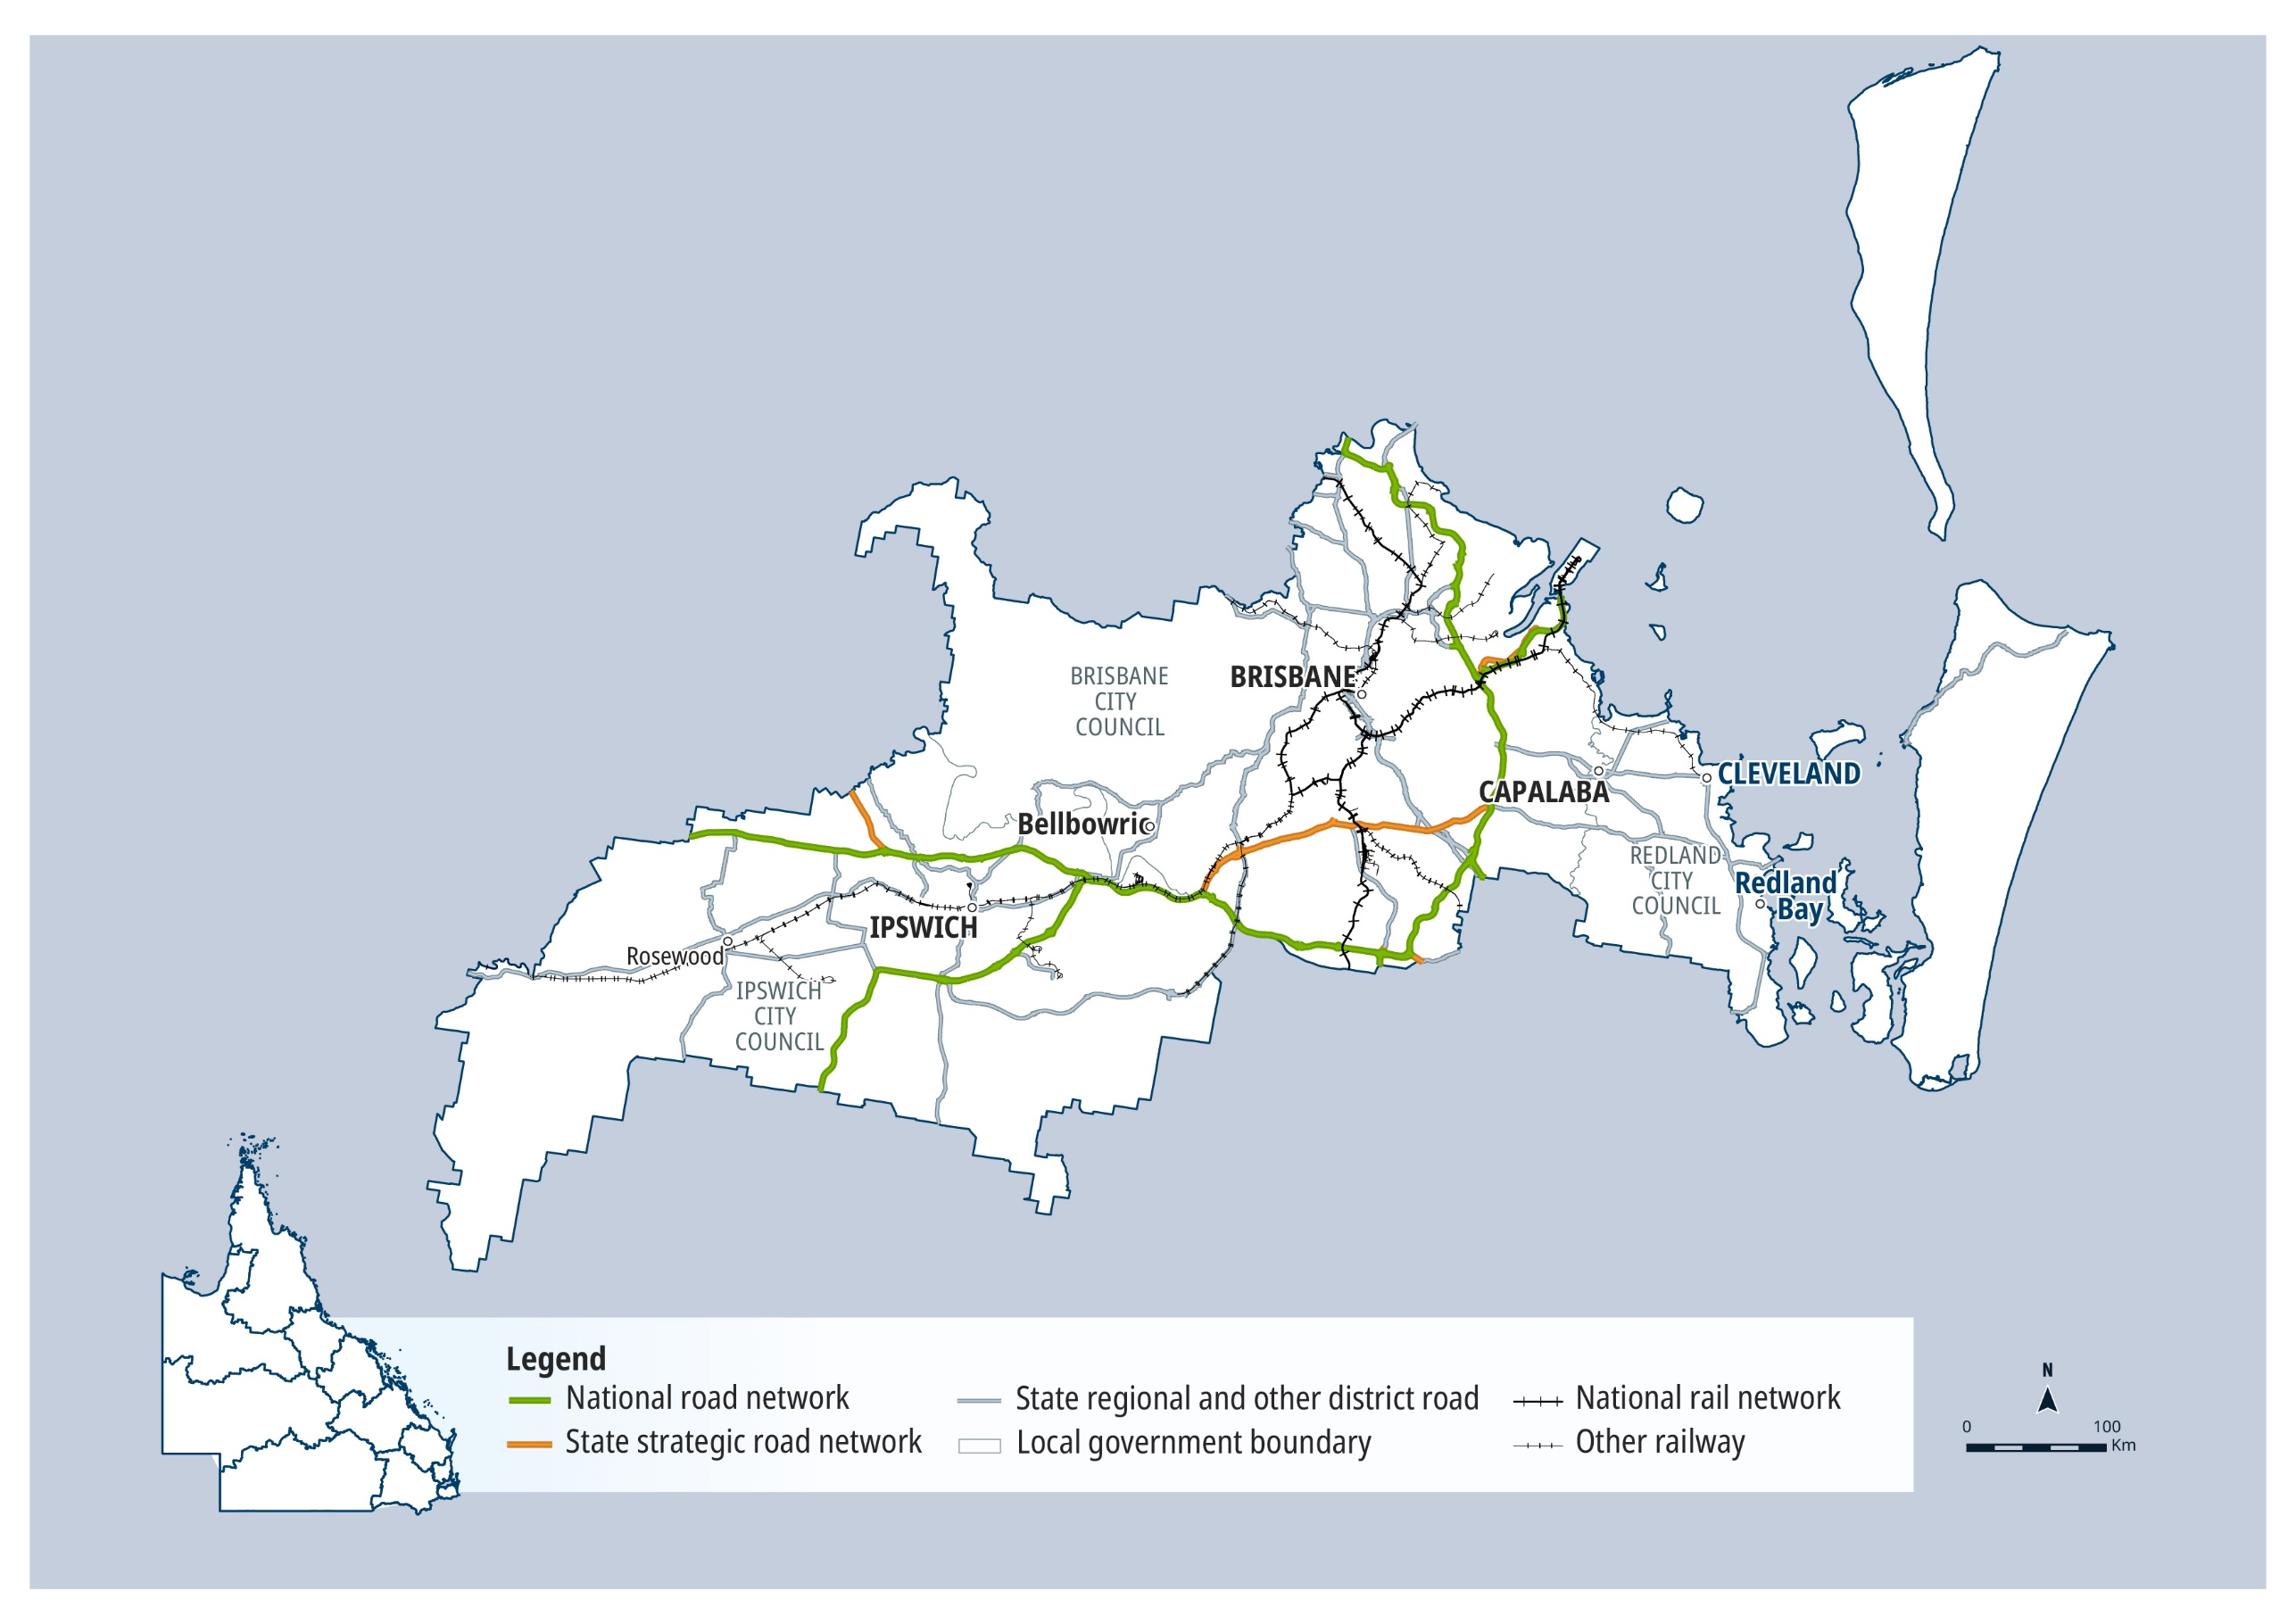

QTRIP 2025-26 to 2028-29

Metropolitan

Planned investments

Projects: $1 billion plus
AG = Australian Government funding, QG = Queensland Government funding, Local/Other = Local Government or other funding partners.
Investment ID | Project title | AG | QG | Local/ Other | Planning | Procurement | Construction Start | Notes
1510417 | Gateway Motorway, Bracken Ridge to Pine River upgrade | ● | ● |  | ✔ | Underway | 2026-27 | The project is in the post-business case stage, with project scope, cost and timing subject to confirmation following market engagement, and consideration.

Projects: $250 million – $1 billion
AG = Australian Government funding, QG = Queensland Government funding, Local/Other = Local Government or other funding partners.

Investment ID | Project title | AG | QG | Local/ Other | Planning | Procurement | Construction Start | Notes
1488479 | Boundary Road (Coopers Plains), upgrade rail level crossing, funding allocation | ● | ● | ● | Underway | - | -
1509103 | Bruce Highway (Brisbane - Gympie), Gateway Motorway to Dohles Rocks Road upgrade (Stage 1) | ● | ● |  | ✔ | Underway | 2025-26 | The project is in the post-business case stage, with project scope, cost and timing subject to confirmation following market engagement, and consideration.
1572882 | Warrego Highway (Ipswich - Toowoomba) and Mount Crosby Road interchange | ● | ● |  | ✔ | 2026-27 | 2027-28 | The project has a business case, with scope, cost and timing subject to further project development and site investigations, and consideration.

Projects: Up to $250 million
AG = Australian Government funding, QG = Queensland Government funding, Local/Other = Local Government or other funding partners.

Investment ID | Project title | AG | QG | Local/ Other | Planning | Procurement | Construction Start | Notes
3573238 | Albany Creek Sub-Arterial Road (Aspley - Albany Creek), road safety audit |  | ● |  | Mid 2025 | - | - | Safer Roads, Better Transport Initiative
1815511 | Bowen Bridge Road to Exhibition Station, upgrade rail pedestrian connection |  | ● |  | Underway | - | -
B06465 | Breakfast Creek Bridge Replacement |  | ● |  | Underway | - | -
3594937 | Bridges for Brisbane, Toowong - St Lucia to West End Bridge, business case | ● |  |  | - | - | - | Grant to Local Government.
3590828 | Brisbane Metro expansion, business case | ● |  |  | Late 2025 | - | - | Tripartite agreement with Australian Government, Queensland Government and Brisbane City Council, with costing to be subject to negotiation.
3454118 | Cabbage Tree Creek Harbour, channel entrance, dredging |  | ● |  | Mid 2026 | 2026-27 | 2026-27
1582984 | Cannon Hill Shopping Centre, upgrade bus station |  | ● |  | Underway | - | -
2605820 | Cavendish Road rail level crossing (Coorparoo), funding allocation | ● |  |  | Underway | - | -
3115009 | Centenary Motorway (Darra to Yamanto), planning |  | ● |  | 2025-26 | - | -
3249110 | Centenary Motorway (Yamanto - Ellen Grove), active transport crossing, planning |  | ● |  | Underway | - | -
8799 | Chermside bus stop, construct southbound platform |  | ● | ● | ✔ | Early 2026 | 2026-27 | The project is in the post-business case stage, with cost and timing subject to confirmation following market engagement and consideration.
2781657 | Cleveland - Redland Bay Road, Anita Street to Giles Road, duplicate lanes |  | ● |  | Underway | 2026-27 | 2027-28
2420128 | Coorparoo Level Crossing precinct, Cavendish Road and Stanley Street East, planning | ● | ● |  | Late 2025 | - | -
B06622 | Cross River Rail Tunnel Maintenance Plant |  | ● |  | ✔ | Underway | Mid 2026
3374814 | Cunningham Highway interchanges upgrades – Ripley Road and Swanbank Road interchange, planning | ● | ● |  | 2025-26 | - | - | Cunningham Highway Planning Package
3614901 | Dunwich (Gumpi) Ferry Terminal upgrade, funding allocation | ● | ● |  | Underway | 2028-29 | 2028-29 | SEQ City Deal
3552704 | Grey Street bikeway, Sidon Street to Russell Street, detailed design separated cycle track |  | ● | ● | 2026-27 | - | -
3594656 | Gympie Arterial Road and Beams Road (Carseldine), upgrade intersection |  | ● |  | 2025-26 | 2025-26 | 2026-27 | Safer Roads, Better Transport Initiative
2275860 | Gympie Arterial Road, Kedron to Bald Hills, planning | ● | ● |  | Underway | - | -
2384603 | Gympie Arterial Road, Telegraph Road to Strathpine Road, improve drainage |  | ● |  | ✔ | Mid 2026 | 2026-27
3655457 | Gympie Road Planning Program |  | ● |  | Mid 2026 | - | -
2604930 | Ipswich to Springfield rail line, business case | ● | ● | ● | Late 2025 | - | - | Project scope, cost and timing subject to further planning and negotiation with funding partners.
1160465 | Linkfield Road Overpass upgrade | ● | ● |  | ✔ | 2025-26 | 2026-27 | The project is in the post-business case stage, with cost and timing subject to confirmation following market engagement and consideration.
3595106 | Moggill Sub-Arterial Road, Kenmore roundabout and Our Lady of the Rosary intersection, safety improvements |  | ● |  | Underway | 2026-27 | 2027-28 | Safer Roads, Better Transport Initiative
3598421 | Moggill Sub-Arterial Road, Moggill District Sports Park and 444 Bus extension, footpath |  | ● |  | Underway | 2025-26 | 2026-27
3247455 | Moggill Sub-Arterial Road, Witton Road to the Centenary Motorway off ramp (Chapel Hill), active transport design and construction |  | ● |  | Underway | - | -
3596733 | Mount Cotton Road and Valley Way intersection, upgrade |  | ● |  | Underway | 2026-27 | 2027-28 | Safer Roads, Better Transport Initiative
3628092 | Prebble Street Bikeway, Prebble Street to Maibry Street, construct active transport facilities |  | ● |  | Underway | 2026-27 | 2027-28 | Project scope, timing and funding subject to negotiation with Brisbane City Council.
2384648 | Riverview - Moggill Ferry Road, River Road to Brisbane River, improve drainage, pavement stabilisation and strengthening |  | ● |  | ✔ | 2025-26 | 2026-27
B06737 | Roma Street surface station integration |  | ● |  | Underway | - | - | This project is being delivered by the Department of Transport and Main Roads.
3527126 | Safety and critical maintenance upgrade, planning |  | ● |  | 2026-27 | - | -
3594497 | Stafford Road and South Pine Road intersection (Everton Park), upgrade |  | ● |  | Underway | 2026-27 | 2027-28 | Safer Roads, Better Transport Initiative
B06692 | Train Crew Capacity Upgrades |  | ● |  | Underway | - | -
1583698 | Upper Mount Gravatt Busway Station, upgrade accessibility |  | ● |  | Underway | - | -
3181839 | Veloway 1 (V1) Cycleway, Birdwood Road cycle bridge and approaches, construction |  | ● |  | Underway | - | -
3214366 | Warrego Highway (Ipswich - Toowoomba), Bremer River Bridge, strengthening | ● | ● |  | ✔ | 2025-26 | 2025-26 | The project is in the post-business case stage, with project scope, cost and timing subject to confirmation following market engagement, and consideration.
3369881 | Weinam Creek Priority Development Area carpark, funding allocation |  | ● |  | Underway | - | -
2635585 | Western Arterial Road (Toowong - Everton Park), Wardell Street Ramp and Pickering Street, improve safety |  | ● |  | ✔ | Underway | 2026-27 | Safer Roads Sooner Program

Contractually committed investments
AG = Australian Government funding, QG = Queensland Government funding, Local/Other = Local Government or other funding partners.
Investment ID | Project title | AG  ($’000’s) | QG  ($’000’s) | Local/ Other  ($’000’s) | Committed total budget ($’000’s) | Estimated expenditure to 30 June 2025 ($’000’s) | 2025-26 ($’000’s) | Post  2025-26 ($’000’s) | Notes
B04735 | European Train Control System Signalling Program: Phase 1 (Pilot line, Tunnel, and Sector 1 to Moorooka) |  | 1,318,323 |  | 1,318,323 | 788,380 | 190,200 | 339,743 | This project is being delivered by Cross River Rail Delivery Authority and Department of Transport and Main Roads with support from Queensland Rail. This is the same project as European Train Control Systems Level 2, but also includes new cyber security/Operational readiness scope, full integration with other Cross River Rail contract schedules to Moorooka, and addresses inflationary signalling costs.
B05732 | Clapham Yard Stabling (Moorooka), construct stabling yard |  | 692,728 |  | 692,728 | 253,270 | 122,386 | 317,072 | This project is being delivered by Cross River Rail Delivery Authority.
669801 | Centenary Bridge Upgrade | 139,250 | 214,250 |  | 353,500 | 179,013 | 65,000 | 109,487 | Funding splits under negotiation with Australian Government.
1677748 | Brisbane Metro, funding allocation | 351,500 |  |  | 351,500 | 346,500 | 5,000 |  | Funding commitment towards Brisbane City Council's Brisbane Metro project.
B05735 | Mayne Yard Accessibility, upgrade vehicle and pedestrian access |  | 300,432 |  | 300,432 | 188,877 | 111,556 |  | This project is being delivered by Cross River Rail Delivery Authority.
2248719 | Beams Road (Carseldine and Fitzgibbon), upgrade rail level crossing | 56,240 | 138,760 | 40,000 | 235,000 | 100,043 | 56,041 | 78,917
B05734 | Station Upgrades Fairfield to Salisbury |  | 203,371 |  | 203,371 | 108,381 | 94,989 |  | This project is being delivered by Cross River Rail Delivery Authority.
B05099 | Buranda train station, Arne Street (Woolloongabba), upgrade station |  | 70,079 |  | 70,079 | 50,954 | 19,125
B06066 | Morningside train station, Waminda Street, upgrade station |  | 68,025 |  | 68,025 | 64,749 | 3,276
1213128 | Lindum rail level crossing, funding allocation | 65,000 |  |  | 65,000 |  |  | 65,000
B06065 | Lindum train station, Sibley Road, upgrade station |  | 62,381 |  | 62,381 | 61,316 | 1,065
2330976 | Lindum rail level crossing, upgrade signalisation, funding allocation | 20,000 | 10,000 | 10,000 | 40,000 | 12,350 | 9,325 | 8,325 | This project is led by Brisbane City Council, with final cost subject to the completion of planning and negotiation with funding partners.
1818471 | Shaftston Avenue bikeway, Mowbray Park to Deakin Street underpass, construct bikeway facilities |  | 22,500 | 17,500 | 40,000 | 1,813 | 2,188 | 18,500
2369175 | Ipswich Motorway (Cunningham Arterial Road), Rocklea to Darra, remaining sections, planning | 12,500 | 12,500 |  | 25,000 | 16,800 | 4,500 | 3,700
1500732 | Port of Brisbane, planning | 20,000 |  |  | 20,000 | 8,256 | 500 | 11,244 | Australian Government Major Projects Business Case Fund, recognising in-kind contribution from the Queensland Government.
1779625 | Hamilton Road and Western Avenue (Prince Charles Hospital entrance), improve intersection |  | 11,000 | 1,000 | 12,000 |  | 7,000 | 4,000 | Includes Safer Roads, Better Transport Initiative funding.
2311859 | Inner Northern Busway, Roma Street, improve bus station |  | 12,000 |  | 12,000 | 10,000 | 2,000
1244277 | Samford Sub-Arterial Road (Samford Road) and Glen Holm Street, upgrade intersection |  | 12,000 |  | 12,000 | 7,624 | 1,834 | 2,542
3601106 | Sylvan Road, Western Freeway Bikeway to Bicentennial Bikeway, construct bikeway | 5,000 |  | 7,000 | 12,000 |  | 500 | 4,500 | Australian Government Active Transport Fund
2655724 | Centenary Motorway Upgrade, planning | 10,000 |  |  | 10,000 | 9,020 | 980
3553600 | Melbourne Street bikeway, current Brisbane Metro works to Boundary Street, extend bikeway |  | 9,600 |  | 9,600 | 720 | 240 | 8,640
1619865 | Cunningham Highway (Ipswich - Warwick), Ipswich - Rosewood Road intersection, planning | 7,200 | 1,800 |  | 9,000 | 2,250 | 2,000 | 4,750 | Cunningham Highway Planning Package
2340520 | Moorooka bus rail interchange, upgrade |  | 8,000 |  | 8,000 | 3,348 | 1,668 | 2,984
3323562 | Purga School Road, Purga Creek (Purga), replace bridge | 5,000 |  | 2,976 | 7,976 |  | 5,000 |  | Australian Government Safer Local Roads and Infrastructure Program
3333542 | Ipswich bus service growth infrastructure improvements |  | 6,270 |  | 6,270 | 1,025 | 1,851 | 3,395
2694693 | Wallaby Road (Redland Bay), construct three lane boat ramp with floating walkway |  | 3,228 | 2,712 | 5,940 | 2,093 | 3,847
3364693 | Mansfield school precinct, active transport improvements and upgrades |  | 2,500 | 2,500 | 5,000 | 500 | 1,000 | 1,000
2393196 | Bicentennial Bikeway, Kurilpa Bridge to Victoria Bridge, design active transport upgrades |  | 4,550 |  | 4,550 | 2,883 | 1,667
3593888 | Bremer River, second river crossing, business case |  | 4,000 |  | 4,000 |  | 500 | 3,500 | Safer Roads, Better Transport Initiative
2682222 | Cleveland Line Upgrade, planning |  | 4,000 |  | 4,000 | 1,000 | 500 | 2,500
3088381 | Illaweena Street, Stretton State College, upgrade carpark |  | 1,800 | 1,800 | 3,600 | 900 | 900
2384694 | Ipswich - Rosewood Road (John Street), improve flood resilience, planning and design |  | 3,000 |  | 3,000 | 1,000 | 2,000
3031443 | Capalaba - Cleveland Road (Shore Street West) and Gordon Street intersection (Ormiston), improve intersection |  | 2,805 |  | 2,805 | 496 | 2,309 |  | Safer Roads Sooner Program
3517117 | East-West Arterial (Junction Road), Morrison Road and Park Avenue (Clayfield) intersection, upgrade safety |  | 2,300 |  | 2,300 |  | 450 | 1,850 | Safer Roads Sooner Program
3031850 | Ipswich - Cunningham Highway Connection Road (East Street), Mansfield Place and Olga Street, undertake safety improvements |  | 2,233 |  | 2,233 | 428 | 1,805
2152631 | Gympie Arterial Road and Murphy Road intersection, Downfall Creek Bridge, planning |  | 2,128 |  | 2,128 | 1,848 | 280
3517082 | East-West Arterial Road (Stafford Road), Appleby Road and Shand Street (Stafford) intersection, upgrade safety |  | 2,125 |  | 2,125 |  | 277 | 1,848 | Safer Roads Sooner Program
3628230 | Rode Road, McDowall State School, undertake safety improvements |  | 2,000 |  | 2,000 |  | 500 | 1,500
8783 | Brisbane Mesoscopic AIMSUN Model |  | 1,612 |  | 1,612 | 1,110 | 128 | 375
3517078 | Centenary Motorway (Yamanto - Ellen Grove) (Springfield and Ripley), install ATLM and RRPMs |  | 1,600 |  | 1,600 |  | 1,600 |  | Safer Roads Sooner Program
1882788 | Metropolitan Region, development of safety projects, planning |  | 1,600 |  | 1,600 | 1,100 | 500
2821602 | Moreton Bay Cycleway, Murarrie to Wynnum, planning |  | 1,500 |  | 1,500 | 600 | 900
3517160 | St Pauls Terrace and Quarry Street (Fortitude Valley), improve intersection | 1,421 |  |  | 1,421 |  | 1,421 |  | Australian Government Black Spot Program
2486066 | Wellington Point Main Road Jetty, repairs |  | 1,275 |  | 1,275 | 679 | 596
3517085 | Birkdale Road (Moreton Bay Road), Capalaba Central Shopping Centre (Capalaba), intersection safety upgrades |  | 1,267 |  | 1,267 |  | 100 | 1,167 | Safer Roads Sooner Program
3517086 | Sandgate Sub-Arterial Road (Braun Street to Deagon Deviation), Board Street and Depot Road, improve intersection |  | 1,243 |  | 1,243 |  | 210 | 1,034 | Safer Roads Sooner Program
2374644 | Brisbane Metro, South Bank Transport Study, planning | 333 | 333 | 333 | 1,000 |  | 667

Metropolitan
2025–26 FY total investment: $1.3 billion
2026–27 FY total investment: $1.4 billion
2027–28 to 2028–29 FY total investment: $2 billion
Metropolitan total investment over four years (2025–26 to 2028–29): $4.7 billion ⁵

North Coast

Key facts
10,539 km² Area covered by location 1
17.59% Population of Queensland 1
1,252 km Other state-controlled road network
129 km National Land Transport Network 2
127 km National rail network 2


Contact details

Office: Buderim
Address: 50 Wises Road | Buderim | Qld 4556
Postal: PO Box 1600 | Maroochydore | Qld 4558
Phone: (07) 5451 7055
Email: northcoast@tmr.qld.gov.au

See Reference section (Notes for Map Pages)
for further details.

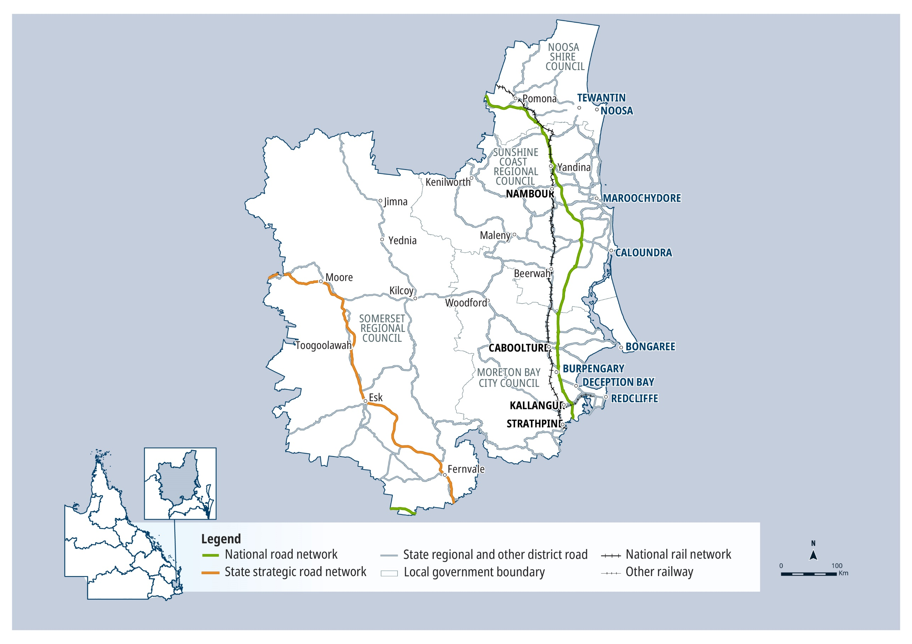

QTRIP 2025-26 to 2028-29

North Coast

Planned investments

Projects: $1 billion plus
AG = Australian Government funding, QG = Queensland Government funding, Local/Other = Local Government or other funding partners.

Investment ID | Project title | AG | QG | Local/ Other | Planning | Procurement | Construction Start | Notes
3024759 | The Wave (Stage 1) | ● | ● |  | ✔ | Underway | 2026-27 | The project has a business case, with scope, cost and timing subject to further project development and site investigations, and consideration. Stage 1 is expected to cost between $5.5 billion to $7 billion, with cost estimates to be finalised following further design development, market engagement and procurement.

Projects: $250 million – $1 billion
AG = Australian Government funding, QG = Queensland Government funding, Local/Other = Local Government or other funding partners.
Investment ID | Project title | AG | QG | Local/ Other | Planning | Procurement | Construction Start | Notes
2588655 | Bruce Highway (Brisbane - Gympie), Anzac Avenue to Uhlmann Road upgrade, funding allocation | ● | ● |  | Underway | 2027-28 | 2028-29 | The project is in the pre-business case stage, with scope, cost and timing subject to further planning and business case development, and consideration.
3644598 | Caboolture - Bribie Island Road, Bribie Island bridge, design and early works |  | ● |  | Underway | - | - | The overall Bribie Island Bridge project is estimated to be in the $250 million to $1 billion category with the final cost to be determined post completion of design. Existing funding will complete design and begin early works.
3582510 | Caloundra Congestion Busting Plan, funding allocation |  | ● |  | Underway | - | - | Safer Roads, Better Transport Initiative
2007574 | Sunshine Motorway, Mooloolah River Interchange Upgrade (Stage 1) | ● | ● |  | Underway | Late 2025 | 2026-27 | Project scope, cost and timing subject to further planning and negotiation with funding partners.

Projects: Up to $250 million
AG = Australian Government funding, QG = Queensland Government funding, Local/Other = Local Government or other funding partners.
Investment ID | Project title | AG | QG | Local/ Other | Planning | Procurement | Construction Start | Notes
3053550 | Beerburrum Road, Twin View Road and English Street (Elimbah) intersection, improve safety |  | ● |  | Underway | Early 2026 | Mid 2026 | Safer Roads Sooner Program
3203844 | Beerburrum to Landsborough (Stage 1), Beerwah to Glass House, construct active transport facilities |  | ● |  | Underway | - | -
2295870 | Beerburrum to Nambour Rail Upgrade, duplication study | ● | ● |  | Underway | - | -
3053007 | Brighton - Redcliffe Road (Hornibrook Esplanade) and Oxley Avenue (Woody Point) intersection, improve safety |  | ● |  | Underway | Late 2025 | Early 2026 | Safer Roads Sooner Program
3591175 | Brisbane - Woodford Road (Mount Mee Road), Dayboro to D'Aguilar, planning |  | ● |  | Early 2026 | - | - | Safer Roads, Better Transport Initiative
3586523 | Brisbane Valley Highway (Ipswich - Harlin), pavement strengthening |  | ● |  | ✔ | Mid 2025 | Late 2025 | Safer Roads, Better Transport Initiative
3548298 | Brisbane Valley Highway Safety Upgrades, funding allocation | ● | ● |  | ✔ | ✔ | Late 2025
3217683 | Bruce Highway (Brisbane - Gympie), Gateway Motorway to Dohles Rocks Road upgrade (Stage 2), detailed design | ● | ● |  | Underway | - | - | The project has a business case, with scope, cost and timing subject to further project development, site investigations, consideration and funding contribution negotiation with the Australian Government.
1779573 | Caboolture - Bribie Island Road, Hickey Road to King Johns Creek, upgrade | ● | ● |  | Underway | 2026-27 | 2027-28 | The project has a business case, with scope, cost and timing subject to further project development and site investigations, and consideration and negotiation with the Australian Government, including funding splits.
3572159 | Caboolture River Road, Gregor Road to Phelps Road (Upper Caboolture), undertake safety improvements | ● |  | ● | - | - | - | Australian Government Safer Local Roads and Infrastructure Program
3552684 | Clive Street (Erskine Street to Chatham Street), construct shared path |  | ● | ● | - | - | 2026-27
3552418 | Clontarf - Anzac Avenue Road (Elizabeth Avenue) and Oasis Court intersection (Clontarf), install traffic signals |  | ● |  | Underway | 2026-27 | 2026-27
3551750 | Clontarf - Anzac Avenue Road (Elizabeth Avenue), Snook Street and King Street intersection (Clontarf), remove slip lanes |  | ● |  | Underway | 2026-27 | 2026-27
2383091 | Coominya Connection Road, Buaraba Creek, replace timber bridge |  | ● |  | ✔ | - | - | The project is in the post-business case stage, with project scope, cost and timing subject to confirmation following market engagement, and consideration.
3333988 | D'Aguilar Highway (Caboolture - Kilcoy) and Ironbark Drive intersection, improve safety |  | ● |  | Underway | Mid 2025 | Late 2025
3333942 | D'Aguilar Highway (Caboolture - Kilcoy) and Lord Lane intersection, improve safety |  | ● |  | Underway | Mid 2025 | Mid 2025
3579951 | D'Aguilar Highway (Caboolture - Kilcoy), upgrade intersections |  | ● |  | Late 2025 | 2026-27 | 2026-27 | Safer Roads, Better Transport Initiative
3552227 | D'Aguilar Highway (Caboolture - Kilcoy), Warmuran State School, signalise pedestrian crossing |  | ● |  | Underway | 2026-27 | 2026-27
3054303 | Deception Bay Road, Bay Avenue and Moreton Downs Drive intersection, improve safety |  | ● |  | Underway | Early 2026 | Mid 2026 | Safer Roads Sooner Program
3552773 | Emu Mountain Road (Old Emu Mountain Road to David Low Way), construct shared path |  | ● | ● | Underway | Early 2026 | 2026-27 | Project scope, timing and funding subject to negotiation with Sunshine Coast Council.
3580519 | Kilcoy - Beerwah Road, upgrade B-Double route |  | ● |  | Underway | Mid 2026 | 2026-27 | Safer Roads, Better Transport Initiative
2383345 | Kin Kin Road, Sallwood Court to Turnbull Road, strengthen and widen pavement |  | ● |  | Underway | Mid 2026 | 2026-27
2383346 | Kin Kin Road, Williams Road to Western Branch Road, strengthen and widen pavement |  | ● |  | Underway | Mid 2026 | 2026-27
2263305 | Landsborough – Maleny Road and Maleny - Montville Road, upgrade intersection, business case |  | ● |  | Underway | - | -
3589031 | Landsborough - Maleny Road and Maleny - Montville Road intersection, improve safety |  | ● |  | Underway | 2027-28 | 2027-28
3550740 | Maroochydore - Mooloolaba Road (Alexandra Parade) and Mayfield Street intersection, install traffic signals |  | ● |  | Underway | 2026-27 | 2026-27 | Safer Roads Sooner Program
3295884 | Maroochydore - Noosa Road (David Low Way) and Mudjimba Esplanade intersection, improve safety |  | ● |  | Underway | Late 2025 | Early 2026
3554084 | Mooloolaba Road and Mayfield Street intersection (Alexandra Headland), undertake safety improvements |  | ● |  | Underway | 2026-27 | 2026-27 | Safer Roads Sooner Program
845329 | Mooloolaba Road, Syd Lingard Drive to Tantula Road West, upgrade intersection |  | ● |  | Underway | Mid 2025 | Late 2025 | Includes Safer Roads, Better Transport Initiative funding.
3571136 | Mount Mee Road, Terrors Creek (Dayboro), construct active transport bridge | ● |  | ● | - | - | - | Australian Government Active Transport Fund
3591080 | Nambour Connection Road and Diddillibah Road intersection, improve safety |  | ● |  | Underway | - | - | Safer Roads, Better Transport Initiative. Project scope, cost and timing subject to further planning.
3552022 | Noosa River, construct new boat infrastructure |  | ● |  | Underway | 2026-27 | 2027-28 | Safer Roads, Better Transport Initiative
3572326 | O'Mara Road, Oakey Flat Road and Stone Ridge Boulevard (Narangba), rehabilitate and widen pavement | ● |  | ● | - | - | - | Grant to Local Government. Australian Government Safer Local Roads and Infrastructure Program.
3551127 | Pomona Connection Road (Reserve Street) and Kin Kin Road (Factory Street) (Pomona), improve pedestrian safety |  | ● |  | Underway | Mid 2026 | 2026-27
3586842 | Pumicestone Road to Wamuran rail trail head, upgrade and construct new pathway |  | ● |  | Underway | - | - | Safer Roads, Better Transport Initiative
3334286 | South Pine Road and Strathpine - Samford Road (Eaton’s Crossing Road) intersection, improve safety |  |  | ● | Underway | 2026-27 | 2026-27
2683782 | Sunshine Motorway (Mooloolaba - Peregian), David Low Way to Yandina - Coolum Road duplication, business case |  | ● |  | Early 2026 | - | -
3587043 | Sunshine Motorway (Mooloolaba - Peregian), West Coolum Road, upgrade interchange |  | ● |  | Underway | 2027-28 | 2027-28 | Safer Roads, Better Transport Initiative. Project scope, cost and timing subject to further planning.
2356108 | Sunshine Motorway (Tanawha - Mooloolaba), Dixon Road to Mooloolah River interchange, business case | ● | ● |  | Underway | - | - | Project scope, cost and timing subject to further planning and negotiation with the Australian Government.
3590527 | Terrors Creek, improve active transport safety |  | ● |  | Underway | - | - | Safer Roads, Better Transport Initiative
3609027 | Tewantin Bypass, Beckmans Road, early works |  | ● |  | Mid 2026 | 2028-29 | 2028-29 | Safer Roads, Better Transport Initiative
3557421 | The Wave (Stage 2 and 3), planning and market readiness |  | ● |  | Underway | - | -

Contractually committed investments
AG = Australian Government funding, QG = Queensland Government funding, Local/Other = Local Government or other funding partners.
Investment ID | Project title | AG  ($’000’s) | QG  ($’000’s) | Local/ Other  ($’000’s) | Committed total budget ($’000’s) | Estimated expenditure to 30 June 2025 ($’000’s) | 2025-26 ($’000’s) | Post  2025-26 ($’000’s) | Notes
858087 | Beerburrum to Nambour Rail Upgrade (Stage 1) | 616,700 | 387,491 |  | 1,004,191 | 243,040 | 284,561 | 476,591
1739444 | Bruce Highway (Brisbane - Gympie), Dohles Rocks Road to Anzac Avenue upgrade (Stage 1) | 232,000 | 58,000 |  | 290,000 | 81,167 | 82,000 | 126,833
1158882 | Caboolture - Bribie Island Road Upgrade Program | 28,915 | 19,315 |  | 48,230 | 19,124 | 15,000 | 14,106
2046348 | North Brisbane - Bruce Highway Western Alternative, planning | 10,000 | 10,000 |  | 20,000 | 10,376 | 700 | 8,924 | Australian Government Major Projects Business Case Fund
2349359 | Bruce Highway (Brisbane - Gympie), Anzac Avenue to Uhlmann Road upgrade, business case | 9,600 | 2,400 |  | 12,000 | 11,234 | 766
2348820 | Bruce Highway (Brisbane - Gympie), Buchanan Road to Caboolture - Bribie Island Road upgrade, business case | 9,600 | 2,400 |  | 12,000 | 9,403 | 268 | 2,329
3006253 | McCulkins Lane and Muckerts Lane (Fernvale), strengthen and widen pavement | 5,000 |  | 5,003 | 10,003 | 416 | 1,834 | 2,751 | Australian Government Safer Local Roads and Infrastructure Program
2349159 | Bruce Highway (Brisbane - Gympie), Uhlmann Road to Buchanan Road upgrade, business case | 8,000 | 2,000 |  | 10,000 | 8,340 | 1,660
1824074 | Memorial Avenue (Tewantin), Doonella Lake bridge, replace bridge | 4,977 |  | 4,977 | 9,953 |  | 2,139 | 2,837 | Australian Government Safer Local Roads and Infrastructure Program
2684020 | Tewantin Bypass, Beckmans Road, planning |  | 8,500 |  | 8,500 | 1,100 | 3,500 | 3,900
2615407 | Neurum Road (Villeneuve), Lester Kropp Bridge, replace bridge | 5,000 |  | 2,274 | 7,274 | 152 | 1,912 | 2,937 | Australian Government Safer Local Roads and Infrastructure Program
1682050 | Mooloolaba Harbour entrance, dredging and bed levelling |  | 5,080 | 570 | 5,650 | 5,150 | 500
1868964 | Maroochydore - Noosa Road (David Low Way), Bli Bli bridge upgrade, planning |  | 3,030 |  | 3,030 | 1,600 | 1,430
3360797 | Brisbane Valley Rail Trail, design, replace and retrofit compliant crossings |  | 2,500 |  | 2,500 | 350 | 1,150 | 1,000
3186073 | Forest Hill Fernvale Road and Lowood Minden Road, Sea Eagle Drive to Russell Road, construct shared path |  | 1,200 | 1,200 | 2,400 | 600 | 600
3631783 | Woombye - Montville Road, 2025 Disaster Recovery Funding Arrangements reconstruction works | 1,566 | 522 |  | 2,088 | 27 | 2,061 |  | Funding administered by the Queensland Reconstruction Authority.
3043499 | Cotton Tree area pedestrian safety project, undertake safety improvements | 1,773 |  |  | 1,773 | 886 | 886 |  | Australian Government Black Spot Program
3556009 | Neurum Road (Woodford), undertake safety improvements | 1,093 |  |  | 1,093 |  | 800 | 293 | Australian Government Black Spot Program
3555916 | Old Toorbul Point Road (Caboolture), undertake safety improvements | 1,086 |  |  | 1,086 |  | 1,086 |  | Australian Government Black Spot Program
3587596 | North Arm - Yandina Creek Road, North Arm State School, undertake safety improvements |  | 1,000 |  | 1,000 |  | 50 | 950

North Coast
2025–26 FY total investment: $1.1 billion
2026–27 FY total investment: $1.9 billion
2027–28 to 2028–29 FY total investment: $4.2 billion
North Coast total investment over four years (2025–26 to 2028–29): $7.2 billion ⁵

Wide Bay Burnett

Key facts
48,503 km² Area covered by location 1
5.94 % Population of Queensland 1
2,699 km Other state-controlled road network
271 km National Land Transport Network 2
242 km National rail network 2


Contact details

Office: Bundaberg
Address: 23 Quay Street | Bundaberg | Qld 4670
Postal: Locked Bag 486 | Bundaberg | Qld 4670
Phone: (07) 4154 0200
Email: bundaberg.office@tmr.qld.gov.au

Office: Gympie
Address: 50 River Road | Gympie | Qld 4570
Postal: PO Box 183 | Gympie | Qld 4570
Phone: (07) 5482 0333
Email: gympie.office@tmr.qld.gov.au
See Reference section (Notes for Map Pages)
for further details.

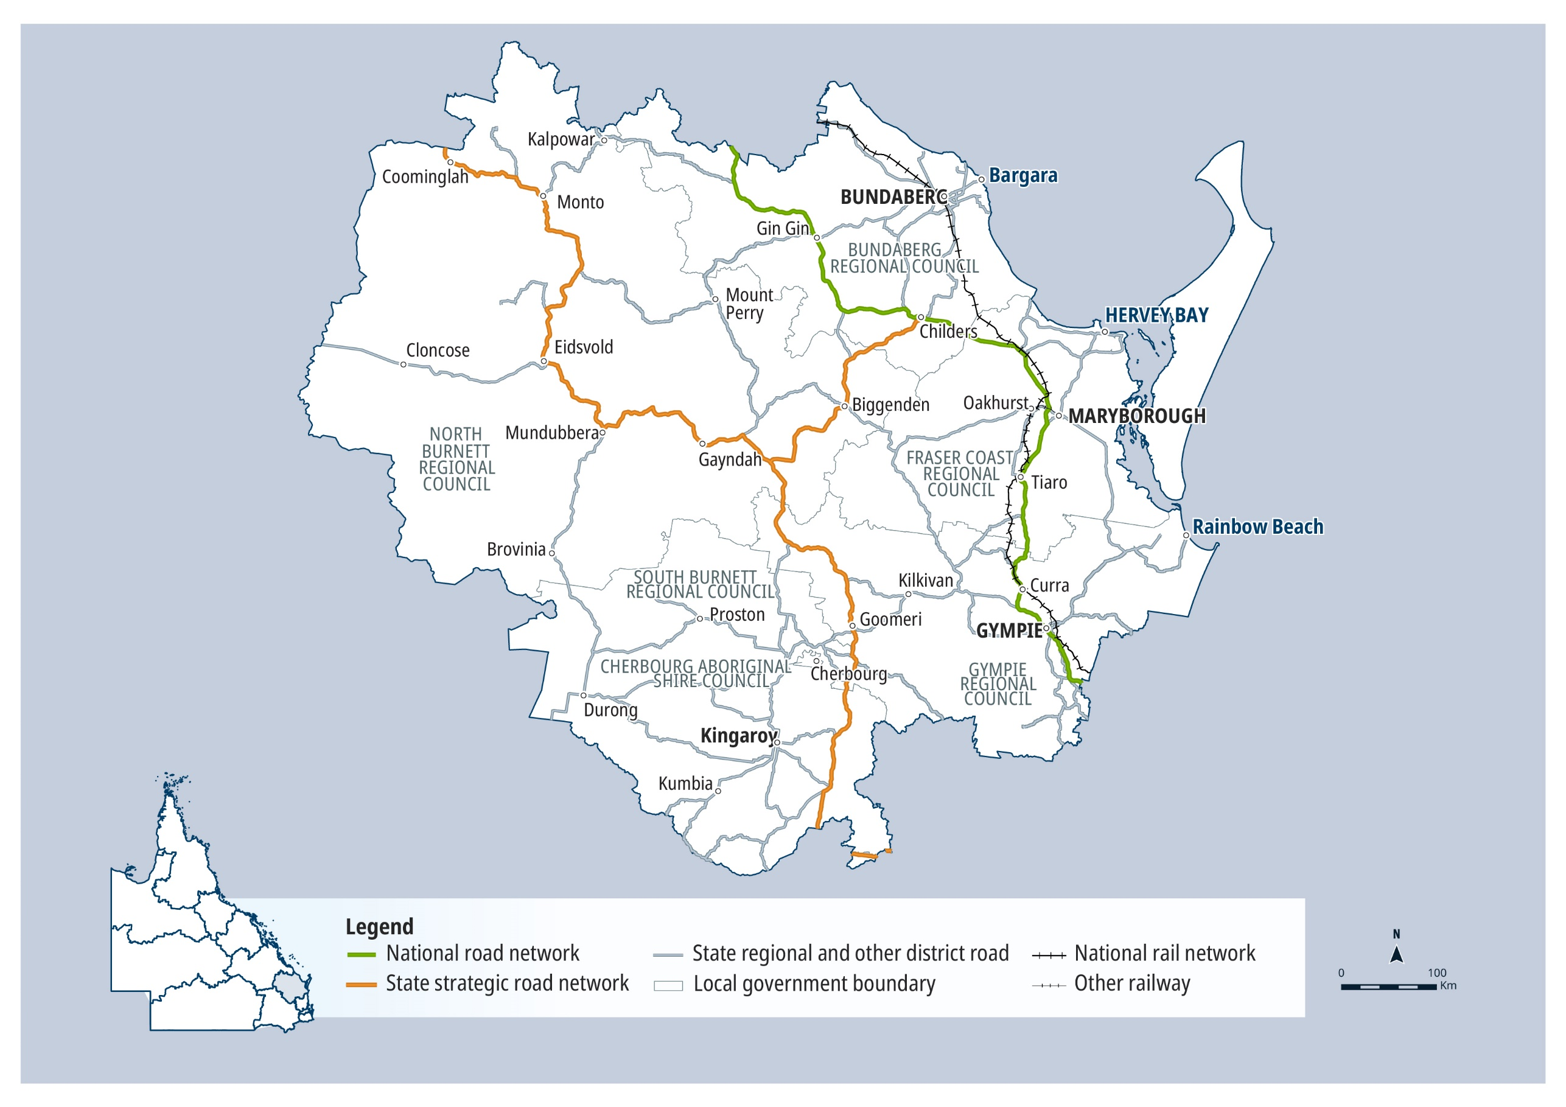

QTRIP 2025-26 to 2028-29

Wide Bay Burnett

Planned investments

Projects: $250 million – $1 billion
AG = Australian Government funding, QG = Queensland Government funding, Local/Other = Local Government or other funding partners.

Investment ID | Project title | AG | QG | Local/ Other | Planning | Procurement | Construction Start | Notes
371601 | Bruce Highway (Gympie - Maryborough), Tiaro Bypass, construct bypass | ● | ● |  | Underway | Early 2026 | 2026-27 | The project has a business case, with scope, cost and timing subject to further project development and site investigations, and consideration. Funding for the project is subject to further negotiation with the Australian Government.

Projects: Up to $250 million
AG = Australian Government funding, QG = Queensland Government funding, Local/Other = Local Government or other funding partners.

Investment ID | Project title | AG | QG | Local/ Other | Planning | Procurement | Construction Start | Notes
2182485 | Booral Road and Boundary Road (Urangan), upgrade intersection |  | ● | ● | ✔ | Late 2025 | Mid 2026 | The project is in the post-business case stage, with project scope, cost and timing subject to confirmation following market engagement, and consideration.
3033451 | Booral Road and Doolong South Road (Nikenbah), improve intersection |  | ● |  | Underway | 2026-27 | 2026-27 | Safer Roads Sooner Program
3288157 | Boundary Road and Denman Camp Road (Kawungan), upgrade intersection |  | ● | ● | ✔ | ✔ | Underway
3555736 | Bruce Highway (Maryborough – Gin Gin), Walker Street, intersection improvement |  | ● |  | Underway | Late 2025 | 2025-26 | Safer Roads, Better Transport Initiative. The project is in the pre-business case stage, with scope, cost and timing subject to further planning and consideration.
8516 | Bundaberg - Bargara Road, Kalkie to Potters Road, develop active transport facility, planning |  | ● |  | Underway | - | -
761820 | Bundaberg - Port Road, Bundaberg - Bargara Road to Port of Bundaberg, planning |  | ● |  | Underway | - | -
1219374 | Bundaberg - Bargara Road, upgrade targeted sections | ● | ● |  | 2027-28 | - | -
3517361 | Burnett Highway (Gayndah - Monto), Binjour Bowls Club, improve access and undertake safety improvements |  | ● |  | ✔ | Early 2026 | 2026-27 | Safer Roads Sooner Program
3181439 | Gatakers Bay (Point Vernon), dredge access channel |  | ● |  | Underway | Early 2026 | 2026-27
3330659 | Goodwood Road, various locations, undertake safety improvements |  | ● |  | Underway | Early 2026 | Mid 2026 | High Risk Roads Initiative
3517366 | Gympie - Brooloo Road, Blackgate Road and Meddleton Road (Amamoor), realign intersection |  | ● |  | ✔ | Early 2026 | 2026-27 | Safer Roads Sooner Program
3517363 | Isis Highway (Bundaberg - Childers), Cane Overpass to Bruce Highway, undertake safety improvements |  | ● |  | ✔ | Early 2026 | 2026-27 | Safer Roads Sooner Program
3517368 | Isis Highway (Bundaberg - Childers), Hills Road to Philips Road (South Bingera), undertake safety improvements |  | ● |  | ✔ | Early 2026 | 2026-27 | Safer Roads Sooner Program
3517367 | Isis Highway (Bundaberg - Childers), Wyper Park to Willdora Drive (South Bingera), undertake safety improvements |  | ● |  | ✔ | Early 2026 | 2026-27 | Safer Roads Sooner Program
3517365 | Isis Highway (Childers - Biggenden) and North South Road intersection, undertake safety improvements |  | ● |  | ✔ | Early 2026 | 2026-27 | Safer Roads Sooner Program
2006450 | Maryborough - Hervey Bay Road and Pialba - Burrum Heads Road, upgrade intersection | ● | ● |  | ✔ | Early 2026 | Mid 2026 | The project is in the post-business case stage, with project scope, cost and timing subject to confirmation following market engagement, and consideration. Funding splits under negotiation.
2225933 | Pialba - Burrum Heads Road, O'Regan Creek, upgrade existing floodway |  | ● |  | Underway | Early 2026 | 2026-27 | The project has a business case, with scope, cost and timing subject to further project development and site investigations, and consideration.
3031848 | Targeted Road Safety Program, Rest areas and stopping places, funding allocation |  | ● |  | Underway | Underway | Underway | This is a program with multiple projects at various stages.
3176283 | Walkers Point (Woodgate), upgrade boat ramp |  | ● |  | ✔ | Late 2025 | Early 2026

Contractually committed investments
AG = Australian Government funding, QG = Queensland Government funding, Local/Other = Local Government or other funding partners.
Investment ID | Project title | AG  ($’000’s) | QG  ($’000’s) | Local/ Other  ($’000’s) | Committed total budget ($’000’s) | Estimated expenditure to 30 June 2025 ($’000’s) | 2025-26 ($’000’s) | Post  2025-26 ($’000’s) | Notes
1776639 | Isis Highway (Bundaberg - Childers), various locations, improve safety |  | 41,943 |  | 41,943 | 22,556 | 15,814 | 3,573 | High Risk Roads Initiative
1388289 | D'Aguilar Highway (Yarraman - Kingaroy), Alexander Lane to Bunya Highway, improve safety |  | 31,110 |  | 31,110 | 21,077 | 6,137 | 3,896 | High Risk Roads Initiative
845296 | D'Aguilar Highway (Yarraman - Kingaroy), Bushnell Road to Homley Road, strengthen and widen pavement |  | 11,500 |  | 11,500 | 3,935 | 5,674 | 1,891
3097711 | Isis Highway (Biggenden - Coalstoun Lakes), upgrade Biggenden railway crossing |  | 7,500 |  | 7,500 | 3,451 | 1,430 | 2,619
3229791 | Wallaville Goondoon Road, rehabilitate and widen pavement |  | 2,970 | 3,880 | 6,850 | 9 | 1,168 | 1,793
2891590 | Gayndah - Mount Perry Road, widen and seal |  | 4,050 |  | 4,050 | 2,890 | 176 | 985 | Transport Infrastructure Development Scheme
1113880 | Mellor Street and Station Road, Chapple Street to Bent Street (Gympie), install traffic signals |  | 1,181 | 1,563 | 2,744 | 627 | 243 | 312
1906220 | Copp Road, Pritchard Road and Smerdon Road, widen pavement and improve intersection |  | 1,141 | 1,197 | 2,338 | 481 | 660
717532 | Burnett Highway (Eidsvold), construct off-road shared path |  | 2,269 |  | 2,269 | 449 | 1,820
3109731 | Owen Cox Street (Poona), upgrade boat ramp and dredge access channel |  | 1,850 |  | 1,850 | 656 | 1,194
2746649 | Inglewood Road (Monkland), over the Mary Valley Railway, replace timber bridge | 1,296 |  | 324 | 1,620 | 72 | 1,224 |  | Australian Government Safer Local Roads and Infrastructure Program
3514864 | George Street and Targo Street intersection (Bundaberg), install pedestrian crossings and undertake safety improvements | 1,335 |  |  | 1,335 |  | 1,335 |  | Australian Government Black Spot Program
2746650 | Howe Road (Traveston), Six Mile Creek, replace timber bridge | 1,000 |  | 250 | 1,250 | 60 | 940 |  | Australian Government Safer Local Roads and Infrastructure Program
3367701 | Granville Road (Maaroom), resurface boat ramp |  | 1,200 |  | 1,200 | 240 | 960
2274126 | Fraser Coast integrated transport strategy planning |  | 862 | 238 | 1,100 | 435 | 545 | 121
2298689 | Maryborough - Hervey Bay Road, Ibis Boulevard and Fairway Drive, upgrade intersection, business case |  | 700 |  | 700 | 380 | 170 | 150

Wide Bay Burnett
2025–26 FY total investment: $253 million
2026–27 FY total investment: $218 million
2027–28 to 2028–29 FY total investment: $677 million
Wide Bay Burnett total investment over four years (2025–26 to 2028–29): $1.1 billion ⁵

Darling Downs

Key facts
79,521 km² Area covered by location 1
5.65% Population of Queensland 1
3,889 km Other state-controlled road network
644 km National Land Transport Network 2
687 km National rail network 2


Contact details

Office: Toowoomba
Address: 122 Margaret Street | Toowoomba | Qld 4350
Postal: Locked Bag 1 | Warwick | Qld 4370
Phone: (07) 4639 0777
Email: downsswr.office@tmr.qld.gov.au

Office: Warwick
Address: 306 Wood Street | Warwick | Qld 4370
Postal: Locked Bag 1 | Warwick | Qld 4370
Phone: (07) 4661 6333
Email: downsswr.office @tmr.qld.gov.au
See Reference section (Notes for Map Pages)
for further details.

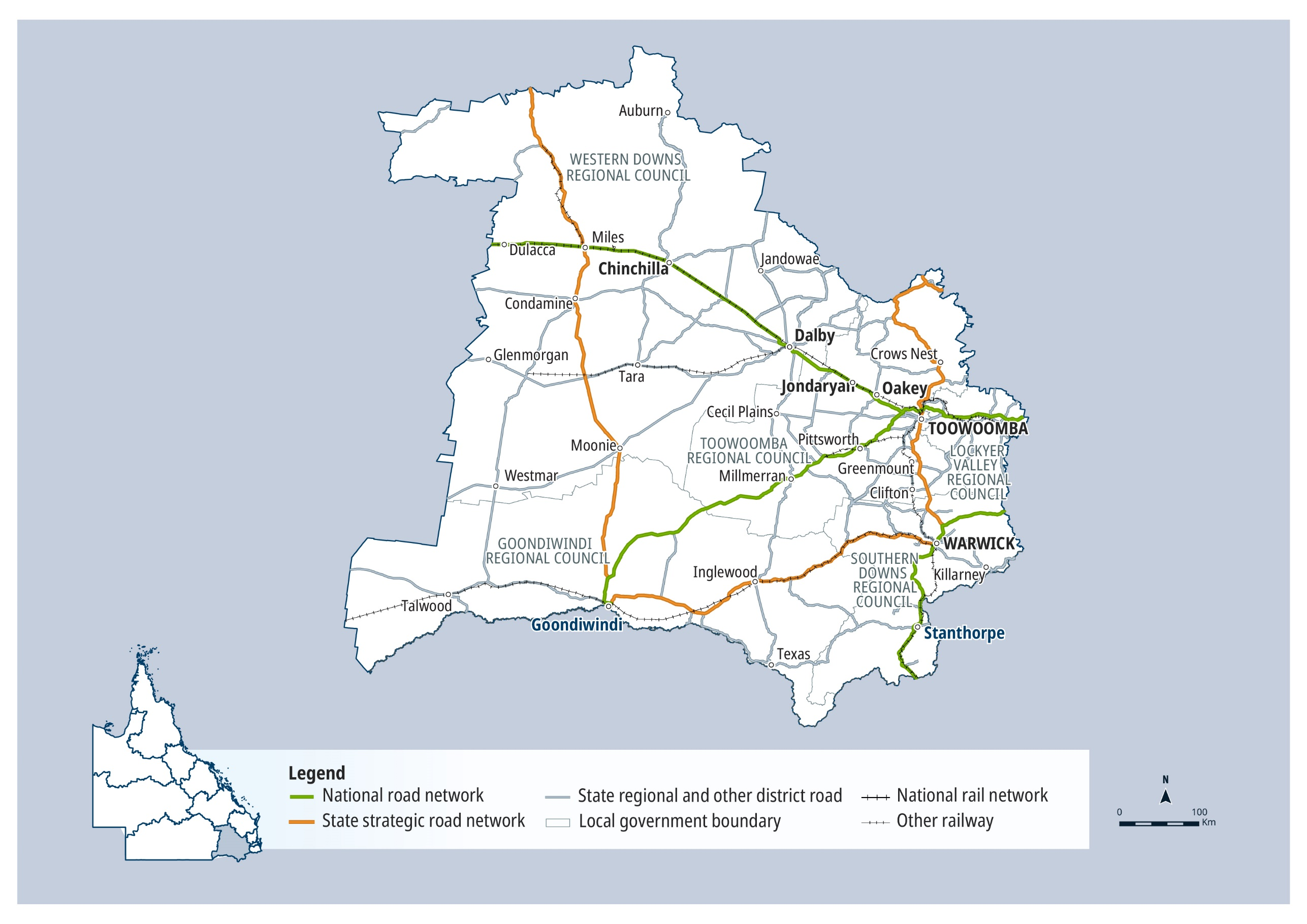

QTRIP 2025-26 to 2028-29

Darling Downs

Planned investments

Projects: Up to $250 million
AG = Australian Government funding, QG = Queensland Government funding, Local/Other = Local Government or other funding partners.

Investment ID | Project title | AG | QG | Local/ Other | Planning | Procurement | Construction Start | Notes
3044774 | Bunya Highway (Dalby - Kingaroy) and Patrick Street, upgrade intersection |  | ● |  | ✔ | Mid 2025 | Early 2026 | Safer Roads Sooner Program
1521429 | Cecil Plains - Moonie Road, improve safety on curves |  | ● | ● | - | - | 2027-28 | Grant to Local Government under the Transport Infrastructure Development Scheme.
3044646 | Dalby - Cooyar Road, install guardrail and delineation |  | ● |  | ✔ | Mid 2025 | Early 2026 | Safer Roads Sooner Program
3045066 | Dalrymple Creek Road, Forde Street and Warwick Street intersection (Allora), raised roundabout retrofit |  | ● |  | ✔ | ✔ | Late 2025 | Safer Roads Sooner Program
2614872 | Gatton - Helidon Road (Spencer Street) and William Street intersection, improve safety |  | ● |  | Underway | - | -
2615428 | Gore Highway (Millmerran - Goondiwindi), improve safety |  | ● |  | ✔ | Late 2025 | Mid 2026 | Safer Roads Sooner Program
2671946 | Gore Highway (Toowoomba - Millmerran) and Toowoomba - Athol Road, improve safety |  | ● |  | ✔ | ✔ | Late 2025 | High Risk Roads Initiative
1203047 | Gore Highway, funding allocation | ● | ● |  | Underway | - | - | Project details and timing subject to further planning and negotiation with the Australian Government.
2820368 | High Risk Rural Roads, improve intersections |  | ● |  | ✔ | Late 2025 | Mid 2026
2687377 | Inverramsay Road (Goomburra), upgrade and widen pavement |  | ● | ● | - | - | 2028-29 | Grant to Local Government under the Transport Infrastructure Development Scheme.
3564133 | Moonie Highway, Esk - Hampton Road, Surat Development Road, guardrail safety package, install guardrail |  | ● |  | ✔ | 2026-27 | 2026-27 | Safer Roads Sooner Program
2615000 | Murphy's Creek Road (Murphy's Creek), improve safety |  | ● |  | ✔ | Early 2026 | Mid 2026 | Safer Roads Sooner Program
2615431 | New England Highway (Toowoomba - Warwick), improve safety |  | ● |  | ✔ | Late 2025 | Mid 2026 | Safer Roads Sooner Program
3563947 | New England Highway (Warwick - Wallangarra), Rosenthal Heights, The Glen and Thulimbah, upgrade package, undertake safety improvements |  | ● |  | ✔ | 2026-27 | 2026-27 | Safer Roads Sooner Program
3481320 | New England Highway (Warwick - Wallangarra), undertake safety improvements |  | ● |  | ✔ | Late 2025 | Late 2025
3517602 | New England Highway (Yarraman - Toowoomba), Chalk Drive, Neil Street and Ruthven Street intersections, improve active transport facilities | ● | ● |  | Underway | Mid 2026 | 2026-27 | Australian Government Active Transport Fund
3130875 | Safety and critical maintenance program, planning |  | ● |  | Early 2026 | - | -
3631389 | School safety upgrades in Wilsonton, Newtown and Highfields, undertake safety improvements |  | ● |  | Underway | - | 2026-27 | Further scope and timelines subject to negotiation with local government.
3563836 | Warrego Highway (Ipswich to Toowoomba) and James Norman Hedges Park intersection (Helidon Spa), improve intersection | ● | ● |  | Underway | 2026-27 | 2026-27 | Safer Roads Sooner Program
3044921 | Warrego Highway (Toowoomba - Dalby), undertake safety improvements |  | ● |  | ✔ | Late 2025 | Mid 2026 | Safer Roads Sooner Program

Contractually committed investments
AG = Australian Government funding, QG = Queensland Government funding, Local/Other = Local Government or other funding partners.
Investment ID | Project title | AG  ($’000’s) | QG  ($’000’s) | Local/ Other  ($’000’s) | Committed total budget ($’000’s) | Estimated expenditure to 30 June 2025 ($’000’s) | 2025-26 ($’000’s) | Post  2025-26 ($’000’s) | Notes
2673200 | Toowoomba - Cecil Plains Road, improve safety |  | 27,031 |  | 27,031 | 2,485 | 18,500 | 6,046 | High Risk Roads Initiative
2392873 | Cunningham Highway (Ipswich - Warwick), Tregony to Maryvale, improve safety | 20,160 | 5,040 |  | 25,200 | 848 | 19,312 | 5,040 | Cunningham Highway Safety Package
2677439 | Cunningham Highway (Warwick - Inglewood), improve safety |  | 18,100 |  | 18,100 | 2,372 | 10,727 | 5,001 | High Risk Roads Initiative
2729338 | Highfields Road, Kratzke Road and O'Brien Road, upgrade intersection |  | 3,521 | 11,600 | 15,121 | 400 |  | 3,121
2207362 | Esk - Hampton Road, Perseverance Creek, replace culvert |  | 12,161 |  | 12,161 | 3,513 | 7,494 | 1,155
2383987 | Toowoomba - Cecil Plains Road, strengthen and widen pavement |  | 10,500 |  | 10,500 | 11 | 9,689 | 800
2742683 | Carpendale Road (Carpendale), Flagstone Creek, Mahon Bridge, replace bridge | 4,994 |  | 4,994 | 9,989 | 2,120 | 2,875 |  | Australian Government Safer Local Roads and Infrastructure Program
2325017 | New England Highway Bikeway, Highfields to Toowoomba (Stage 2), construct shared path |  | 9,396 |  | 9,396 | 4,649 | 3,158 | 1,589
2580092 | Branchview Road (Branchview), replace bridge | 3,800 |  | 3,800 | 7,600 | 1,606 | 2,194 |  | Australian Government Safer Local Roads and Infrastructure Program
2805115 | Roma - Condamine Road (Condamine), rehabilitate and widen pavement |  | 5,290 |  | 5,290 |  |  | 5,290 | Transport Infrastructure Development Scheme
2296209 | Tenthill Creek Road (Tenthill), rehabilitate pavement |  | 2,289 | 2,289 | 4,579 |  | 763 | 1,526
2624444 | Bowenville - Moola Road (Bowenville) (Stage 1a), widen and seal | 2,160 |  | 2,160 | 4,320 | 888 | 1,272 |  | Australian Government Safer Local Roads and Infrastructure Program
2392874 | Cunningham Highway (Ipswich - Warwick), various locations, improve safety | 2,920 | 730 |  | 3,650 | 460 | 2,840 | 350 | Cunningham Highway Safety Package
1521280 | Haden - Crows Nest Road, strengthen and widen pavement |  | 1,750 | 1,750 | 3,500 |  | 1,000 | 750
1977221 | New England Highway Bikeway, Highfields to Toowoomba CBD (Stage 3), design shared path |  | 3,245 |  | 3,245 | 1,985 | 1,260
2287642 | Darling Downs District, priority freight network flood study, planning |  | 3,141 |  | 3,141 | 2,991 | 150
1890956 | Clifton - Pittsworth Road, various locations, strengthen and widen pavement |  | 1,500 | 1,500 | 3,000 |  | 1,000 | 500
2624474 | Oakey Biddeston Road and Oakey Crosshill Road, upgrade and widen | 1,796 |  | 449 | 2,245 | 790 | 1,006 |  | Australian Government Safer Local Roads and Infrastructure Program
1834567 | Cunningham Highway (Ipswich - Warwick), Tregony to Sladevale, improve safety |  | 2,130 |  | 2,130 | 443 | 444 | 1,243 | Safer Roads Sooner Program
1175233 | Toowoomba Central Active Transport Link, business case |  | 1,997 |  | 1,997 | 1,752 | 245
3442049 | Bunya Highway (Dalby - Kingaroy), 2024 Disaster Recovery Funding Arrangements reconstruction works | 1,316 | 439 |  | 1,754 | 100 | 1,359 | 295 | Funding administered by the Queensland Reconstruction Authority.
2690925 | Yelarbon - Keetah Road (Stage 4), widen pavement |  | 1,623 |  | 1,623 | 1,004 | 319 | 300 | Transport Infrastructure Development Scheme
2751205 | Toowoomba - Cecil Plains Road (Taylor Street), Tor Street to Boundary Street, design separated cycle track |  | 1,450 |  | 1,450 | 500 | 950
3045577 | Warwick - Allora Road (Victoria Street) and Palmerin Street (Warwick), wombat crossing upgrade |  | 1,371 |  | 1,371 | 217 | 1,022 | 132
2751529 | Toowoomba City Cycle Paths, Karrool Street and Goode Street, construct active transport facilities |  | 1,314 |  | 1,314 | 968 | 346

Darling Downs
2025–26 FY total investment: $302 million
2026–27 FY total investment: $179 million
2027–28 to 2028–29 FY total investment: $255 million
Darling Downs total investment over four years (2025–26 to 2028–29): $736 million ⁵

South West

Key facts
319,275 km² Area covered by location 1
0.45% Population of Queensland 1
3,555 km Other state-controlled road network
418 km National Land Transport Network 2
418 km National rail network 2


Contact details

Office: Roma
Address: 30 McDowall Street | Roma | Qld 4455
Postal: PO Box 126 | Roma | Qld 4455
Phone: (07) 4622 9511
Email: southwest.office@tmr.qld.gov.au

Office: Charleville
Address: Hood Street | Charleville | Qld 4470
Postal: PO Box 240 | Charleville | Qld 4470
Phone: (07) 4693 2020
Email: southwest.office@tmr.qld.gov.au
See Reference section (Notes for Map Pages)
for further details.

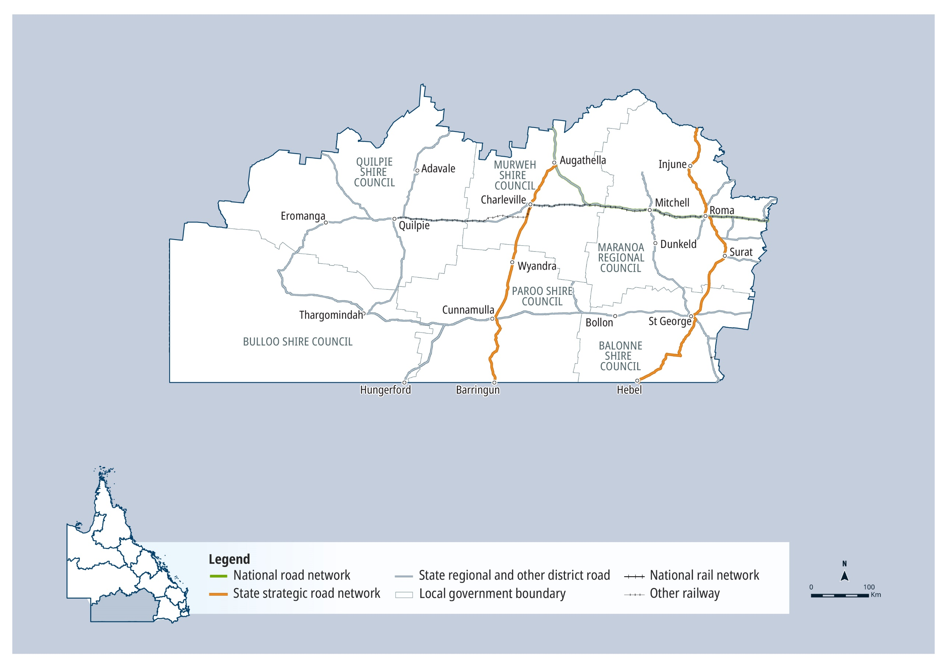

QTRIP 2025-26 to 2028-29

South West

Planned investments

Projects: Up to $250 million
AG = Australian Government funding, QG = Queensland Government funding, Local/Other = Local Government or other funding partners.
Investment ID | Project title | AG | QG | Local/ Other | Planning | Procurement | Construction Start | Notes
3522620 | Castlereagh Highway (St George - Hebel) and Noondoo - Thallon Road, improve intersection |  | ● |  | Underway | Early 2026 | Mid 2026 | Safer Roads Sooner Program
3575339 | Castlereagh Highway (St George - Hebel), upgrade floodways |  | ● |  | Underway | Mid 2026 | 2026-27

Contractually committed investments
AG = Australian Government funding, QG = Queensland Government funding, Local/Other = Local Government or other funding partners.
Investment ID | Project title | AG  ($’000’s) | QG  ($’000’s) | Local/ Other  ($’000’s) | Committed total budget ($’000’s) | Estimated expenditure to 30 June 2025 ($’000’s) | 2025-26 ($’000’s) | Post  2025-26 ($’000’s) | Notes
2707251 | Redford Road and Yuleba - Surat Road, construct to sealed standard | 12,000 |  | 3,000 | 15,000 | 6,000 | 6,000 |  | Australian Government Remote Roads Upgrade Pilot Program
2707186 | Bollon Road, construct to sealed standard | 12,000 |  |  | 12,000 | 6,000 | 6,000 |  | Australian Government Remote Roads Upgrade Pilot Program
2707280 | Warri Gate Road (Stage 1), Noccundra Waterhole, construct to sealed standard | 8,000 |  | 2,000 | 10,000 | 4,000 | 4,000 |  | Australian Government Remote Roads Upgrade Pilot Program
3078755 | Landsborough Highway (Morven - Augathella), upgrade rest area facilities |  | 2,629 |  | 2,629 | 98 | 2,266 | 265
3536295 | Jobs Gate Road, rehabilitate pavement |  | 1,070 | 1,070 | 2,140 |  | 1,070
3477434 | Roma truck stop precinct, Roma Saleyards, apply asphalt surfacing | 1,600 |  | 400 | 2,000 |  | 1,600 |  | Australian Government Safer Local Roads and Infrastructure Program
3140291 | Bulloo Developmental Road (Thargomindah - Bundeena), seal shoulders |  | 1,894 |  | 1,894 | 823 | 1,070 |  | Transport Infrastructure Development Scheme
453814 | Safety and critical maintenance program, planning |  | 1,305 |  | 1,305 | 855 | 150 | 300
3567261 | Blackall - Adavale Road, construct to sealed standard |  | 1,070 |  | 1,070 |  | 1,070 |  | Transport Infrastructure Development Scheme
2323775 | Carnarvon Highway (Surat - Roma), Balonne River Surat, upgrade bridge and approaches, planning |  | 874 |  | 874 | 574 | 100 | 200

South West
2025–26 FY total investment: $110 million
2026–27 FY total investment: $81 million
2027–28 to 2028–29 FY total investment: $134 million
South West total investment over four years (2025–26 to 2028–29): $325 million ⁵

Fitzroy

Key facts
117,588 km² Area covered by location 1
4.36% Population of Queensland 1
3,131 km Other state-controlled road network
399 km National Land Transport Network 2
374 km National rail network 2


Contact details

Office: Fitzroy
Address: 31 Knight Street | Rockhampton | Qld 4701
Postal: PO Box 5096 | Red Hill Rockhampton | Qld 4701
Phone: (07) 4931 1500
Email: fitzroydistrict@tmr.qld.gov.au

See Reference section (Notes for Map Pages)
for further details.

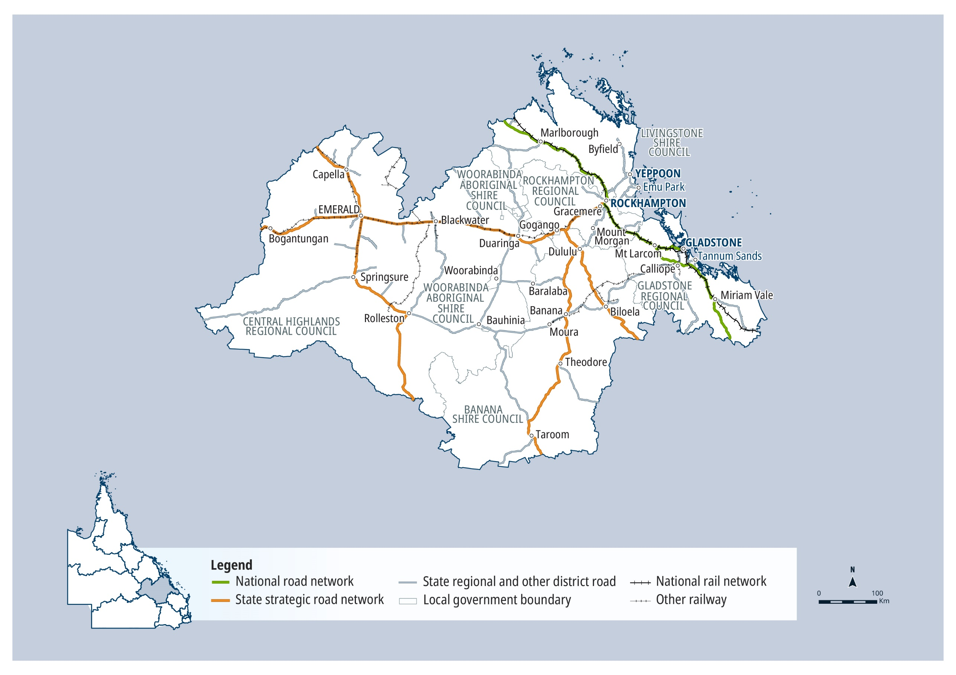

QTRIP 2025-26 to 2028-29

Fitzroy

Planned investments

Projects: $250 million – $1 billion
AG = Australian Government funding, QG = Queensland Government funding, Local/Other = Local Government or other funding partners.
Investment ID | Project title | AG | QG | Local/ Other | Planning | Procurement | Construction Start | Notes
2603662 | Bruce Highway, Gladstone to Rockhampton, funding allocation | ● | ● |  | Underway | Underway | Underway | This is a program with multiple projects at various stages.

Projects: Up to $250 million
AG = Australian Government funding, QG = Queensland Government funding, Local/Other = Local Government or other funding partners.
Investment ID | Project title | AG | QG | Local/ Other | Planning | Procurement | Construction Start | Notes
1193429 | Access to Gladstone Port, improve heavy vehicle access | ● | ● |  | Underway | - | -
2719513 | Arcadia Valley Road (Stage 2), pave and seal |  | ● | ● | - | - | 2026-27 | Grant to local government under the Transport Infrastructure Development Scheme.
3057688 | Bruce Highway (Benaraby - Rockhampton), Bajool, undertake safety upgrades |  | ● |  | ✔ | Late 2025 | Early 2026 | Safer Roads Sooner Program
3325192 | Bruce Highway (Gin Gin - Benaraby), 2024 Disaster Recovery Funding Arrangements reconstruction works | ● | ● |  | ✔ | ✔ | Mid 2025 | Funding administered by the Queensland Reconstruction Authority.
854972 | Bruce Highway (Rockhampton - St Lawrence) and Bolsover Street, upgrade intersection | ● | ● |  | Underway | 2026-27 | 2026-27
1390151 | Bruce Highway (Rockhampton - St Lawrence), Pine Mountain Creek to Kooltandra Road intersection, improve safety | ● | ● |  | ✔ | ✔ | Late 2025
1509453 | Capricorn Highway (Duaringa - Emerald) and Gregory Highway (Springsure - Emerald), improve intersection | ● | ● |  | ✔ | 2026-27 | 2026-27
2335273 | Capricorn Highway (Emerald - Alpha) (Package 1), strengthen and widen pavement, funding allocation | ● | ● |  | Underway | - | -
2338131 | Capricorn Highway (Emerald - Alpha) (Package 3), strengthen and widen pavement, funding allocation | ● | ● |  | Underway | 2026-27 | 2027-28 | Project details and timing subject to further planning and negotiation with the Australian Government.
3161934 | Fitzroy Developmental Road (Bauhinia - Duaringa), pave and seal | ● | ● |  | ✔ | Late 2025 | Early 2026 | Australian Government Queensland Beef Corridors Program
2356110 | Glenroy Road (Mornish), widen, seal and upgrade floodway | ● |  | ● | - | - | 2027-28 | Australian Government Grant to Local Government.
2356436 | Injune Road (Taroom), seal, widen and repair drainage | ● |  | ● | ✔ | ✔ | Early 2026
3556656 | Rockhampton - Emu Park Road, Hartley Street to Pattison Street, construct shared path | ● | ● |  | - | Mid 2026 | 2026-27 | Australian Government Active Transport Fund
3265541 | Rockhampton Railyards Rejuvenation, capital upgrades |  | ● |  | Underway | Underway | Early 2026
3264845 | Rockhampton Railyards, site management and high priority remediation works |  | ● |  | Underway | Underway | Early 2026
3454721 | Rosslyn Bay Harbour, channel maintenance, dredging |  | ● |  | ✔ | Late 2025 | Mid 2026
1603161 | Townsville to Roma corridor upgrade, Springsure to Tambo, funding allocation | ● | ● |  | ✔ | Underway | Underway
3057006 | Western Yeppoon - Emu Park Road (Tanby Road) and Taranganba Road (Taroomball), upgrade intersection |  | ● |  | ✔ | Mid 2026 | 2026-27 | Safer Roads Sooner Program
3556566 | Western Yeppoon - Emu Park Road, Vernon Street to Hill Street, construct shared path | ● | ● |  | - | Mid 2026 | 2026-27 | Australian Government Active Transport Fund

Contractually committed investments
AG = Australian Government funding, QG = Queensland Government funding, Local/Other = Local Government or other funding partners.
Investment ID | Project title | AG  ($’000’s) | QG  ($’000’s) | Local/ Other  ($’000’s) | Committed total budget ($’000’s) | Estimated expenditure to 30 June 2025 ($’000’s) | 2025-26 ($’000’s) | Post  2025-26 ($’000’s) | Notes
1167108 | Rockhampton Ring Road | 1,399,500 | 580,500 |  | 1,980,000 | 379,879 | 193,401 | 1,406,719
1192019 | Rockhampton - Yeppoon Road, Yeppoon Road upgrade | 85,000 | 70,000 |  | 155,000 | 124,221 | 19,976 | 10,803 | Funding splits under negotiation with Australian Government.
2515815 | Dawson Developmental Road (Springsure - Tambo), priority upgrades | 20,430 | 5,108 |  | 25,538 | 5,412 | 4,080 | 16,046
1454793 | Bruce Highway (Gin Gin - Benaraby), Station Creek and Boyne River, upgrade bridges | 11,040 | 2,760 |  | 13,800 | 3,687 | 6,113 | 4,000
2725506 | Lowmead Road, upgrade unsealed to sealed road | 10,701 |  | 2,675 | 13,376 | 5,350 | 5,350 |  | Australian Government Remote Roads Upgrade Pilot Program
2356274 | Bonnie Doon Road (Emerald), seal and upgrade bridge | 9,600 |  | 2,400 | 12,000 | 1,880 | 2,400 | 5,320
1454810 | Bruce Highway (Benaraby - Rockhampton), Raglan Creek, upgrade bridge | 7,072 | 1,768 |  | 8,840 | 2,553 | 6,287
2738672 | Normanby Street (Stage 1 and 2), upgrade to urban sub-arterial standard |  | 3,150 | 4,650 | 7,800 | 1,506 | 822 | 822
2356170 | Artillery and Greenlake Road (Sandringham), widen and seal | 6,184 |  | 1,545 | 7,729 | 3,800 | 2,384
3525998 | Orange Creek Road, rehabilitate pavement |  | 3,539 | 3,539 | 7,077 |  | 1,013 | 2,526
2591360 | Alexandra Street, Wade Street and McLaughlin Street, Parkhurst Industrial Area, upgrade roads and intersections | 4,918 |  | 1,229 | 6,147 | 2,078 | 2,840 |  | Australian Government Safer Local Roads and Infrastructure Program
1545800 | Wyntoon Road, pave and seal |  | 2,392 | 2,392 | 4,783 | 1,642 | 750
2722959 | Cracow Road, improve safety | 3,308 |  | 828 | 4,136 | 1,654 | 1,654 |  | Australian Government Remote Roads Upgrade Pilot Program
3351974 | South Yaamba Road (South Yaamba), upgrade road and floodways | 2,542 |  | 636 | 3,178 | 127 | 1,017 | 1,398 | Australian Government Safer Local Roads and Infrastructure Program
2721644 | Glenlee Road, pave and seal |  | 1,525 | 1,525 | 3,050 |  | 779 | 746
3351871 | Fairy Bower Road, Scrubby Creek Crossing (Gracemere), replace culvert | 1,685 |  | 421 | 2,106 |  | 758 | 927 | Australian Government Safer Local Roads and Infrastructure Program
3556848 | Jambin Dakenba Road (Callide), upgrade level crossing | 1,000 |  | 1,000 | 2,000 |  | 500 | 500 | Australian Government Regional Level Crossing Upgrade Fund
3557145 | Jambin Dakenba Road (Earlsfield), upgrade level crossing | 1,000 |  | 1,000 | 2,000 |  | 500 | 500 | Australian Government Regional Level Crossing Upgrade Fund
2338996 | Paines Road, rehabilitate pavement |  | 1,000 | 1,000 | 2,000 |  | 500 | 500
3541920 | Razorback Road, Poison Creek Road to Jump Up (Moongan), undertake safety improvements | 1,981 |  |  | 1,981 |  | 1,981 |  | Australian Government Black Spot Program
2743913 | Red Rover Road (Gladstone), strengthen bridge | 1,541 |  | 385 | 1,926 | 698 | 843 |  | Australian Government Safer Local Roads and Infrastructure Program
3351955 | Malchi Nine Mile Road, Kabra Scrubby Creek Road to Hopper Road (Nine Mile), upgrade intersections | 1,460 |  | 365 | 1,825 |  | 73 | 1,387 | Australian Government Safer Local Roads and Infrastructure Program
3145208 | Livingstone Shire urban traffic congestion, planning |  | 1,184 |  | 1,184 | 186 | 774 | 225
3521049 | Programmed maintenance of safety treatments |  | 1,120 |  | 1,120 |  | 560 | 560

Fitzroy
2025–26 FY total investment: $442 million
2026–27 FY total investment: $564 million
2027–28 to 2028–29 FY total investment: $1.1 billion
Fitzroy total investment over four years (2025–26 to 2028–29): $2.1 billion ⁵

Central West

Key facts
395,765 km² Area covered by location 1
0.20% Population of Queensland 1
3,692 km Other state-controlled road network
693 km National Land Transport Network 2
4 km National rail network 2


Contact details

Office: Barcaldine
Address: 69 Ash Street | Barcaldine | Qld 4725
Postal: PO Box 3 | Barcaldine | Qld 4725
Phone: (07) 4651 2777
Email: barcaldine.offfice@tmr.qld.gov.au

See Reference section (Notes for Map Pages)
for further details.

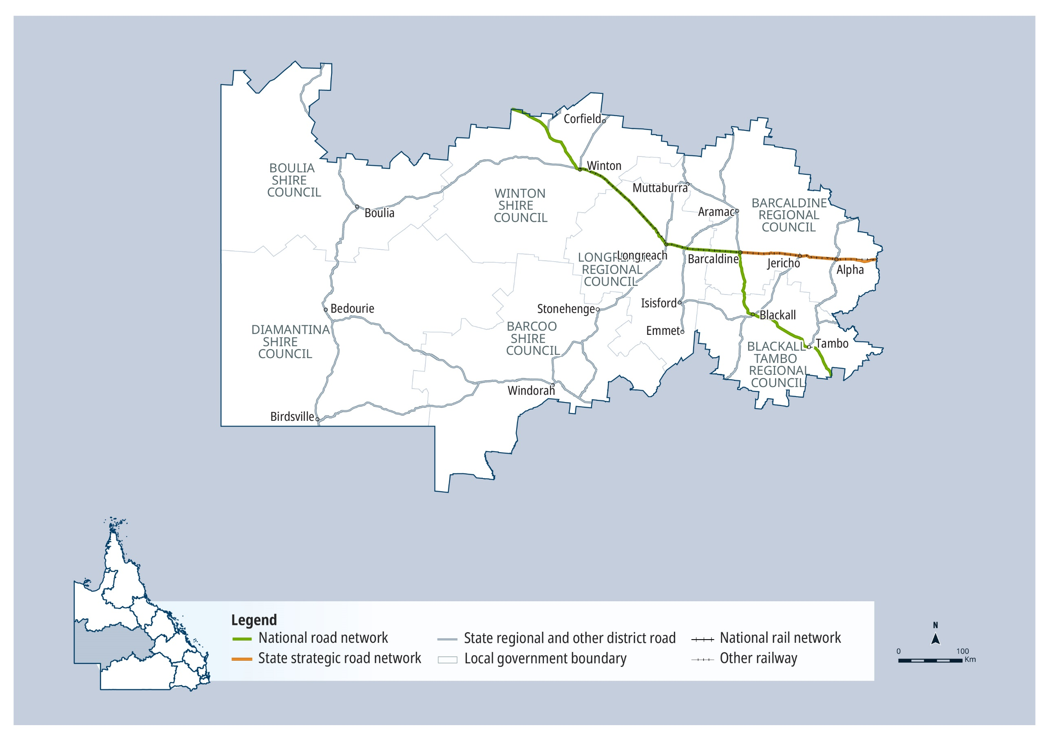

QTRIP 2025-26 to 2028-29

Central West

Planned investments

Projects: Up to $250 million
AG = Australian Government funding, QG = Queensland Government funding, Local/Other = Local Government or other funding partners.
Investment ID | Project title | AG | QG | Local/ Other | Planning | Procurement | Construction Start | Notes
3209354 | Alpha - Tambo Road, pave and seal | ● | ● |  | Underway | Mid 2026 | 2026-27 | Australian Government Queensland Beef Corridors Program
3153124 | Barcaldine - Aramac Road (Section 3), rehabilitate and widen |  | ● |  | Underway | 2026-27 | 2026-27 | Transport Infrastructure Development Scheme
2337706 | Capricorn Highway (Emerald - Alpha) (Package 2), strengthen and widen pavement | ● | ● |  | Underway | - | -
3157860 | Clermont - Alpha Road, pave and seal | ● | ● |  | ✔ | ✔ | Mid 2025 | Australian Government Queensland Beef Corridors Program
2605321 | Outback Way Queensland Future Priorities, funding allocation | ● | ● |  | Underway | Late 2025 | Mid 2026
3098543 | Richmond - Winton Road, pave and seal |  | ● |  | Underway | Mid 2026 | 2026-27 | Transport Infrastructure Development Scheme
3154142 | Thomson Developmental Road (Jundah - Longreach), rehabilitate and widen |  | ● |  | Underway | 2027-28 | 2027-28 | Transport Infrastructure Development Scheme

Contractually committed investments
AG = Australian Government funding, QG = Queensland Government funding, Local/Other = Local Government or other funding partners.
Investment ID | Project title | AG  ($’000’s) | QG  ($’000’s) | Local/ Other  ($’000’s) | Committed total budget ($’000’s) | Estimated expenditure to 30 June 2025 ($’000’s) | 2025-26 ($’000’s) | Post  2025-26 ($’000’s) | Notes
2353432 | Donohue Highway (Boulia - Tobermorey), progressive sealing | 41,500 |  |  | 41,500 | 5,400 | 4,000 | 32,100 | Project scope, cost and timing subject to further planning and negotiation with the Australian Government.
2351207 | Winton - Jundah Road, progressive sealing | 12,960 |  | 3,240 | 16,200 | 2,630 | 4,600 | 5,730
3445366 | Landsborough Highway (Winton - Kynuna), 2024 Disaster Recovery Funding Arrangements reconstruction works | 6,466 | 2,155 |  | 8,622 |  | 8,622 |  | Funding administered by the Queensland Reconstruction Authority.
3445342 | Blackall - Adavale Road, 2024 Disaster Recovery Funding Arrangements reconstruction works | 4,381 | 1,460 |  | 5,841 |  | 5,841 |  | Funding administered by the Queensland Reconstruction Authority.
3154146 | Eyre Developmental Road (Bedourie - Birdsville), pave and seal |  | 2,764 |  | 2,764 | 160 | 2,454 | 150 | Transport Infrastructure Development Scheme
3153611 | Blackall - Jericho Road, rehabilitate and widen |  | 2,454 |  | 2,454 |  | 2,454 |  | Transport Infrastructure Development Scheme
3445387 | Kennedy Developmental Road (Winton - Boulia), 2024 Disaster Recovery Funding Arrangements reconstruction works | 1,550 | 517 |  | 2,066 |  | 2,066 |  | Funding administered by the Queensland Reconstruction Authority.
2745847 | Landsborough Highway (Barcaldine - Longreach), Lagoon Creek, construct shared path |  | 1,370 |  | 1,370 | 218 | 1,152

Central West
2025–26 FY total investment: $98 million
2026–27 FY total investment: $98 million
2027–28 to 2028–29 FY total investment: $199 million
Central West total investment over four years (2025–26 to 2028–29): $396 million ⁵

Mackay Whitsunday

Key facts
90,140 km² Area covered by location 1
3.47 % Population of Queensland 1
2,213 km Other state-controlled road network
451 km National Land Transport Network 2
437 km National rail network 2


Contact details

Office: Mackay
Address: Floor 2, 44 Nelson Street | Mackay | Qld 4740
Postal: PO Box 62 | Mackay | Qld 4740
Phone: (07) 4951 8555
Email: mackay.office@tmr.qld.gov.au

See Reference section (Notes for Map Pages)
for further details.

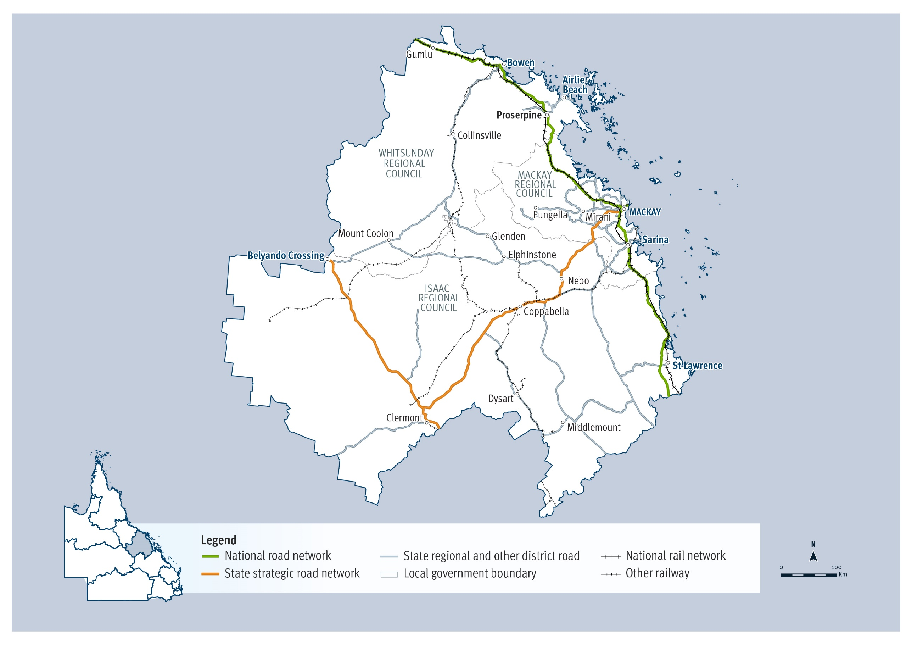

QTRIP 2025-26 to 2028-29

Mackay Whitsunday

Planned investments

Projects: $250 million – $1 billion
AG = Australian Government funding, QG = Queensland Government funding, Local/Other = Local Government or other funding partners.
Investment ID | Project title | AG | QG | Local/ Other | Planning | Procurement | Construction Start | Notes
2342729 | Bruce Highway (Mackay - Proserpine), O'Connell River to Proserpine (Goorganga Floodplain), upgrade flood immunity | ● | ● |  | Underway | 2027-28 | 2027-28 | The project has a business case, with scope, cost and timing subject to further project development and site investigations, and consideration.
1170084 | Mackay Port Access, Bruce Highway to Mackay - Slade Point Road (Stage 1) | ● | ● |  | Underway | - | -

Projects: Up to $250 million
AG = Australian Government funding, QG = Queensland Government funding, Local/Other = Local Government or other funding partners.
Investment ID | Project title | AG | QG | Local/ Other | Planning | Procurement | Construction Start | Notes
1199635 | Blue Water Trail - Cross City Link (Mackay), construct off-road shared cycle path |  | ● |  | ✔ | ✔ | Late 2025
3522975 | Bowen Developmental Road (Bowen - Collinsville) and Mt Dangar Road, improve intersection |  | ● |  | Underway | 2026-27 | 2026-27 | Safer Roads Sooner Program
3531012 | Bowen Developmental Road (Bowen - Collinsville), upgrade level crossing | ● | ● |  | ✔ | Early 2026 | Mid 2026 | Australian Government Regional Level Crossing Upgrade Fund
3034062 | Bruce Highway (Mackay - Proserpine) and Glendaragh Road (Glenella), improve intersection |  | ● |  | ✔ | Late 2025 | Early 2026 | Safer Roads Sooner Program
2342944 | Bruce Highway (Mackay - Proserpine), Goorganga overtaking lanes | ● | ● |  | ✔ | Late 2025 | Early 2026
3161733 | Clermont - Alpha Road, pave and seal | ● | ● |  | ✔ | Mid 2025 | Early 2026 | Australian Government Queensland Beef Corridors Program
2631950 | Eton - Homebush Road, Peak Downs Highway to Sarina - Homebush Road, improve safety |  | ● |  | ✔ | Underway | Late 2025 | Safer Roads Sooner Program
3522546 | Gregory - Cannon Valley Road and Richardson Road (Cannon Valley), improve intersection |  | ● |  | Underway | 2026-27 | 2026-27 | Safer Roads Sooner Program
3543473 | Mackay - Bucasia Road and Golf Links Road, upgrade intersection |  | ● |  | Underway | 2026-27 | 2026-27 | Safer Roads, Better Transport Initiative
2632254 | Mackay - Eungella Road, Pleystowe Connection Road and Pleystowe School Road intersections, improve intersections |  | ● |  | ✔ | Late 2025 | Mid 2026 | Safer Roads Sooner Program
2631773 | Maraju - Yakapari Road, Bald Hill Road to Bruce Highway, improve safety |  | ● |  | ✔ | Underway | Late 2025 | Safer Roads Sooner Program
3162853 | May Downs Road, pave and seal | ● | ● |  | Underway | Early 2026 | 2026-27 | Australian Government Queensland Beef Corridors Program
3288847 | Peak Downs Highway (Clermont - Nebo), Bee Creek bridge replacement and approaches upgrade, pre-construction |  | ● |  | Mid 2025 | - | - | Further work is subject to finalisation of design.
1197099 | Peak Downs Highway (Clermont - Nebo), Millennium Coal Mine to Carborough Downs Coal Mine, construct overtaking lane |  | ● |  | ✔ | Mid 2025 | Early 2026
3627787 | Peak Downs Highway (Clermont - Nebo), west of Nebo, construct overtaking lane |  | ● |  | Underway | 2026-27 | 2026-27 | The project is in the pre-business case stage, with scope, cost and timing subject to further planning and business case development, and consideration.
833566 | Peak Downs Highway (Nebo - Mackay), Kirkup Bridge (Walkerston), upgrade timber bridge |  | ● |  | Underway | Mid 2026 | 2026-27 | The project has a business case, with scope, cost and timing subject to further project development and site investigations, and consideration.
1198985 | Proserpine - Shute Harbour Road Upgrades | ● | ● |  | ✔ | Underway | Mid 2025 | The project is in the post-business case stage, with project scope, cost and timing subject to confirmation following market engagement, and consideration.
1197433 | Proserpine - Shute Harbour Road, Valley Drive (Cannonvale), capacity upgrades |  | ● |  | ✔ | Late 2025 | Mid 2026 | The project is in the post-business case stage, with project scope, cost and timing subject to confirmation following market engagement, and consideration.
3552018 | Shute Harbour, construct four lane boat ramp and carpark |  | ● |  | Underway | 2027-28 | 2028-29 | Safer Roads, Better Transport Initiative. Project scope, cost and timing subject to further planning.
3522861 | Yakapari - Seaforth Road, various sections, undertake safety improvements |  | ● |  | Underway | 2026-27 | 2026-27 | Safer Roads Sooner Program

Contractually committed investments
AG = Australian Government funding, QG = Queensland Government funding, Local/Other = Local Government or other funding partners.
Investment ID | Project title | AG  ($’000’s) | QG  ($’000’s) | Local/ Other  ($’000’s) | Committed total budget ($’000’s) | Estimated expenditure to 30 June 2025 ($’000’s) | 2025-26 ($’000’s) | Post  2025-26 ($’000’s) | Notes
2353800 | Saraji Road, Phillips Creek, replace bridge | 14,400 | 3,600 | 3,500 | 21,500 | 5,400 | 12,600
2617742 | Munbura Road (Balberra), Bell Creek, replace bridge | 5,000 |  | 2,483 | 7,483 | 2,034 | 2,966 |  | Australian Government Safer Local Roads and Infrastructure Program
2346493 | Various roads, construct floodways |  | 2,958 | 2,958 | 5,915 | 1,258 | 500 | 1,200
3529546 | Anzac Street (Sarina), upgrade level crossing | 2,000 |  | 2,500 | 4,500 |  | 1,000 | 1,000 | Australian Government Regional Level Crossing Upgrade Fund
2348296 | Blue Water Trail, Sydney Street and River Street intersection, construct active transport crossing |  | 1,724 | 1,724 | 3,447 | 1,293 | 431
3006072 | Mount Stuart Bedford Weir Road, Cooroorah Creek, replace bridge | 2,408 |  | 602 | 3,010 | 1,084 | 1,325 |  | Australian Government Safer Local Roads and Infrastructure Program
2346598 | Peak Downs Mine Road, rehabilitate pavement |  | 1,340 | 1,340 | 2,680 | 838 | 502
2756648 | Renwick Road, Carnation Street to Stanbury Street, construct shared path |  | 1,100 | 1,100 | 2,200 | 550 | 550
3529702 | Booroondarra Road (Middlemount), upgrade level crossing | 1,000 |  | 1,000 | 2,000 |  | 500 | 500 | Australian Government Regional Level Crossing Upgrade Fund
3323716 | Asset Management Safety Treatments |  | 1,136 |  | 1,136 | 596 | 270 | 270

Mackay Whitsunday
2025–26 FY total investment: $160 million
2026–27 FY total investment: $176 million
2027–28 to 2028–29 FY total investment: $764 million
Mackay Whitsunday total investment over four years (2025–26 to 2028–29): $1.1 billion ⁵

Northern

Key facts
80,036 km² Area covered by location 1
4.46 % Population of Queensland 1
1,144 km Other state-controlled road network
521 km National Land Transport Network 2
531 km National rail network 2


Contact details

Office: Townsville
Address: Floor 6, 445 Flinders Street | Townsville | Qld 4810
Postal: PO Box 1089 | Townsville | Qld 4810
Phone: Phone: 1800 625 648
Email: engagement.northern@tmr.qld.gov.au

See Reference section (Notes for Map Pages)
for further details.

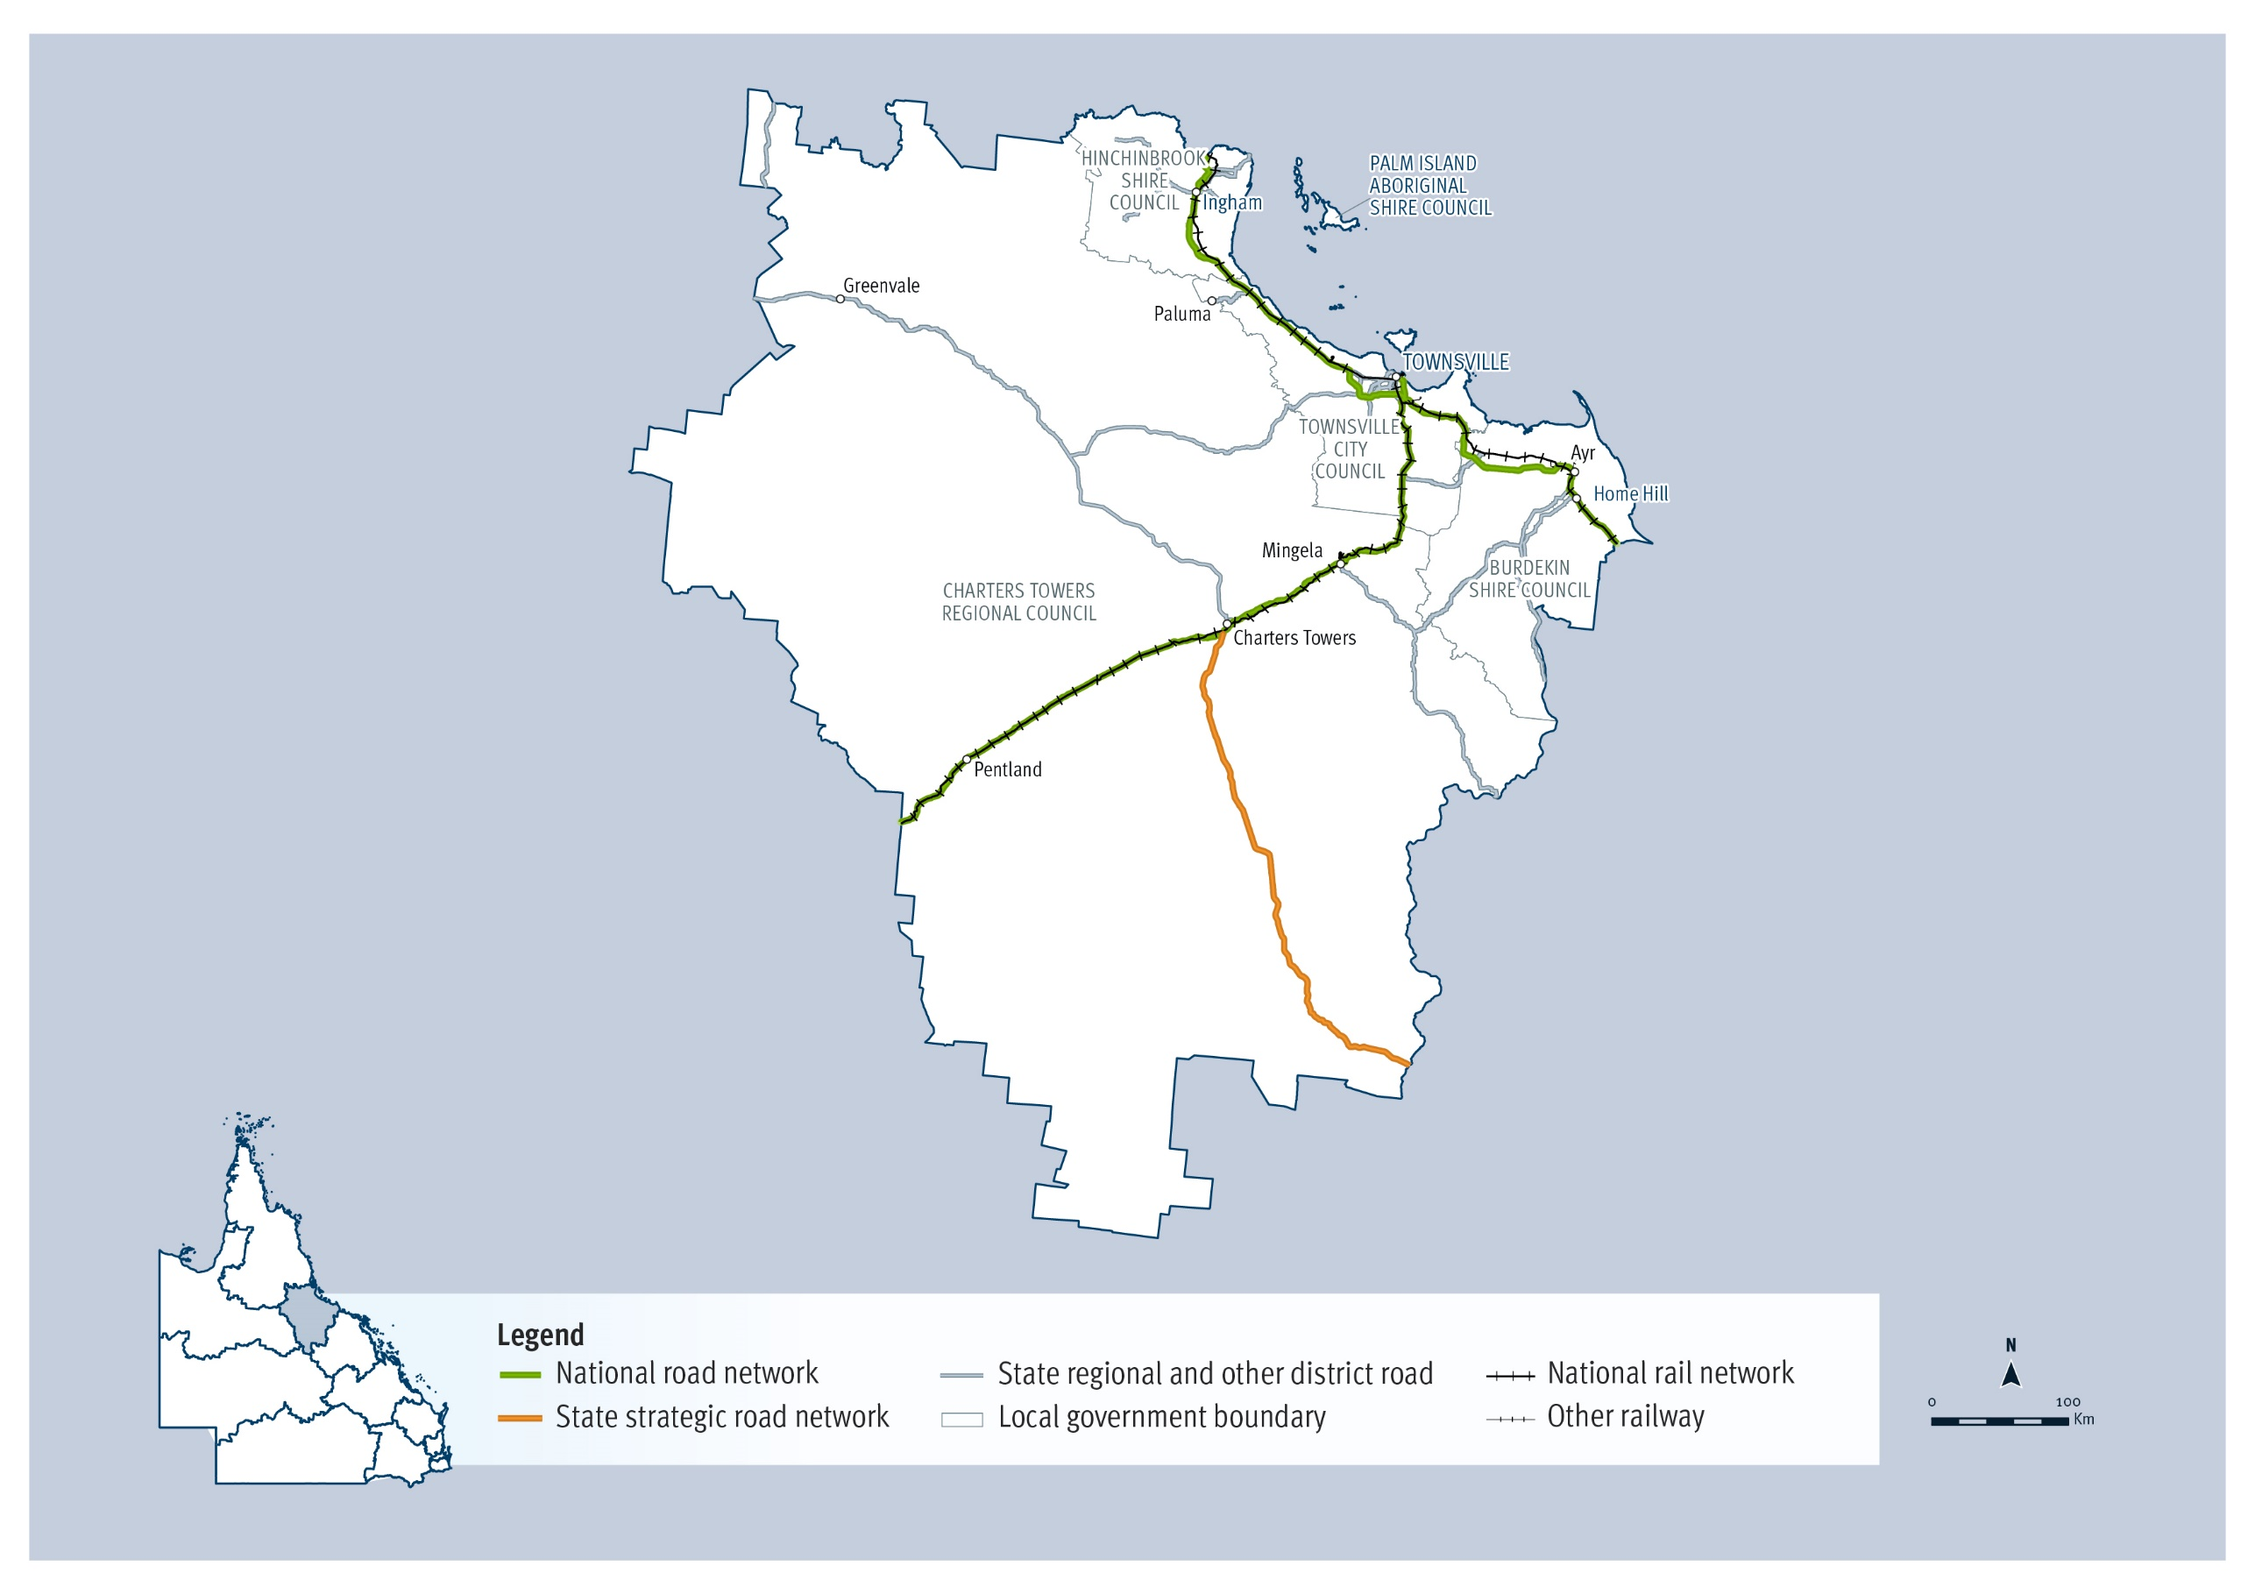

QTRIP 2025-26 to 2028-29

Northern

Planned investments

Projects: Up to $250 million
AG = Australian Government funding, QG = Queensland Government funding, Local/Other = Local Government or other funding partners.
Investment ID | Project title | AG | QG | Local/ Other | Planning | Procurement | Construction Start | Notes
3048798 | Abbott Street Connection Road (Lakeside Drive) and Oonoonba Road (Idalia), undertake safety improvements |  | ● |  | Underway | Late 2025 | 2026-27 | Safer Roads Sooner Program
3605966 | Angus Smith Drive (Douglas), upgrade roundabout, funding allocation | ● | ● |  | - | - | - | Includes Safer Roads, Better Transport Initiative funding. Project scope and timing subject to further negotiations with Queensland Health and Townsville City Council.
3537116 | Barrett Road, Bruce Highway to Mt Spec Road, rehabilitate pavement |  | ● | ● | - | - | 2026-27
2129809 | Bruce Highway (Ingham - Innisfail), Gairloch Floodway, improve safety | ● |  |  | Underway | 2026-27 | 2026-27 | The project has a business case, with scope, cost and timing subject to further project development and site investigations, and consideration.
399292 | Bruce Highway, Burdekin Deviation, plan and preserve corridor | ● | ● |  | Underway | - | -
3048705 | Douglas - Garbutt Road (Duckworth Street) and Dalrymple Road (Garbutt), improve intersection |  | ● |  | Underway | Late 2025 | Early 2026 | Safer Roads Sooner Program
3492923 | Flinders Highway (Charters Towers – Hughenden), Homestead West, construct heavy vehicle rest area | ● | ● |  | Underway | Early 2026 | Mid 2026 | Australian Government Safer Local Roads and Infrastructure Program
2684163 | Garbutt - Upper Ross Road, Halliday Street to Gouldian Avenue, improve safety |  | ● |  | Underway | - | -
3580418 | Ingham - Abergowrie Road, various locations, upgrade level crossings | ● | ● |  | Underway | Early 2026 | Mid 2026 | Australian Government Regional Level Crossing Upgrade Fund
3580768 | Ingham - Halifax - Bemerside Road, various locations, upgrade level crossings | ● | ● |  | Underway | Early 2026 | Mid 2026 | Australian Government Regional Level Crossing Upgrade Fund
1870433 | Lansdown Eco-Industrial Precinct (Calcium), upgrade road and rail infrastructure, funding allocation |  | ● |  | Underway | - | - | Project scope, cost and timing subject to further planning and negotiation with funding partners.
3531085 | North Townsville Road (Boundary Street), Charters Towers Road to Tenth Avenue, safety and capacity upgrade, planning |  | ● |  | 2026-27 | - | -
3091547 | Ross River (Townsville), channel dredging |  | ● |  | Underway | Late 2025 | Early 2026
2339436 | Townsville CBD - Douglas Cycleway, Ross River Road to Burt Street, design cycling facilities |  | ● |  | Underway | - | -
738293 | Townsville Eastern Access Rail Corridor, Cluden to Port of Townsville, acquire land | ● | ● |  | Underway | - | -

Contractually committed investments
AG = Australian Government funding, QG = Queensland Government funding, Local/Other = Local Government or other funding partners.
Investment ID | Project title | AG  ($’000’s) | QG  ($’000’s) | Local/ Other ($’000’s) | Committed total budget ($’000’s) | Estimated expenditure to 30 June 2025 ($’000’s) | 2025-26 ($’000’s) | Post  2025-26 ($’000’s) | Notes
1776745 | Garbutt - Upper Ross Road (Riverway Drive) (Stage 2), Allambie Lane to Dunlop Street, duplicate to four lanes | 76,000 | 59,000 |  | 135,000 | 33,268 | 30,000 | 71,732 | Funding splits under negotiation with Australian Government.
2419830 | Townsville Connection Road (Stuart Drive), Bowen Road Bridge (Idalia), duplicate bridge and approaches |  | 99,800 |  | 99,800 | 55,817 | 30,204 | 13,779
3347830 | Bruce Highway (Bowen - Ayr), Burdekin River Bridge, rehabilitation program | 64,732 | 32,199 |  | 96,931 | 65,713 | 4,500 | 26,717 | Includes an agreed contribution from Queensland Rail.
1810128 | Townsville Connection Road (Stuart Drive), University Road to Bowen Road Bridge (Idalia), improve safety |  | 96,000 |  | 96,000 | 69,621 | 17,900 | 8,479
2682871 | Ross River Road, Mabin Street to Rolfe Street, improve safety |  | 19,320 |  | 19,320 | 3,267 | 4,309 | 11,744 | High Risk Roads Initiative
1817986 | Jones Road, Lansdown Eco-Industrial Precinct (Calcium), construct and upgrade roads | 2,000 |  | 4,994 | 6,994 | 800 | 1,200 |  | Australian Government Safer Local Roads and Infrastructure Program
1846367 | Ross River Road, various intersections, install pedestrian facilities |  | 5,800 |  | 5,800 | 3,300 | 2,500
3116465 | South Townsville Road, upgrade safety and efficiency, planning |  | 5,000 |  | 5,000 | 200 | 1,000 | 3,800
3032053 | Gouldian Drive, Riverway Drive to Beck Drive, apply asphalt resurfacing |  | 2,000 | 2,000 | 4,000 | 1,000 | 1,000
1156080 | Ewan Road (Paluma), various locations Hidden Valley to Paluma, rehabilitate pavement |  | 1,163 | 1,163 | 2,325 |  | 336 | 826 | Transport Infrastructure Development Scheme
2572891 | Copleys Road (Abergowrie), replace bridge | 1,840 |  | 460 | 2,300 | 1,480 | 360 |  | Australian Government Safer Local Roads and Infrastructure Program
2291358 | Garbutt - Upper Ross Road (Dalrymple Road), Bayswater Road to Thuringowa Drive, upgrade safety and efficiency, planning |  | 1,490 |  | 1,490 | 932 | 558
2292045 | South Townsville Road, Lakeside Drive to Boundary Street, improve safety and efficiency, planning |  | 1,300 |  | 1,300 | 1,228 | 72
2663771 | North Townsville Road (Woolcock Street) and Dalrymple Road intersection, improve safety and efficiency, planning |  | 1,260 |  | 1,260 |  | 300 | 960
2291087 | North Townsville Road (Woolcock Street), Weston Street to Pilkington Street, upgrade safety and capacity, planning |  | 1,256 |  | 1,256 | 396 | 560 | 300

Northern
2025–26 FY total investment: $201 million
2026–27 FY total investment: $166 million
2027–28 to 2028–29 FY total investment: $443 million
Northern total investment over four years (2025–26 to 2028–29): $810 million ⁵

North West

Key facts
307,082 km² Area covered by location 1
0.57 % Population of Queensland 1
2,562 km Other state-controlled road network
1,024 km National Land Transport Network 2
692 km National rail network 2


Contact details

Office: Cloncurry
Address: 16–22 Ramsay Street | Cloncurry | Qld 4824
Postal: PO Box 338 | Cloncurry | Qld 4824
Phone: (07) 4769 3200
Email: cloncurry.office@tmr.qld.gov.au

See Reference section (Notes for Map Pages)

for further details.

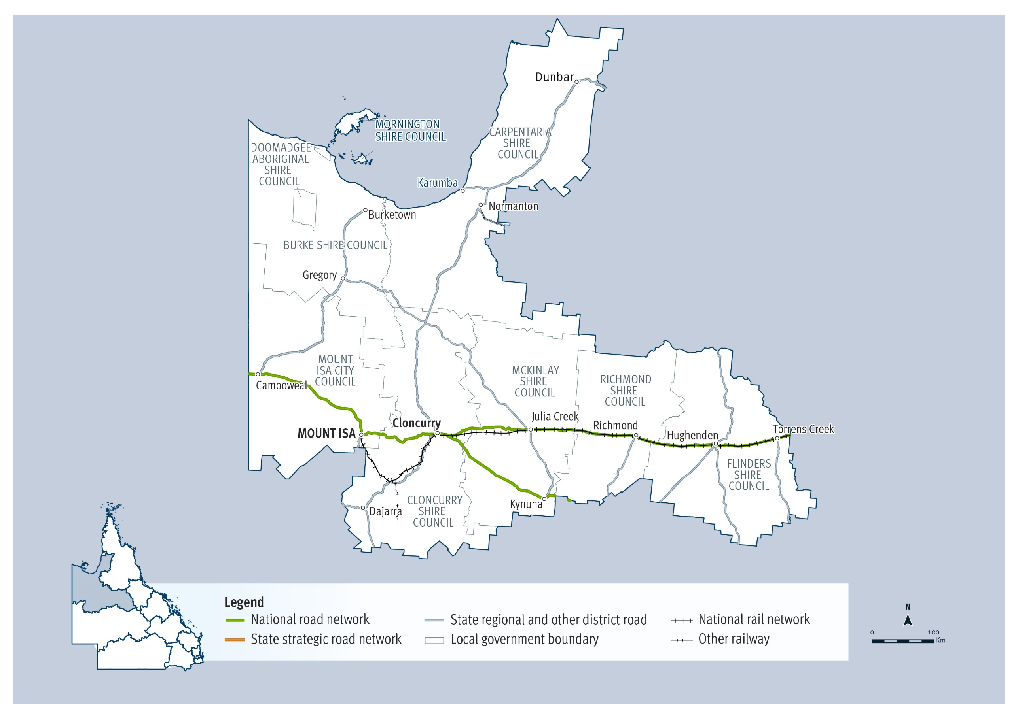

QTRIP 2025-26 to 2028-29

North West

Planned investments

Projects: Up to $250 million
AG = Australian Government funding, QG = Queensland Government funding, Local/Other = Local Government or other funding partners.
Investment ID | Project title | AG | QG | Local/ Other | Planning | Procurement | Construction Start | Notes
2905154 | Burke Developmental Road (Normanton - Dimbulah), construct emergency airstrip |  | ● |  | Underway | Mid 2025 | Late 2025
3107636 | Burketown Road, widen and seal |  | ● | ● | - | - | 2026-27
2340394 | Cloncurry - Dajarra Road, Malbon River floodway, upgrade culvert and approaches | ● | ● |  | ✔ | Underway | Late 2025 | The project is in the post-business case stage, with project scope, cost and timing subject to confirmation following market engagement, and consideration. Funding splits under negotiation.
3649679 | Cloncurry – Dajarra Road, Maud A Crossing upgrade |  | ● |  | Mid 2026 | - | -
2340159 | Flinders Highway (Hughenden - Richmond), various locations, improve pavement and culvert | ● | ● |  | Underway | 2026-27 | 2026-27 | The project is in the pre-business case stage, with project scope, cost and timing subject to further planning, business case development and consideration.
2340056 | Flinders Highway (Julia Creek - Cloncurry), Canal Creek, replace bridge and approaches | ● | ● |  | Underway | Mid 2026 | 2026-27 | The project has a business case, with scope, cost and timing subject to further project development and site investigations, and consideration.
2340058 | Flinders Highway (Richmond - Julia Creek), Alick Creek, upgrade floodway and install major culvert | ● | ● |  | Underway | 2026-27 | 2026-27 | The project is in the pre-business case stage, with project scope, cost and timing subject to further planning, business case development and consideration.
2340086 | Flinders Highway (Richmond - Julia Creek), various locations, improve pavement and upgrade culvert | ● | ● |  | Underway | 2026-27 | 2026-27 | The project has a business case, with scope, cost and timing subject to further project development and site investigations, and consideration.
2339886 | Landsborough Highway (Kynuna - Cloncurry), McKinlay River, improve pavement and drainage works | ● | ● |  | Underway | 2026-27 | 2026-27 | The project is in the pre-business case stage, with project scope, cost and timing subject to further planning, business case development and consideration.
2339972 | Landsborough Highway (Kynuna - Cloncurry), Nora Creek, improve pavement and drainage works | ● | ● |  | Underway | 2026-27 | 2027-28 | The project is in the pre-business case stage, with project scope, cost and timing subject to further planning, business case development and consideration.
2339651 | Landsborough Highway (Kynuna - Cloncurry), Rutchillo Creek, improve pavement and drainage works | ● | ● |  | Underway | 2026-27 | 2027-28 | The project is in the pre-business case stage, with project scope, cost and timing subject to further planning, business case development and consideration.
3552772 | Soldiers Hill, Barkly Highway to Camooweal Street, construct shared path |  | ● | ● | - | - | 2026-27

Contractually committed investments
AG = Australian Government funding, QG = Queensland Government funding, Local/Other = Local Government or other funding partners.
Investment ID | Project title | AG  ($’000’s) | QG  ($’000’s) | Local/ Other  ($’000’s) | Committed total budget ($’000’s) | Estimated expenditure to 30 June 2025 ($’000’s) | 2025-26 ($’000’s) | Post  2025-26 ($’000’s) | Notes
2351428 | Burketown - Normanton Road, seal unsealed sections | 16,000 |  | 4,000 | 20,000 |  | 3,000 | 13,000
3420399 | Burke Developmental Road (Normanton - Dimbulah), 2023 Disaster Recovery Funding Arrangements betterment works | 8,000 | 8,000 |  | 16,000 | 1,547 | 13,547 | 906 | Funding administered by the Queensland Reconstruction Authority.
800390 | Burke Developmental Road (Cloncurry - Normanton), various locations, widen pavement |  | 11,240 |  | 11,240 | 200 | 4,600 | 6,440
3007586 | Scheaffe Street (Cloncurry), Coppermine Creek, replace bridge | 5,000 |  | 2,552 | 7,552 | 2,000 | 2,000 | 1,000 | Australian Government Safer Local Roads and Infrastructure Program
3258085 | Malbon - Selwyn Road (Cloncurry), upgrade causeways | 5,000 |  | 1,710 | 6,710 |  | 2,250 | 2,750 | Australian Government Safer Local Roads and Infrastructure Program
2383061 | Gregory Downs - Camooweal Road, progressive sealing |  | 5,000 |  | 5,000 |  | 1,000 | 4,000
1904881 | Old Richmond Road, form and seal |  | 2,485 | 2,485 | 4,970 | 1,645 | 440 | 400
2905155 | Burke Developmental Road (Normanton - Dimbulah), Clark Creek, upgrade culvert |  | 4,500 |  | 4,500 | 1,600 | 2,900
3207680 | Rest areas and stopping places management |  | 3,640 |  | 3,640 | 1,820 | 910 | 910
1106598 | Various roads, install or replace floodways |  | 1,449 | 1,449 | 2,897 | 848 | 301 | 300
1904904 | Byrimine Road, construct to a sealed standard |  | 1,172 | 1,172 | 2,345 | 805 | 117 | 250
2271225 | Maxwelton - Frontage Road, various locations, rehabilitate and widen |  | 1,154 | 1,154 | 2,307 | 286 | 467 | 400
1904899 | Hughenden - Muttaburra Road, construct to a sealed standard |  | 1,972 |  | 1,972 | 1,633 | 189 | 150 | Transport Infrastructure Development Scheme
3599024 | Dunbar - Kowanyama Road, Plain Creek Crossing, upgrade floodway |  | 1,250 |  | 1,250 |  | 1,250
2936669 | Various outstation access roads, resheet gravel |  | 1,232 |  | 1,232 | 873 | 200 | 159

North West
2025–26 FY total investment: $120 million
2026–27 FY total investment: $135 million
2027–28 to 2028–29 FY total investment: $220 million
North West total investment over four years (2025–26 to 2028–29): $474 million ⁵

Far North

Key facts
272,216 km² Area covered by location 1
5.47 % Population of Queensland 1
2,925 km Other state-controlled road network
232 km National Land Transport Network 2
211km National rail network 2

Contact details

Office: Cairns
Address: 15 Lake Street | Cairns | Qld 4870
Postal: PO Box 6185 | Cairns | Qld 4870
Phone: (07) 4045 7144
Email: cairns.office@tmr.qld.gov.au

See Reference section (Notes for Map Pages)

for further details.

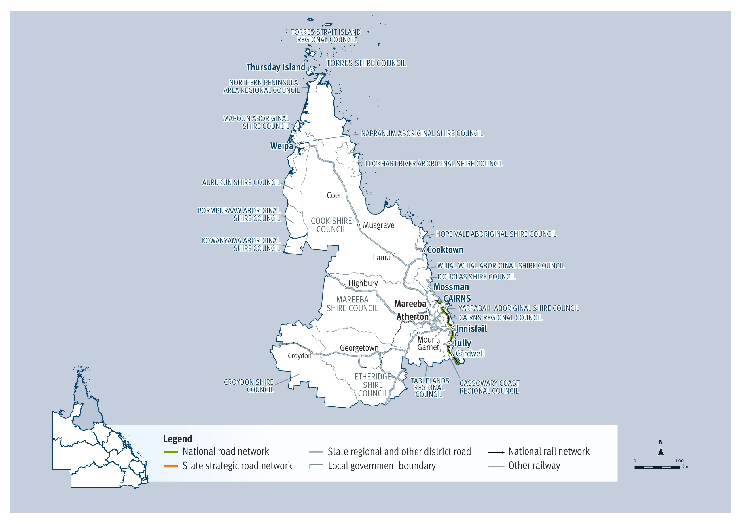

QTRIP 2025-26 to 2028-29

Far North

Planned investments

Projects: $250 million – $1 billion
AG = Australian Government funding, QG = Queensland Government funding, Local/Other = Local Government or other funding partners.
Investment ID | Project title | AG | QG | Local/ Other | Planning | Procurement | Construction Start | Notes
1810618 | Cairns Western Arterial Road, Redlynch Connector Road to Captain Cook Highway, funding allocation | ● | ● |  | Underway | - | -
1351442 | Captain Cook Highway, Cairns CBD to Smithfield, funding allocation | ● | ● |  | Underway | - | -
3095406 | Kennedy Highway (Cairns - Mareeba), Barron River bridge (Kuranda) replacement | ● | ● |  | ✔ | 2026-27 | 2027-28 | Project scope, cost and timing subject to further planning.
2713515 | Kuranda Range Road, safety and resilience upgrades, funding allocation | ● | ● |  | Underway | 2026-27 | 2027-28 | Delivery of Disaster Recovery Funding Arrangement works on Kuranda Range Road remains the priority. Project details and timing subject to further planning and negotiation with the Australian Government.

Projects: Up to $250 million
AG = Australian Government funding, QG = Queensland Government funding, Local/Other = Local Government or other funding partners.
Investment ID | Project title | AG | QG | Local/ Other | Planning | Procurement | Construction Start | Notes
3559424 | Atherton - Herberton Road (Wongabel), undertake safety improvements |  | ● |  | Early 2026 | 2026-27 | 2027-28
2817993 | Bramble Street (Kurrimine Beach), upgrade boat ramp and construct walkway |  | ● |  | ✔ | Late 2025 | Early 2026
386517 | Bruce Highway (Ingham - Innisfail), Dallachy Road, install floodway | ● | ● |  | ✔ | Underway | Mid 2025
3558085 | Bruce Highway (Ingham - Innisfail), Kurrimine Beach Road and Silkwood - Japoon Road, improve intersections |  | ● |  | Early 2026 | 2026-27 | 2027-28 | Safer Roads Sooner Program
3431974 | Bruce Highway (Innisfail - Cairns), 2024 Disaster Recovery Funding Arrangements reconstruction works | ● | ● |  | ✔ | Underway | Late 2025 | Funding administered by the Queensland Reconstruction Authority.
1176520 | Bruce Highway, Cairns Southern Access Corridor (Stage 5), Foster Road, funding allocation | ● | ● |  | - | - | 2032-33 | The project is in the pre-business case stage, with project scope, cost and timing subject to further planning, business case development and consideration.
3615581 | Cape Tribulation Road (Lower Daintree), widen boat ramp and floating walkway and improve flood resilience |  | ● |  | Mid 2025 | Late 2025 | Early 2026
3444503 | Captain Cook Highway (Cairns - Mossman), Mowbray River Bridge, 2024 Disaster Recovery Funding Arrangements reconstruction works | ● | ● |  | ✔ | Mid 2025 | Early 2026 | Funding administered by the Queensland Reconstruction Authority.
3042943 | Captain Cook Highway (Cairns - Mossman), Sheridan Street and Mulgrave Road intersection, improve intersection |  | ● |  | ✔ | Early 2026 | 2026-27 | Safer Roads Sooner Program
3243211 | Cooktown to Weipa Corridor upgrade, Future Stages of the Cape York Region Package (Stage 3), funding allocation |  | ● |  | Underway | - | - | Queensland Government's 20 per cent contribution to the next stage of the Cape York Region Package, subject to negotiation with the Australian Government. Funding will focus on continued progressive sealing of the Peninsula Developmental Road, with initial priorities being sections just north of Yarraden.
3042944 | Gillies Range Road (Little Mulgrave), undertake safety improvements |  | ● |  | ✔ | Early 2026 | 2026-27 | Safer Roads Sooner Program
3558749 | Gillies Range Road and Malanda - Lake Barrine Road (Lake Eacham), improve intersection |  | ● |  | Early 2026 | 2026-27 | 2027-28 | Safer Roads Sooner Program
3556459 | Gillies Range Road, various locations, undertake safety improvements |  | ● |  | Underway | Mid 2026 | 2026-27 | Safer Roads Sooner Program
3432376 | Gulf Developmental Road (Georgetown - Mount Garnet), Routh Creek, 2024 Disaster Recovery Funding Arrangements reconstruction works | ● | ● |  | ✔ | Mid 2025 | Late 2025 | Funding administered by the Queensland Reconstruction Authority.
3583128 | Kennedy Developmental Road (The Lynd - Hughenden), funding allocation | ● |  |  | Early 2026 | 2026-27 | 2026-27 | Project details and timing subject to further planning and negotiation with the Australian Government.
3505774 | Kennedy Highway (Cairns - Mareeba) (Koah), construct heavy vehicle rest area | ● | ● |  | Underway | 2026-27 | 2026-27 | Australian Government Safer Local Roads and Infrastructure Program
3549236 | Leadingham Creek Road, widen and seal | ● | ● | ● | ✔ | ✔ | Mid 2025 | Australian Government Safer Local Roads and Infrastructure Program
3149913 | Mareeba - Charters Towers, route upgrade strategy, planning |  | ● |  | Underway | - | -
3557144 | Mossman - Mount Molloy Road, various locations, undertake safety improvements |  | ● |  | Underway | Mid 2026 | 2026-27 | Safer Roads Sooner Program
2745763 | Mulgrave Road, Gordon Creek, construct active transport bridge and approaches |  | ● |  | Underway | - | -
3058262 | Mulligan Highway (Mount Molloy - Lakeland), 2024 Disaster Recovery Funding Arrangements reconstruction works | ● | ● |  | ✔ | Underway | Late 2025 | Funding administered by the Queensland Reconstruction Authority.
3495681 | Mulligan Highway (Mount Molloy - Lakeland), Rifle Creek, Spear Creek and McLeod River bridges, pre-construction |  | ● |  | Underway | - | -
2729045 | Mundoo Road, Bamboo Creek, upgrade bridge |  | ● | ● | - | Early 2026 | Mid 2026
3369917 | Port Douglas Boat Harbour, maintenance dredging |  | ● |  | ✔ | Underway | Mid 2026
3561162 | Port Douglas Road, Grant Street and Macrossan Street (Port Douglas), improve intersections |  | ● |  | Early 2026 | 2026-27 | 2027-28
3245397 | Rocky Point (Weipa), upgrade boating facility |  | ● |  | Underway | Early 2026 | 2026-27 | Project scope, cost and timing subject to further planning.
3553118 | Seisia Road, Langie Draha Street to Tumema Street, construct shared path |  | ● | ● | - | - | 2026-27
3353453 | Tinaroo Creek Road, Ada Creek causeway (Mareeba), replace causeway | ● |  | ● | - | - | 2026-27 | Australian Government Safer Local Roads and Infrastructure Program

Contractually committed investments
AG = Australian Government funding, QG = Queensland Government funding, Local/Other = Local Government or other funding partners.
Investment ID | Project title | AG  ($’000’s) | QG  ($’000’s) | Local/ Other  ($’000’s) | Committed total budget ($’000’s) | Estimated expenditure to 30 June 2025 ($’000’s) | 2025-26 ($’000’s) | Post  2025-26 ($’000’s) | Notes
3053252 | Captain Cook Highway (Cairns - Mossman), 2024 Disaster Recovery Funding Arrangements reconstruction works | 92,614 | 30,871 |  | 123,485 | 16,375 | 33,367 | 73,742 | Funding administered by the Queensland Reconstruction Authority.
3059169 | Kennedy Highway (Cairns - Mareeba), 2024 Disaster Recovery Funding Arrangements reconstruction works | 71,581 | 23,860 |  | 95,441 | 10,311 | 23,787 | 61,344 | Funding administered by the Queensland Reconstruction Authority.
3057461 | Captain Cook Highway (Cairns - Mossman), 2024 Disaster Recovery Funding Arrangements reconstruction works | 48,839 | 16,280 |  | 65,118 | 10,311 | 20,507 | 34,300 | Funding administered by the Queensland Reconstruction Authority.
3280227 | Palmerston Highway (Innisfail - Millaa Millaa), 2024 Disaster Recovery Funding Arrangements reconstruction works | 43,314 | 14,438 |  | 57,752 | 11,911 | 11,964 | 33,877 | Funding administered by the Queensland Reconstruction Authority.
1249733 | Cairns Southern Access Cycleway, construct cycleway | 33,223 | 8,306 |  | 41,529 | 30,611 | 240 | 10,678 | Forms part of the Bruce Highway, Cairns Southern Access Stage 2 (Robert Road to Foster Road) project. Project scope, cost and timing subject to further project development and site investigations, and consideration.
3058164 | Mossman - Daintree Road, 2024 Disaster Recovery Funding Arrangements reconstruction works | 30,419 | 10,140 |  | 40,558 | 3,471 | 10,934 | 26,154 | Funding administered by the Queensland Reconstruction Authority.
2902598 | Torres Strait Islands Marine Infrastructure Program, funding allocation |  | 38,120 |  | 38,120 | 2,266 | 6,800 | 29,054 | Project scope, cost and timing subject to further planning.
3059282 | Kennedy Highway (Mareeba), 2024 Disaster Recovery Funding Arrangements reconstruction works | 26,964 | 8,988 |  | 35,951 | 5,212 | 7,579 | 23,160 | Funding administered by the Queensland Reconstruction Authority.
3057647 | Mossman - Mount Molloy Road, 2024 Disaster Recovery Funding Arrangements reconstruction works | 21,060 | 7,020 |  | 28,080 | 3,508 | 7,428 | 17,145 | Funding administered by the Queensland Reconstruction Authority.
3059363 | Gillies Range Road (Tablelands Regional), 2024 Disaster Recovery Funding Arrangements reconstruction works | 19,970 | 6,657 |  | 26,627 | 200 | 13,437 | 12,990 | Funding administered by the Queensland Reconstruction Authority.
3059345 | Gillies Range Road, 2024 Disaster Recovery Funding Arrangements reconstruction works | 18,032 | 6,011 |  | 24,043 | 1,200 | 7,144 | 15,700 | Funding administered by the Queensland Reconstruction Authority.
3050268 | Kennedy Highway (Cairns - Mareeba), 2024 Disaster Recovery Funding Arrangement reconstruction works | 14,078 | 4,693 |  | 18,770 | 4,419 | 5,388 | 8,964 | Funding administered by the Queensland Reconstruction Authority.
3441773 | Captain Cook Highway (Cairns - Mossman), 2024 Disaster Recovery Funding Arrangements reconstruction works | 13,425 | 4,475 |  | 17,900 | 12,872 | 1,523 | 3,504 | Funding administered by the Queensland Reconstruction Authority.
3059427 | Shiptons Flat Road, 2024 Disaster Recovery Funding Arrangements reconstruction works | 12,133 | 4,044 |  | 16,177 | 950 | 3,344 | 11,883 | Funding administered by the Queensland Reconstruction Authority.
2383189 | Kennedy Highway (Mareeba - Ravenshoe), design and construct overtaking lanes |  | 12,354 |  | 12,354 | 2,721 | 3,700 | 5,932
2361416 | Gulf Developmental Road (Georgetown - Mount Garnet) (Package 4), strengthen and widen pavement | 9,648 | 2,412 |  | 12,060 | 1,408 | 5,361 | 5,291
1474076 | Malanda - Lake Barrine Road, improve safety |  | 9,930 |  | 9,930 | 1,848 | 5,920 | 2,162 | Safer Roads Sooner Program
3446737 | Captain Cook Highway (Cairns - Mossman), 2024 Disaster Recovery Funding Arrangements reconstruction works | 7,367 | 2,456 |  | 9,823 |  | 1,183 | 8,640 | Funding administered by the Queensland Reconstruction Authority.
1810917 | Jardine Ferry Road (Section 2), bitumen seal and drainage | 7,331 | 1,833 |  | 9,164 | 1,564 | 613 | 6,987 | Part of the Cape York Region Package Stage 2, jointly funded by the Queensland Government and Australian Government.
3446071 | Cook Shire, 2024 Disaster Recovery Funding Arrangements reconstruction works | 3,606 | 1,202 |  | 4,808 |  | 1,037 | 3,771 | Funding administered by the Queensland Reconstruction Authority.
3434091 | Peninsula Developmental Road (Coen - Weipa), 2024 Disaster Recovery Funding Arrangements reconstruction works | 2,976 | 992 |  | 3,968 |  | 2,885 | 1,083 | Funding administered by the Queensland Reconstruction Authority.
3081481 | Priors Creek, Vernon Street to Jack Street, construct active transport facilities |  | 1,576 | 2,198 | 3,774 | 946 | 630
3436886 | Peninsula Developmental Road (Laura - Coen), 2024 Disaster Recovery Funding Arrangements reconstruction works | 2,555 | 852 |  | 3,407 |  | 2,421 | 986 | Funding administered by the Queensland Reconstruction Authority.
2361982 | Ootann Road, Almaden to Kennedy Highway (Gunnawarra), Mareeba Section, widen and seal pavement | 2,658 |  | 665 | 3,323 | 1,246 | 1,412
3599237 | Port Douglas Road, Lakeland Avenue to Old Port Road (Port Douglas), construct shared path | 1,288 |  | 1,288 | 2,575 |  |  | 1,288 | Australian Government Active Transport Fund
3445329 | Gregory Developmental Road (The Lynd - Quartz Blow Creek), 2024 Disaster Recovery Funding Arrangements reconstruction works | 1,693 | 564 |  | 2,257 |  | 1,194 | 1,063 | Funding administered by the Queensland Reconstruction Authority.
3599661 | Dauan Island, barge ramp, improve ramp |  | 2,210 |  | 2,210 |  | 2,048 | 162
1496643 | Cairns Western Arterial Road, upgrade strategy, planning |  | 2,000 |  | 2,000 | 750 | 1,239 | 11
3446772 | Burke Developmental Road (Normanton - Dimbulah), 2024 Disaster Recovery Funding Arrangements reconstruction works | 1,415 | 472 |  | 1,887 |  | 673 | 1,214 | Funding administered by the Queensland Reconstruction Authority.
3354756 | Portland Roads Road, upgrade causeway |  | 1,750 |  | 1,750 | 518 | 1,232
3278367 | Various roads, upgrade pavement and drainage |  | 1,722 |  | 1,722 | 268 | 364 | 1,091
3436865 | Cassowary Coast Region, 2024 Disaster Recovery Funding Arrangements reconstruction works | 1,183 | 394 |  | 1,577 |  |  | 1,577 | Funding administered by the Queensland Reconstruction Authority.
3369493 | Injinoo Back Road and Ferry Road, upgrade to sealed standard |  | 1,500 |  | 1,500 |  | 1,500
3207063 | Northern Peninsula Airport, upgrade runway |  | 1,499 |  | 1,499 |  | 1,499
1902301 | Palmerston Highway (Innisfail - Ravenshoe), strategy upgrade, planning |  | 1,250 |  | 1,250 | 1,085 | 165
3595503 | Aubrey Parade and Douglas Street (Thursday Island), design and upgrade footpath | 1,200 |  |  | 1,200 |  |  | 1,200 | Australian Government Active Transport Fund
3598422 | Bloomfield Road, Davies Hill, upgrade pavement and drainage |  | 1,200 |  | 1,200 |  | 1,200
3360291 | Gulf Developmental Road (Croydon - Georgetown), 2024 Disaster Recovery Funding Arrangements reconstruction works | 863 | 288 |  | 1,151 |  | 714 | 437 | Funding administered by the Queensland Reconstruction Authority.
1903969 | Far North District, various roads, network analysis to vision standards, planning |  | 1,100 |  | 1,100 | 659 | 441
3320486 | Tully - Mission Beach Road, 2024 Disaster Recovery Funding Arrangements reconstruction works | 761 | 254 |  | 1,015 | 146 | 200 | 669 | Funding administered by the Queensland Reconstruction Authority.
1672443 | Half Moon Creek, construct groyne |  | 1,000 |  | 1,000 | 500 |  | 500
3444841 | Portland Road, pave and seal |  | 1,000 |  | 1,000 | 381 | 619

Far North
2025–26 FY total investment: $380 million
2026–27 FY total investment: $472 million
2027–28 to 2028–29 FY total investment: $1 billion
Far North total investment over four years (2025–26 to 2028–29): $1.9 billion ⁵

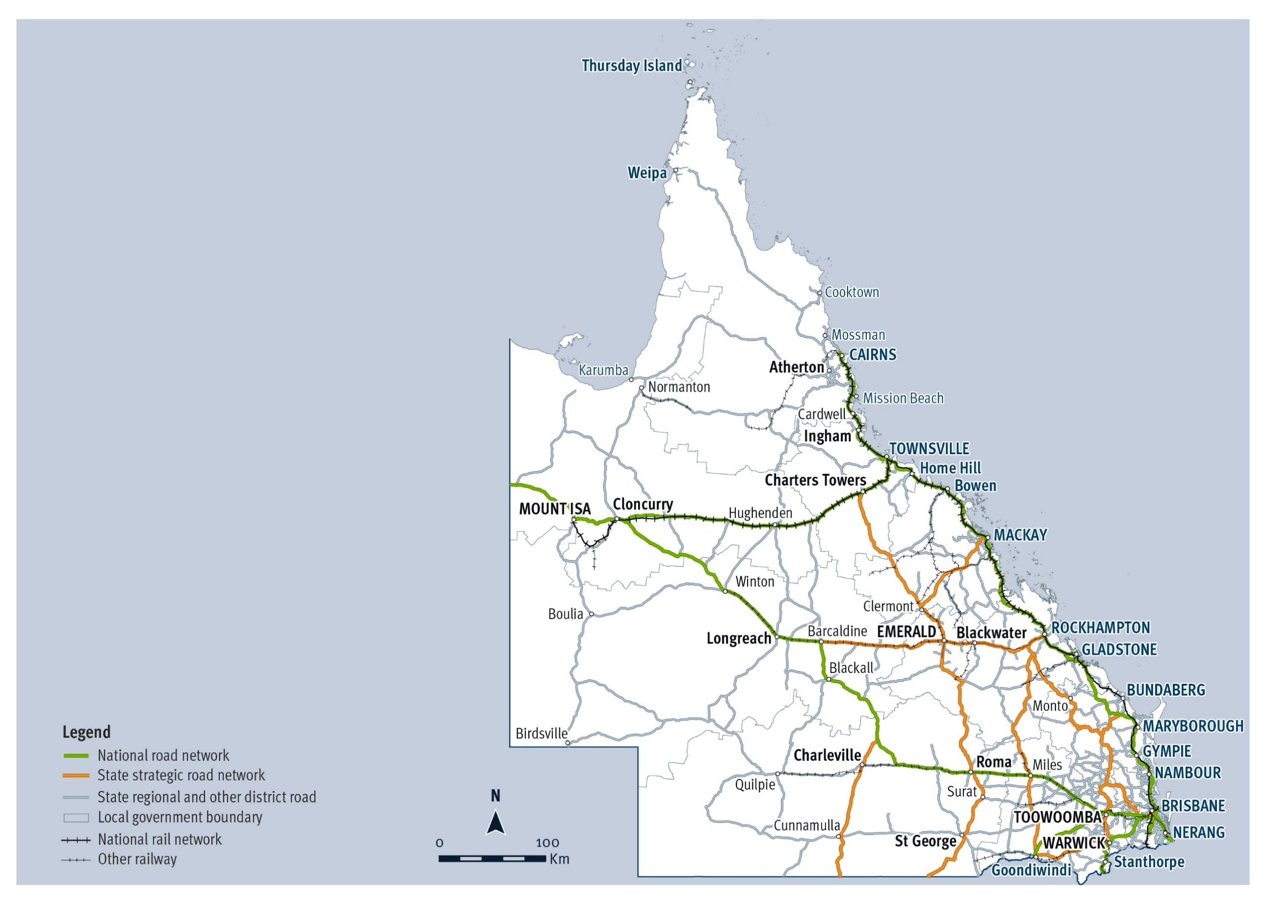

Statewide

QTRIP 2025-26 to 2028-29

Statewide

Planned investments

Projects: $250 million – $1 billion
AG = Australian Government funding, QG = Queensland Government funding, Local/Other = Local Government or other funding partners.
Investment ID | Project title | AG | QG | Local/ Other | Planning | Procurement | Construction Start | Notes
2605407 | Queensland Beef Corridors, funding allocation | ● | ● |  | Underway | - | - | Represents the balance of the Queensland Beef Corridors Program, with early works projects listed individually in QTRIP.
1217978 | Warrego Highway, funding allocation | ● | ● |  | Underway | - | - | Project details and timing subject to further planning and negotiation with the Australian Government.

Projects: Up to $250 million
AG = Australian Government funding, QG = Queensland Government funding, Local/Other = Local Government or other funding partners.
Investment ID | Project title | AG | QG | Local/ Other | Planning | Procurement | Construction Start | Notes
2392871 | Aids to Navigation Network infrastructure, funding allocation |  | ● |  | - | - | - | Program allocation to fund future aids to navigation network infrastructure.
2392872 | Aids to Navigation Network maintenance, funding allocation |  | ● |  | - | - | - | Program allocation to fund future aids to navigation network maintenance.
2785514 | Black Spot Program, funding allocation | ● |  |  | Underway | - | - | Australian Government Black Spot Program
2789836 | Boating Infrastructure, funding allocation |  | ● |  | - | - | - | Program allocation to fund future priority boating infrastructure.
2790086 | Boating Maintenance, funding allocation |  | ● |  | - | - | - | Program allocation to fund future boating maintenance activities.
3585831 | Bruce Highway Flood Resilience Program, funding allocation | ● | ● |  | Underway | Early 2026 | 2026-27
3654755 | Bus stop infrastructure to support new services |  | ● |  | Early 2026 | Early 2026 | Mid 2026 | A program of infrastructure investment on the State and Local Networks to support the introduction of bus growth services initiatives.
3521964 | Country Roads Connect, funding allocation |  | ● |  | Underway | - | - | Country Roads Connect Program
842546 | Cunningham Highway, funding allocation | ● | ● |  | Underway | - | - | Project details and timing subject to further planning and negotiation with the Australian Government.
2666060 | Cycling grants, funding allocation |  | ● |  | - | - | - | Cycling grants program allocation, with prioritisation subject to negotiation with local governments.
3089049 | Disaster Ready Fund, funding allocation |  | ● |  | Underway | - | - | Project scope, cost and timing subject to further planning and negotiation with the Australian Government.
3392298 | Inland Connection and Road Resilience Program, funding allocation | ● | ● |  | Underway | Early 2026 | 2026-27 | Funding administered by the Queensland Reconstruction Authority.
3107890 | Long-term rail network plan initiatives, planning |  | ● |  | Underway | - | -
QR1992 | Mount Isa Line, resilience improvements |  | ● |  | Underway | Underway | Underway
3514857 | Multi-modal Transport Coordination Centre, planning |  | ● |  | Underway | - | -
B06735 | New Generation Rollingstock compatible stabling yard upgrades |  | ● |  | Underway | - | -
3126892 | North Coast Rail Line, Exhibition station to Elimbah, improve capacity, planning |  | ● |  | Underway | - | -
3538963 | North Coast Rail Line, Exhibition to Elimbah Capacity Study |  | ● |  | Underway | - | -
2725316 | Passenger Transport Accessible Infrastructure, various locations |  | ● |  | Underway | - | -
3654767 | Public Transport Bus Stops and Stations Disability Standards |  | ● |  | 2025-26 | - | - | Procurement and construction subject to further planning.
2635687 | Queensland walking network plans,  Phase 2, planning |  | ● |  | Underway | - | -
B00030 | Rail station access improvements |  | ● |  | Underway | ✓ | Underway | Rail station access improvements include Roma Street subway, Dutton Park train station and Boggo Road train station.
3081493 | Regional Level Crossing Upgrade Fund, funding allocation | ● |  |  | Underway | - | - | Project scope, cost and timing subject to further planning and negotiation with the Australian Government.
3234325 | Regional Level Crossing Upgrade Fund, funding allocation |  | ● |  | Underway | - | - | Project scope, cost and timing subject to further planning and negotiation with the Australian Government.
3518803 | Regional Passenger Transport Network, planning |  | ● |  | Underway | - | -
3146173 | Rollingstock program, planning |  | ● |  | Underway | - | -
3052608 | Safer Local Roads and Infrastructure Program, Australian Government funding allocation | ● |  |  | Underway | Underway | Underway | Australian Government Safer Local Roads and Infrastructure Program
3245197 | Safer Local Roads and Infrastructure Program, funding allocation |  | ● |  | Underway | Underway | Underway | Australian Government Safer Local Roads and Infrastructure Program
2973903 | SEQ City Deal, funding allocation | ● | ● |  | Underway | - | - | SEQ City Deal
3147530 | SEQ level crossing program, planning |  | ● |  | Underway | - | -
3107449 | SEQ network optimisation (Tranche 2), planning |  | ● |  | Mid 2025 | - | -
3128717 | SEQ passenger rail program, planning |  | ● |  | Underway | - | -
3394603 | SEQ Rail Corridor, Digital Connectivity | ● |  |  | Underway | - | - | SEQ City Deal
3536944 | SEQ Rail, Sector 2, planning |  | ● |  | Underway | - | -
3493595 | Statewide open access intermodal freight terminal strategy |  | ● |  | Mid 2025 | - | -
3533241 | Strategic Transport Models, traffic data collection |  | ● |  | Underway | - | -
2392870 | Technical Marine Infrastructure and Services, funding allocation |  | ● |  | Underway | - | -
2707464 | Timber Bridge Replacement Program, funding allocation |  | ● |  | Underway | - | -
3147017 | Vulnerable steel structures, planning |  | ● |  | Mid 2025 | - | -
3517079 | Western Brisbane multimodal transport network study |  | ● |  | Late 2025 | - | -

Contractually committed investments
AG = Australian Government funding, QG = Queensland Government funding, Local/Other = Local Government or other funding partners.
Investment ID | Project title | AG  ($’000’s) | QG  ($’000’s) | Local/ Other  ($’000’s) | Committed total budget ($’000’s) | Estimated expenditure to 30 June 2025 ($’000’s) | 2025-26 ($’000’s) | Post  2025-26 ($’000’s) | Notes
3484065 | Bruce Highway Targeted Safety Program, funding allocation | 7,200,000 | 1,800,000 |  | 9,000,000 | 13,340 | 412,000 | 8,574,660
2008163 | Logan and Gold Coast Faster Rail | 2,875,078 | 2,875,078 |  | 5,750,155 | 898,200 | 603,000 | 4,248,956
1804863 | Queensland Train Manufacturing Program |  | 4,869,000 |  | 4,869,000 | 1,484,321 | 950,000 | 2,434,679
14199 | Targeted Road Safety Program, Road Safety |  | 1,123,553 | 10 | 1,123,562 | 80,423 | 19,128 | 1,024,012
2586600 | Inland Freight Route (Charters Towers to Mungindi), funding allocation | 800,000 | 200,000 |  | 1,000,000 | 61,341 | 30,186 | 908,473 | Queensland Government has commenced early works package.
1805139 | New Generation Rollingstock, European Train Control System fitment, install new signalling |  | 380,484 |  | 380,484 | 206,275 | 114,004 | 60,206 | This project is being delivered as a Public Private Partnership.
2417122 | New Generation Rollingstock, Automatic Train Operation and Platform Screen Doors fitment |  | 275,700 |  | 275,700 | 108,675 | 46,589 | 120,436 | This project is being delivered as a Public Private Partnership.
B06449 | Signalling Integration Works |  | 250,259 |  | 250,259 | 167,243 | 83,016 |  | This project is being delivered by Cross River Rail Delivery Authority.
2835468 | Targeted Road Safety Program, Camera Detected Offence Program, Camera Assets |  | 155,183 |  | 155,183 | 7,048 | 4,050 | 144,085
3033000 | New Generation Rollingstock, integration and ancillary works |  | 51,600 |  | 51,600 | 4,145 | 20,000 | 27,455
1196542 | School Transport Infrastructure Program, funding allocation |  | 17,483 |  | 17,483 |  | 4,000 | 13,483 | School transport infrastructure program grants, with prioritisation subject to application and assessment.
2652932 | Boating Maintenance Program |  | 14,806 | 804 | 14,610 | 9,234 | 5,376
2038941 | Rail Network Infrastructure Planning |  | 13,425 |  | 13,425 | 6,122 | 1,981 | 5,322
1063026 | Boating Capital Grants |  | 4,478 |  | 4,478 | 478 | 1,000 | 3,000
1829332 | SEQ strategic transport model development and maintenance |  | 4,249 |  | 4,249 | 2,373 | 437 | 1,439
2661306 | Model for urban land-use and transport interaction (Multi) |  | 4,123 |  | 4,123 | 1,790 | 500 | 1,833
3129784 | SEQ traction power requirements, planning |  | 4,000 |  | 4,000 | 380 | 850 | 2,770
2156649 | Bus stop signage improvements, various locations |  | 3,600 |  | 3,600 | 1,299 | 650 | 1,652
1829692 | Public transport model |  | 2,997 |  | 2,997 | 1,442 | 431 | 1,125
14105 | Queensland Transport snapshot benefits reporting, planning |  | 2,234 |  | 2,234 | 1,583 | 151 | 500
3377282 | Passenger Transport Data Collection and Accessibility Audit |  | 2,000 |  | 2,000 | 400 | 1,600
741100 | Region focused strategic transport model development and maintenance planning |  | 1,958 |  | 1,958 | 1,358 | 150 | 450
1829507 | Queensland freight, goods and services model |  | 1,797 |  | 1,797 | 868 | 189 | 739
3530314 | Infrastructure improvements for bus stops, various locations |  | 1,682 |  | 1,682 | 1,432 | 250
3109884 | Improve bus station accessibility, planning |  | 1,535 |  | 1,535 | 80 | 475 | 980
2611858 | Busway Tunnel Safety System, planning |  | 1,337 |  | 1,337 | 1,085 | 102 | 150
3541331 | Busway Tunnel Safety System (Tranche 2), planning |  | 1,300 |  | 1,300 |  |  | 1,300
1878728 | Regional city traffic model development and maintenance |  | 1,068 |  | 1,068 | 225 | 243 | 600
3236272 | SEQ 10-year bus network strategy, planning |  | 1,028 |  | 1,028 | 508 | 250 | 270
3398825 | SEQ rail level crossing prioritisation |  | 1,000 |  | 1,000 |  | 400 | 600 | SEQ City Deal

Statewide
2025–26 FY total investment: $2.9 billion
2026–27 FY total investment: $4.0 billion
2027–28 to 2028–29 FY total investment: $9.2 billion
Statewide total investment over four years (2025–26 to 2028–29): $16 billion ⁵

References

Key Terms
Key terms used throughout the Queensland Transport and Roads Investment Program publication include:
Active transport infrastructure: TMR plans, constructs, operates and also provides grants to local governments for walking and bike riding facilities across the state, including shared paths, cycle tracks and safe road crossings. Funding is prioritised for the delivery of highest priority routes on the principal cycle network on state and local roads.
Active Transport Fund: The Active Transport Fund is a program to encourage an increase in active transport through the upgrade of existing and construction of new bicycle and walking pathways across Australia.
Australian Government Road Safety Program: A joint-funded initiative between the Australian Government and Queensland Government that targets road safety treatments to reduce the risk of fatal and serious injury road crashes across four key streams: regional roads, remote roads, urban roads, and footpaths and cycleways.
Black Spot Program: An Australian Government-funded minor capital works program that aims to improve the safety of the national, state and local road networks through the implementation of high-benefit, cost-effective engineering countermeasures and safety treatments that target known and potential high-severity (fatalities and serious injuries) crash sites at specific locations.
Camera Detected Offence Program: Comprises funds collected through camera-detected offence fines (speed and red light, unregistered/uninsured, dangerous goods in tunnels, mobile phone and seatbelt offence camera fines). The distribution of funds collected from camera-detected offences is restricted by the Transport Operations (Road Use Management) Act 1995. This requires that all money collected for penalties imposed for camera-detected offences, in excess of the administrative costs, be used for specific road safety purposes. This includes funding to improve the safety of the sections of state-controlled roads where crashes happen most frequently.
Camera Detected Offence Program funds are used as a partial source of funding for the Safer Roads Sooner Program and a number of other safety-related special initiatives.
Cape York Region Package: A joint-funded initiative between the Australian Government and Queensland Government to upgrade critical infrastructure on the Cape York Peninsula. This program provides improved access to Cape York; improved safety, reduced ongoing road maintenance costs and improved community infrastructure; and employment, training and business development opportunities for Indigenous and non-Indigenous people.
Country Roads Connect Program: A grants program providing funding to local governments to assist in paving unsealed regional roads, delivering targeted investments to enhance the safety and resilience of the regional road network.
Disaster Recovery Funding Arrangements: A joint-funded initiative between the Australian Government and Queensland Government to repair and restore state-controlled road network damaged by natural disasters to their pre-disaster level of service.
Funding Allocation: An allocation of funding towards either a partially or fully funded initiative; a program of works with specific investments to be prioritised; or a specific project to progress planning and/or preconstruction activities to confirm finalised scope and detailed cost estimates.
High Risk Roads Initiative: An approach that aims to identify high-risk routes and their associated safety risks and develop route-based solutions that maximises the road safety benefit achieved, based on value for money, and providing a consistent user experience. The deliverables identified by the produced Options Analysis and Business Case development for each High Risk Road proposal are prioritised with funding provided under the Targeted Road Safety Program.
Local government-controlled roads: Local government-controlled roads are owned, managed and operated by local governments across Queensland. State controlled roads and franchised roads, such as toll roads, are not local government-controlled roads.
Local Roads of Regional Significance (LRRS): Lower-order state-controlled roads and higher-order local government-controlled roads performing a similar function.
Major Project Business Case Fund: An Australian Government initiative that provides funding towards planning and business case development of future major land transport infrastructure projects with clear strategic merit.
Maritime infrastructure: Includes boat ramps, pontoons, jetties, floating walkways, dredging works and navigation aids, which are managed and operated by TMR.
Mode: The type of transport infrastructure used to connect people, places and services. Modes of transport infrastructure include road, rail, active transport, maritime, bus infrastructure, multi-modal infrastructure and other options.
Movement and Place: Movement and place is TMR’s best practice planning methodology, which can guide the way our transport networks and the places they interact with are planned, designed and operated. Movement and Place seeks to balance the transport network’s role in the movement of people and goods with the role of transport corridors, nodes and precincts, as places that are essential to live, shop, work, carry out business and socialise.
National Land Transport Network (National Network): A defined network of nationally significant road and rail infrastructure links and their intermodal connections. The network is determined by the Australian Government under the National Land Transport Act 2014.
Natural disaster: A natural disaster is one or a combination of the following rapid onset events – bushfire, earthquake, flood, storm surge, landslide, tsunami, meteorite strike or tornado. Funds may be provided by the Australian Government and Queensland Government to reinstate parts of the transport network that have been subject to disaster damage under declared emergency conditions.
Other state-controlled roads: Roads controlled by the Queensland Government, other than those on the National Land Transport Network.
Outback Way: A 2,720km route that traverses Central Australia, connecting Laverton in Western Australia with Winton in Queensland via Alice Springs in the Northern Territory. The condition of the route varies, with sections of unsealed, single lane seal and dual lane seal of differing standards and quality.
Public Private Partnership: A contract between the public and private sectors, where the government pays the private sector to deliver infrastructure and related services over the long-term. The private provider builds the facility and operates and/or maintains it to specified standards over a long period. The private provider usually finances the project.
Queensland Beef Corridors Program: A joint-funded initiative between the Australian Government and Queensland Government to the upgrading and sealing of heavy vehicle corridors in Queensland that are critical to the Australian beef industry.
Queensland Transport Strategy (QTS): TMR’s 30-year vision for how the Queensland Government plans to harness emerging transport trends to continue to move people and products safely and efficiently into the future.
Regional Infrastructure Plans: Supporting the State Infrastructure Strategy 2022–42, the seven Regional Infrastructure Plans outline regional priorities and infrastructure responses to provide a more place-based approach that better reflects the unique strengths and opportunities of each region.
Regional Roads and Transport Group (RRTG): The primary decision-making bodies of the Roads and Transport Alliance. There are 17 RRTGs across the state that determine regionally prioritised improvements to their communities’ transport infrastructure. Each RRTG comprises representatives from TMR and local governments. RRTGs take into consideration the economic, social, environmental and geographic characteristics of a region, which serves to influence the planning, investment strategies and management of the regional roads and transport network.
Regional Level Crossing Upgrade Fund: An Australian Government initiative to improve safety around railway crossings in regional areas.
Regional Transport Plans (RTP): Developed in partnership with local governments, the RTPs provide guidance for the development of the transport system across all areas of the state in a way that supports regional goals and priorities while maintaining consistency with the Transport Coordination Plan and State Infrastructure Strategy.
Remote Roads Upgrade Pilot Program: An Australian Government initiative that targets road improvements for regional communities, and addresses significant deficiencies on key regional and rural roads that limit community access, pose safety risks and impact the economic development of the surrounding area.
Road Safety Minor Works: A minor works program that distributes funding to respond to emerging local road safety needs.
Safer Local Roads and Infrastructure Program: An Australian Government initiative that provides funding for projects to address emerging priorities in road infrastructure needs across Australia. This program consolidates the previous Australian Government's Bridge Renewal Program and Heavy Vehicle Safety and Productivity Program.
Safer Roads, Better Transport initiative: A Queensland Government initiative to provide greater transport connectivity for all Queenslanders and keep Queenslanders safe on their roads.
Safer Roads Sooner: A minor capital works program that aims to improve the safety of the state-controlled road network through the implementation of high-benefit, cost-effective engineering countermeasures and safety treatments that target known and potential high-severity (fatalities and serious injuries) crash sites at specific locations.
School Transport Infrastructure Program: Provides funding to improve the safety and operation of schools through new or improved infrastructure at the school and/or on the surrounding road network.
SEQ City Deal: The SEQ City Deal is a commitment by the Australian Government, Queensland Government and the Council of Mayors SEQ, to plan and deliver enhanced investment for the South East Queensland region.
State-controlled roads: Roads declared to be controlled by TMR, including the National Land Transport Network. Toll roads are not state-controlled roads, rather they are operated by franchisees.
State Infrastructure Strategy 2022–42 (SIS): Sets out a 20-year vision to guide infrastructure planning and investment in Queensland. It outlines four key objectives that form the foundation of the SIS underpinning the Queensland Government’s 20-year vision for infrastructure: Encourage jobs, growth and productivity; Develop regions, places and precincts; Enhance sustainability and resilience; and Adopt smarter approaches. It also includes five infrastructure focus areas over the medium-term: Realising our future as a renewable energy superpower; Building a Brisbane 2032 legacy; Connecting our regions; Creating liveable communities; and Driving infrastructure performance. For each infrastructure focus area, the SIS highlights key priority actions that will be critical to realising the infrastructure vision.
Strategic Plan 2023–2027 (Revised 2024–25): TMR’s four-year strategic planning document that provides the shorter-term view and strategic direction of the department. TMR’s vision is connected communities in a sustainable, thriving and inclusive Queensland. The plan outlines six key objectives to realising this vision: Accessible and integrated; Safe and secure; Responsive; Efficient and productive; Sustainable; and Capable, adaptable and aligned.
Targeted Road Safety Program: A program with a number of jointly funded initiatives dedicated to the delivery of high-benefit safety interventions and route-based treatments to support safer roads and roadsides.
Transport Coordination Plan 2017–2027: Articulates the Queensland Government’s objectives for the transport system over the 10-year period. The plan identifies five objectives to help achieve TMR’s vision: customer experience and affordability, community connectivity, efficiency and productivity, safety and security and environment and sustainability. The plan also includes investment criteria that informs how TMR will prioritise investment in transport infrastructure and services (that is, Run, Maintain, then Build).

Transport Infrastructure Act 1994: This legislation ensures the Queensland Government has strategic oversight over the provision and operation of all transport infrastructure. The Act establishes a regime under which a safe and effective system of roads, miscellaneous transport infrastructure, rail, ports, air, public maritime transport, buses and light rail is planned and managed effectively.
Transport Infrastructure Development Scheme (TIDS): The grants program through which TMR provides funding to local governments, for the development of transport-related infrastructure.
Transport Planning and Coordination Act 1994: This legislation establishes a regime under which overall transport effectiveness and efficiency is ensured through strategic planning and management of transport resources.
Vulnerable users: This program treats state-controlled network locations with safety issues specifically related to cyclists, pedestrians and motorcyclists.

Notes for Fast Facts
- See Key Terms for definition of Mode.
- Figures quoted in this section are not mutually exclusive.
- Represents maintenance activities on roads, passenger transport, maritime and cycling infrastructure assets.
- Represents funding under the Targeted Road Safety Program. Includes federal funding as part of the Australian Government’s Road Safety and Black Spot Programs.
- District totals include other works, such as other construction works, routine maintenance, traffic operations, traffic management enhancements, rehabilitation, routine maintenance, for example.

Notes for Map Pages
- Queensland Government Statistician’s Office (Queensland Treasury) Queensland Regional Profiles. www.qgso.qld.gov.au (retrieved 18 March 2025).
- The detailed mapping data reflects the latest National Land Transport Network (NLTN) Determination 2020 as published.



See Reference section (Notes for Fast Facts) for further details.
See Reference section (Notes for Fast Facts) for further details.

