Risk, Need, Responsivity (RNR): Overview

What is RNR?
There is a significant body of evidence, built up over several decades, that clearly shows the most effective way to reduce reoffending in youth justice is to apply Risk Need Responsivity (RNR) principles.
Risk principle – The level of service provided to a young person matches their risk of reoffending as identified by a valid and standardised tool, which in Youth Justice is through use of the Youth Level of Service/Case Management Inventory (YLS/CMI™) 2.0.
Need principle – Work with the young person focuses on the highest need areas identified through validated assessment and use of the YLS/CMI™ 2.0.
Responsivity principle – Programs proven to reduce reoffending are used and adapted in line with the individual characteristics of the young person. The responsivity principle is split into two sections:
- General responsivity means that programs and services used to target reoffending risk and criminogenic needs are evidence-informed or evidence-based, tried and tested through research, and proven to be effective in reducing youth reoffending.
- Specific responsivity recognises that a range of individual characteristics and circumstances impact how well a young person can interact and engage in programs and services. In order to be effective, programs and services are adapted for age, gender, cognitive abilities, culture, strengths, and personality. This helps the young people engage, learn, and grow.

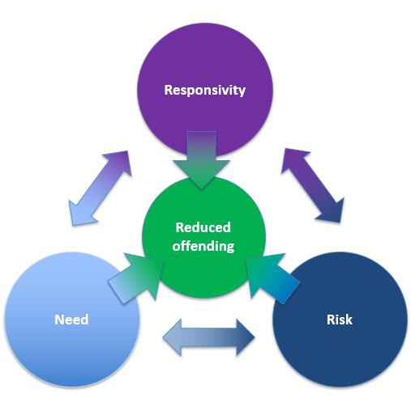
What does this mean?
WHO = RISK: YLS/CMI™ 2.0 assesses a young person’s reoffending risk level (very high, high, moderate, low) and informs how much change-oriented service delivery is needed to reduce offending.
WHAT = NEED: Focus on needs proven to predict reoffending. There are eight criminogenic need domains identified in YLS/CMI™ 2.0 with focus on Big Four. (The Big Four needs are stronger indicators of future offending and include Attitudes/Orientation, Personality/Behaviour, Peer Relations, Prior/ Current Offences/ Orders/Interventions, and for Aboriginal and Torres Strait Islander young people, Family Circumstances/Parenting).
HOW = RESPONSIVITY: Use proven programs to reduce reoffending and tailor delivery to young peoples’ individual characteristics, strengths, context, and culture.

How to apply RNR?
RNR is applied to the Service Response Plan, an individualised document that outlines young peoples’ current orders and requirements, overall level of risk, goals and agreed actions and sessions that a young person will engage with Youth Justice to address their criminogenic needs. To assist in developing a service response plan, additional resources are available including an RNR flowchart which outlines step-by-step processes in assessing risk dosage, how to target criminogenic needs, and application of responsivity to individual characteristics. The Service Response Plan must be completed within six weeks of order commencement and is monitored through an ongoing case review process.

