Conditional release order

What is a conditional release order (CRO)?
A judge gives you this if:
 | - you say you are guilty
 | - a court finds you guilty
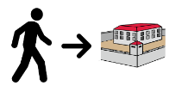 | - you have been sentenced to go to youth detention.
 | But the judge wants you to do this order first so you do not go to detention.  If you cannot finish this, you may go to detention.
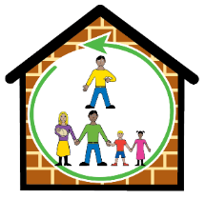 | You can live with your family.  You must do a program for up to 6 months.
 | It means a youth justice officer (or YJ officer) will supervise you.

What happens?
 | - Before you get this order, the court may get a YJ officer to write a report about you.
 | - You will meet the YJ officer.  They will talk to you more about what you can do in your program.
 | - You go back to court.  The judge will give you a conditional release order.

The program may have activities about
 | - school or TAFE
 | - getting a job
 | - good things you want to do in your life
 | - how you can stop offending in a positive way.

Rules
You must:
 | - do all the activities in your CRO
 | - not break the law
 | - do what your YJ officer says
 | - let your YJ officer visit you.
You must tell your YJ officer within 2 days if you:
 | - move house
 | - change schools
 | - change jobs.
You must tell and give lots of time to the YJ officer if you:
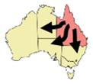 | - want to leave Queensland.
 | Your YJ officer needs to say ‘yes’.
Court can give you extra things for you to do on your order.
Extra things like:
 | - help to get off drugs and alcohol
 | - mental health help.

What if I break the rules?
 | Your YJ officer will tell you what happens if you break the rules.
 | If you break a rule, your YJ officer will give you a warning letter.
 | If you keep breaking the rules, you will go back to court.  The court will decide if you will go to detention or not.
 | You must stay out of trouble,
 | If you do another offence, the court may decide you have breached your order.
 | This means the court gave you rules but you did not follow the rules.  The court may give you more punishment.
 | Talk to your YJ officer to know more.

My order
 | How long is the order (in months) _________________
 | My 1st meeting with my YJ officer is:
 | Date _________________________________________
 | Time _________________________________________

Who do I talk to in YJ?
 | Ask for the intake officer.  You must call them 1 day after court.
 | Where _______________________________________
 | Phone _______________________________________
 | Email ________________________________________
The material presented in this publication is distributed by the Queensland Government for information only and is subject to change without notice. The Queensland Government disclaims all responsibility and liability (including liability in negligence) for all expenses, losses, damages and costs incurred as a result of the information being inaccurate or incomplete in any way and for any reason. © State of Queensland (Department of Youth Justice) 2024.

