**Domestic and Family Violence**

**Media Guide**

|  |  |
| --- | --- |
| Queensland’s reform program to  end domestic and family violence |  |

Broadly under Queensland law, domestic and family violence includes behaviour that is physically, sexually, emotionally, psychologically or economically abusive, threatening, coercive or aimed at controlling or dominating another person through fear.

The Queensland legislative definition of domestic and family violence can be found at [www.legislation.qld.gov.au](https://www.legislation.qld.gov.au/view/html/inforce/current/act-2012-005#sec.8)

**A call to action**

Shaping the public conversation

|  |  |
| --- | --- |
| **Domestic and family violence, in all forms, is a violation of basic human rights. Everyone, regardless of their sex, religion, nationality, race, language, relationship, or living arrangements, has the right to feel safe, and be safe, in public and at home. Domestic and family violence must not be accepted or excused.**  Journalists can play a powerful role in helping to build a society where fewer people find excuses for violent behaviour, fewer people blame victims, and where all members of the community are informed and empowered to take action to stop domestic and family violence. With more media reporting on the issue and more public discussion, Queenslanders can be challenged to rethink their attitudes towards domestic and family violence.  However, journalists are often faced with difficult questions about whether to report and how to report on this important social issue.  This media guide is a resource to support journalists in reporting on domestic and family violence incidents. But it is more than that. This guide outlines some of the key issues we still face in changing community attitudes towards domestic and family violence and seeks the media’s support in tackling these issues.  The Queensland Government recognises that domestic and family violence occurs in a range of relationships but for the purposes of this guide and in recognition of the gendered nature of the issue, some examples in this guide may reference victims as female and perpetrators as male. | The Special Taskforce on Domestic and Family Violence in Queensland provided its report, *Not Now, Not Ever: Putting an End to Domestic and Family Violence in Queensland (Not Now, Not Ever* report*)* to the Premier and Minister for the Arts in February 2015.  The report contains 140 recommendations and outlines a framework for a vision where all Queenslanders can live free from domestic and family violence.  The Government accepted all 121 Government based recommendations and supported the 19 non-government recommendations.  In acknowledgement of the influential role media has in shaping community perceptions on the issue, the Taskforce recommended the development of a media guide (recommendation 70). |

**Community attitudes**

**The media can play an important role in shaping community attitudes and opinions towards domestic and family violence. However, sometimes when sources are interviewed, they may inadvertently perpetuate some of the common misconceptions and assumptions that surround domestic and family violence.**

|  |
| --- |
| **He didn’t hit her, so it’s not domestic and family violence.**  *She didn’t have any bruises.*  *Plenty of men control the finances.*  Domestic and family violence is not only physical violence. It can include behaviour that is sexually, emotionally, psychologically or economically abusive, threatening, coercive or aimed at controlling the other person through fear. |
| **Domestic and family violence is a cultural problem.**  *Domestic violence is the norm in those communities.*  *Domestic and family violence is accepted in some cultural groups.*  Domestic and family violence is a broad-based problem that cuts across socio-economic groups and factors such as race, wealth, education, religion and age. |
| **Domestic and family violence is not a public issue.**  *It’s not our business.*  *We didn’t want to get involved.*  *Domestic and family violence is a private matter.*  Domestic and family violence is everyone’s business. As a community, we owe it to each other to speak up when we see someone at risk. Domestic and family violence is estimated to cost the Queensland economy between $2.7 to $3.2 billion every year1 and that has an impact on government, business and society. |
| **There must have been a reason.**  *He was stressed after losing his job.*  *Financial strain caused cracks in the relationship.*  *He was addicted to drugs and alcohol.*  Domestic and family violence is not caused by unemployment, financial stress, or addiction. Perpetrators use violence (whether it is physical or not) to maintain power and control over their victims. Regardless of the challenges a perpetrator has in life, their decision to use violence is deliberate. |

1 Queensland Government Terms of Reference for the Premier’s Special Taskforce on Domestic and Family Violence in Queensland, 2014.

|  |
| --- |
| **The victim must be partly to blame.**  *What did the victim do to provoke him?*  *Why didn’t she leave?*  A victim is not to blame for the actions of the perpetrator. The perpetrator has made a deliberate decision to use violence and fear to control the victim.  In many cases, a woman has remained because of the economic consequences of leaving, concerns about housing for herself and any children, or fear of what the perpetrator may do in retaliation to her or her family. Due to the extent of the power and control that may have been exerted by the perpetrator, the victim may also not have the confidence to leave the relationship and may feel she still loves the perpetrator, despite his actions. |
| **He didn’t seem like the type.**  *Domestic violence doesn’t happen around here.*  *He was a great dad.*  *They lived in a nice house and he had a good job.*  To a friend, colleague or bystander, the perpetrator may present as a good neighbour, a loving dad and a hard worker. This is because they have not witnessed his pattern of controlling or dominating behaviour behind closed doors. |

**Challenging the attitudes**

|  |  |
| --- | --- |
| **The willingness to trivialise or minimise the impact and seriousness of domestic and family violence**  Despite the amount of work done, there are still members of the community who do not treat domestic and family violence as a serious issue. The past view of “it’s just a domestic” still lingers in the way people trivialise the violence.  **Journalists can help by:**   * Using statistics to reinforce the seriousness of the issue. * Including information about domestic and family violence support services at the bottom of articles. | **The readiness to blame the victim and pass judgement**  Too often, people question what the victim did to cause the violent behaviour. Victim shaming and blaming is a common community response to domestic and family violence incidents.  **Journalists can help by:**   * Focusing on the perpetrator’s behaviour, not the victim’s. * Avoiding ‘character-reference’ reporting on the victim. |
| **The eagerness to offer up excuses for violent abusers and murderers**  More than one in five Australians believe that partner violence can be excused if the person is genuinely regretful afterward or if they temporarily lost control.2 The community often seeks reasons for the violence. There is a tendency to focus on the perpetrator’s good points or lack of violent behaviour in the past. But violence cannot be excused.  **Journalists can help by:**   * Recognising that drugs, alcohol and mental health issues are not an excuse for domestic and family violence; it is a much more complex issue. * Recognising that domestic and family violence is usually an ongoing pattern of behaviour aimed at controlling a partner or family member through fear. * Not reporting positive character references of the perpetrator e.g. “he was a great dad”. | **The awareness of domestic and family violence as a gendered issue**  Statistics paint a very clear picture of domestic and family violence: one in six Australian women have experienced physical or sexual violence from a current or former partner, compared to one in 19 Australian men; and, of those who experience domestic and family violence, approximately 95 per cent of victims are female and 90 per cent of perpetrators are male.3  **Journalists can help by:**   * Recognising that, in the overwhelming number of cases, victims/survivors of domestic and family violence are female and perpetrators are male. * Challenging the gendered elements behind domestic and family violence, including in broader stories about women and men, and their roles in society. |

2 VicHealth 2014, Australians’ attitudes to violence against women. Findings from the 2013 National Community Attitudes towards Violence Against Women Survey (NCAS), Victorian Health Promotion Foundation, Melbourne, Australia.

3 [www.anrows.org.au/publications/fast-facts-0/violence-against-women-key-statistics](http://www.anrows.org.au/publications/fast-facts-0/violence-against-women-key-statistics)

**Consider the language you use**

|  |  |
| --- | --- |
| **The language choices that are made when reporting on domestic and family violence can play a subtle, but very influential, role in how domestic and family violence is presented as an issue to the broader community.**  By calling out domestic and family violence for what it is, and placing the blame where it belongs, it helps to change the way the community talks about domestic and family violence. Across all media, active language is a key element for delivering strong stories about domestic and family violence.  Headlines can also be deeply influential. For example “Murdered mum a secret prostitute” shames the victim with no blame on the perpetrator. “Violent man kills mother of two” could be an alternative. | **Promote help seeking by using a tagline at the end of a story.**  Media outlets can assist victims and their families by including the details of a support service at the end of every domestic and family violence story.  Depending on the content of the story and whether it is running online, in print, or on radio or television, the following taglines may be useful.  **Queensland only audience:**  If you or someone you know is impacted by domestic and family violence, call DVConnect Womensline on 1800 811 811 or Mensline on 1800 600 636. In an emergency, call triple zero (000).  **National audience:**  If you or someone you know is impacted by domestic and family violence, call 1800 RESPECT on 1800 737 732 or visit [www.1800RESPECT.org.au](http://www.1800RESPECT.org.au). In an emergency, call triple zero (000). |

|  |  |
| --- | --- |
| **The issue** | **Preferred language4** |
| Questioning a victim’s actions or relationship shifts the blame to the victim and implies she could have prevented the violence.  *e.g. The couple had a volatile relationship.* | Language that emphasises the need for perpetrators to take accountability for their behaviour.  *e.g. The man regularly abused his wife both physically and emotionally.* |
| Framing instances of domestic and family violence as unpredictable or isolated underplays the long-term and repeated nature of a perpetrator’s behaviour.  *e.g. He simply snapped and hit her.* | Language that acknowledges violent and controlling behaviour is a choice, and it is a behaviour that can escalate in relationships over time.  *e.g. The victim described a history of controlling behaviour in the relationship.* |
| Presenting perpetrators as good people driven to violence by circumstance belittles the criminality of, and accountability for, their behaviour.  *e.g. He was a good guy and a great dad but he was stressed / had drinking issues / had a difficult upbringing.* | Language that brings to light the hidden truths of a domestic and family violence situation.  *e.g. His charismatic public persona was very different from the daily at home reality of violent and controlling behaviour.* |
| Some phrases can demean the seriousness of a domestic and family violence incident, sensationalise the issue, or suggest both parties are at fault.  *e.g. It was just a domestic dispute.*  *e.g. It was a love triangle gone wrong.* | Language that uses the term domestic and family violence where it applies.  *e.g. It was a domestic and family violence incident.* |

4 It is recommended that media be guided by internal language guidelines, independent legal advice, industry standards and codes of practice when making language selections.

**Reporting on domestic and family violence: the legalities**

|  |  |
| --- | --- |
| When reporting on specific incidents:  Just as every incidence of domestic and family violence is unique and complex, every report that seeks to tell the story is unique and nuanced by complex issues. In many instances, a journalist’s close proximity to the details of a story means the journalist is best positioned to navigate the intricacies of what should and shouldn’t be disclosed. Notwithstanding that, it is always recommended that media be guided by independent legal advice and industry standards and codes of practices.  **At the end of the day, the decision to include specific information in a media report and the decision to publish that report always rests with the media outlet—as do the legal defences which may be available should a court or other party pursue a media outlet regarding a published report.**  Some restrictions journalists may wish to consider when reporting on domestic and family violence are outlined in this section. These examples are by no means exhaustive and simply illustrate the potential breadth of issues to consider. | **Contempt of court:**   * It is a contempt of court to publish material which has a real tendency to prejudice or interfere with a particular proceeding or the administration of justice. These rules apply equally whether the prejudice would be to the prosecution or the defence. * Generally, publication of material which is only a fair summary of court proceedings conducted in open court will not constitute contempt. However, publication of such material may still breach legislative restrictions on publication. * Failure to comply with a court order restraining publication would constitute contempt. |
| **Defamation:**   * Journalists who publish defamatory material may be sued for defamation. * Defences to defamation include where the defendant proves that the defamatory imputations are substantially true or that the defamatory matter was in a fair report of court proceedings. |

|  |  |
| --- | --- |
| **Queensland legislative restrictions:**   * Under the *Domestic and Family Violence Protection Act 2012*, it is generally an offence to publish: * evidence given in court in a proceeding under the Act; or * information that could identify a party, witness or a child concerned in a proceeding under the Act.   There are certain exceptions from this requirement, for example, where a court expressly authorises the information to be published.   * The *Criminal Law (Rehabilitation of Offenders) Act 1986* may prevent publication of previous criminal convictions of individuals involved in domestic and family violence. For example, a person must not disclose a criminal conviction if the rehabilitation period for the conviction has expired. This applies to convictions where the offender was ordered to serve 30 months or less in custody or was not ordered to serve in custody. * Other legislation may restrict publication of information: * identifying victims of sexual offences; * identifying a child; * provided in closed court including, for example, a child’s evidence (many domestic and family violence proceedings occur in a closed court); or * the subject of a coronial inquest. * Journalists may need to consider how restrictions in **Commonwealth legislation** may impact on their ability to report on a domestic and family violence incident. For example: * the *Family Law Act 1975* prohibits publication of information about family court proceedings that identifies a party, or a person associated with a party, to the proceedings; and * a court may suppress publication of evidence related to witness protection under the *Witness Protection Act 1994.* | **Breach of confidentiality and negligence:**   * Journalists who receive confidential information or improperly or surreptitiously obtain information may be subject to a duty of confidentiality. Journalists who misuse this information may be sued for breach of confidentiality. * Journalists may be liable for negligence if they owed a duty of care and caused loss by breaching that duty.   **For the avoidance of doubt, the above is general information and should not be considered legal advice. Journalists should seek their own legal advice about media reports regarding domestic and family violence.** |

**Data and statistics**

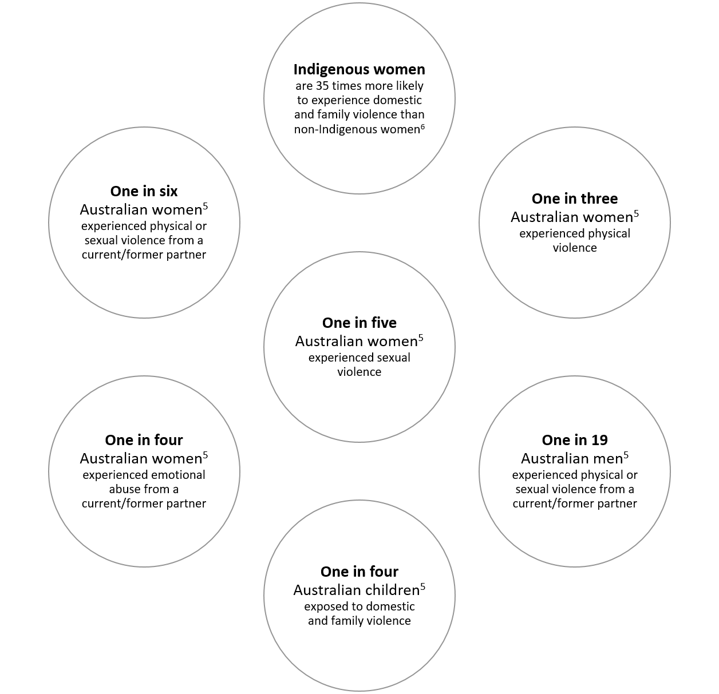

5 [www.anrows.org.au/publications/fast-facts-0/violence-against-women-key-statistics](http://www.anrows.org.au/publications/fast-facts-0/violence-against-women-key-statistics)

6 National Plan to Reduce Violence Against Women and their Children.

**Queensland statistics**

**266 homicides 2006–2016**

**Source:** [www.courts.qld.gov.au/__data/assets/pdf_file/0008/489167/ccq-dfv-qld-domestic-and-family-homicide-stat-overview.pdf](http://www.courts.qld.gov.au/__data/assets/pdf_file/0008/489167/ccq-dfv-qld-domestic-and-family-homicide-stat-overview.pdf)

**87,000 domestic violence incidents each year involving a Police response, or 240 around the state daily**

**Source:** [www.police.qld.gov.au/corporatedocs/reportsPublications/statisticalReview/Documents/2016-17/AnnualStatisticalReview_2016-17.pdf](http://www.police.qld.gov.au/corporatedocs/reportsPublications/statisticalReview/Documents/2016-17/AnnualStatisticalReview_2016-17.pdf)

**29,967 applications for Domestic Violence Orders (2016–17)**

**Source:** [www.police.qld.gov.au/corporatedocs/reportsPublications/statisticalReview/Documents/2016-17/AnnualStatisticalReview_2016-17.pdf](http://www.police.qld.gov.au/corporatedocs/reportsPublications/statisticalReview/Documents/2016-17/AnnualStatisticalReview_2016-17.pdf)

**25,678 breaches of Domestic Violence Orders (2016–17)**

**Source:** [www.police.qld.gov.au/corporatedocs/reportsPublications/statisticalReview/Documents/2016-17/AnnualStatisticalReview_2016-17.pdf](http://www.police.qld.gov.au/corporatedocs/reportsPublications/statisticalReview/Documents/2016-17/AnnualStatisticalReview_2016-17.pdf)

**Breaches—searchable by date and region (live data):**

<https://mypolice.qld.gov.au/queensland-crime-statistics>

**Economic cost**

Domestic and family violence is estimated to cost the Queensland economy between $2.7 and $3.2 billion every year

**Source:** [www.communities.qld.gov.au/resources/gateway/campaigns/end-violence/about/special-taskforce/dfv-report-vol-one.pdf](http://www.communities.qld.gov.au/resources/gateway/campaigns/end-violence/about/special-taskforce/dfv-report-vol-one.pdf)

**You can request further data from:**

* Courts at [www.courts.qld.gov.au/courts-statistics](http://www.courts.qld.gov.au/courts-statistics)
* Police at [www.police.qld.gov.au/online/data](http://www.police.qld.gov.au/online/data)

Police media can be contacted on 3015 2444 or at [policemedia@police.qld.gov.au](mailto:policemedia@police.qld.gov.au)

**Information sources**

|  |  |
| --- | --- |
| **Using a range of sources in an article about domestic and family violence can assist in increasing understanding of the issue.**  Local contacts spanning all areas of interest from the domestic and family violence service sector to legal services can be found in the resource pack at [www.qld.gov.au/dfvreferralpack](http://www.qld.gov.au/dfvreferralpack) | Interested in the Queensland Government’s domestic and family violence reform program?  End Domestic and Family Violence:  [www.qld.gov.au/enddomesticandfamilyviolence](http://www.qld.gov.au/enddomesticandfamilyviolence)  Domestic and Family Violence Death Review and Advisory Board:  [www.courts.qld.gov.au/reviewofdfvdeaths](https://apac01.safelinks.protection.outlook.com/?url=http%3A%2F%2Fwww.courts.qld.gov.au%2Freviewofdfvdeaths&data=01%7C01%7CLesley.Caldwell%40premiers.qld.gov.au%7Cbba5b7cd40fc49ba74d408d517748f10%7C51778d2aa6ab4c7697dc782782d65046%7C0&sdata=1u2Gz2XkMQiu7Z1HtESIAkiBtAOa%2BWkg7yqpY%2Fcq2Hg%3D&reserved=0)  Interested in domestic and family violence research?  Queensland Centre for Domestic and Family Violence Research:  [www.noviolence.org.au](http://www.noviolence.org.au)  Interested in what’s happening in the national arena?  National Plan to Reduce Violence against Women and their Children: [www.plan4womenssafety.dss.gov.au](http://www.plan4womenssafety.dss.gov.au)  Australia’s National Research Organisation for Women’s Safety (ANROWS):  [www.anrows.org.au](http://www.anrows.org.au)  Our Watch:  [www.ourwatch.org.au](http://www.ourwatch.org.au)  Interested in other potential sources of information?  Ending Violence Against Women Queensland—The peak body for sexual violence, women’s health and domestic and family violence services: [www.evawq.org](http://www.evawq.org)  DVConnect: [www.dvconnect.org](http://www.dvconnect.org)  Women’s Legal Service: [www.wlsq.org.au](http://www.wlsq.org.au)  Queensland Law Society: [www.qls.com.au](http://www.qls.com.au)  Legal Aid Queensland: [www.legalaid.qld.gov.au](http://www.legalaid.qld.gov.au)  Australian Psychological Society: [www.psychology.org.au](http://www.psychology.org.au) |

**Tips for supporting survivors and families**

Stories about domestic and family violence help to raise awareness and can provide genuine assistance to those experiencing domestic and family violence. However, people who are, or who have been, affected by domestic and family violence are often vulnerable. Even if a survivor presents as confident and comfortable about speaking to the media, they may not have considered the immediate and longer-term impacts of a news story.

The following questions have been developed in consultation with domestic and family violence service providers. They are intended to raise awareness of issues that may arise and prompt discussions in newsrooms as to what may be most appropriate in the individual circumstances of each story.

**When compiling a story always make the safety and needs of victims/survivors your first priority.**

|  |  |
| --- | --- |
| **Does the interviewee have the emotional and psychological stability required to be interviewed at this time?** | The trauma of domestic and family violence can impair a person’s thinking and decision-making ability. It may be appropriate to delay the interview or wait until a support person is available to assist them. |
| **Are there any additional steps the newsroom can take to support the interviewee?** | For example, it may be helpful for a support worker to follow up with the interviewee after the interview, to check on their wellbeing. |
| **Does the interviewee want to know when the story will be printed, uploaded or broadcast?** | They may want to see the story or they may want to switch off from media during that period. |
| **Is the interviewee aware the story may run on more than one platform, including social media?** | An interviewee may not realise the long-term impact of stories appearing online, for example, being available in the future, appearing in search results and receiving comments on news sites and social media. |
| **Is the interviewee fully aware of what personal details will be disclosed, and what will not?** | Sometimes a survivor may want certain details to be made public, but the law may prevent it. On other occasions, they may not want personal information included in the story. |
| **What identifying information (including visuals) will be included in the story?** | This is a critical consideration, if the interviewee’s safety may be at risk. |
| **Is the interviewee aware there may be further requests for interviews?** | An interviewee may not realise that their story could generate further media attention or that the original story may be reposted online by other media outlets. |

**Looking after yourself**

If you are affected by a story you are writing on domestic and family violence, consider talking with someone you trust or contact a support service.

**For more information call 1800 RESPECT.**

**Useful contacts**

Add your own local contacts or other helpful sources of information here:

**One final word**

**You can help make a difference today, by adding a suitable tagline to every domestic and family violence story.**

**Queensland:**

If you or someone you know is impacted by domestic and family violence, call DVConnect Womensline on 1800 811 811 or Mensline on 1800 600 636. In an emergency, call triple zero (000).

**National:**

If you or someone you know is impacted by domestic and family violence, call 1800 RESPECT on 1800 737 732 or visit [www.1800RESPECT.org.au](http://www.1800RESPECT.org.au). In an emergency, call triple zero (000).