Equity and diversity plan 2025-2028
About this plan  The Department of Youth Justice and Victim Support (DYJVS) was formed in October 2024. The new department brought together the former Department of Youth Justice, with Victim Support functions (including Victim Assist Queensland) and provides support for the Office of Victims’ Commissioner.  We are committed to fostering equity, diversity, and inclusion, creating a workplace where everyone feels safe, valued and included. Our people are treated with fairness and provided with meaningful opportunities to contribute, with a particular focus on supporting diverse groups and promoting greater equity.  The Equity and diversity plan builds on this commitment by providing a clear roadmap for implementing our equity and diversity strategy and addressing the findings of the Equity and diversity audit report. It outlines the priorities, actions, and measures needed to drive meaningful change. Key objectives include improving recruitment and selection processes, increasing the participation of diversity groups, and cultivating a safe, inclusive and equitable workplace culture. This plan is reviewed on an annual basis to remain aligned with evolving priorities. |  |  | Our diversity target  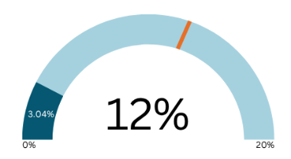  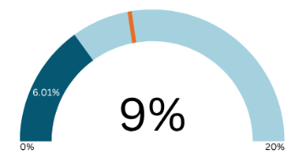  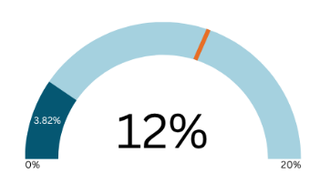  For 2025-2026*  Aboriginal and Torres Strait Islander Peoples  People with disability  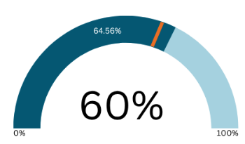  People from culturally and linguistically diverse background  Women in leadership (at levels SO and above or equivalent)

Our focus area
Focus area | Actions | Measures of success
  Recruitment processes | - Promote the department’s employee value proposition to attract a broader pool of quality candidates  - Implement targeted strategies and initiatives to improve representation and employment outcomes  - Review and enhance resources for employees and hiring managers to improve equity and diversity consideration in recruitment process  - Maintain and enhance recruitment processes that are fair, transparent, and equitable across the department | - Increased representation of applicants in diversity groups  - Improved measures on previous years’ result  - Improved Working for Queensland survey results | *Based on MOHRI data as at March 2025. Reportable targets are set for a three-year period, provided to the Public Sector Commission by all agencies  Our guidance  - Public Sector Act 2022  - Recruitment and selection (Directive 07/23) and Recruitment and selection summary guide  - Even better public sector for Queensland strategy 2024-2028  - Queensland women’s strategy 2022-27  - Queensland public sector inclusion and diversity strategy 2021-2025  - Come together, talk together, walk together Reframing the relationship plan 2023-2025  - Disabling the barriers to employment in the Queensland public sector implementation plan 2023  - Queensland public sector LGBTIQ+ action plan 2023-2025  - Queensland multicultural action plan 2024-25 to 2026-27  - DYJ strategic workforce plan 2024-2028  - VS strategic workforce plan 2025-2028  - DYJ interim disability service plan 2023-2025
  Sharing diversity Information | - Include the collection of workforce diversity information into the onboarding process  - Promote accessible ways for employees to share and update their diversity information, while clearly communicating its benefits, usage, and access to ensure transparency and trust  - Foster a supportive workplace culture where employees feel safe and confident sharing their diversity information | - Improved measures on previous years’ result  - Improved Working for Queensland survey results
  Workplace culture | - Foster a diverse, inclusive, and culturally safe workplace where everyone feels valued, respected, and empowered to bring their whole self to work by embedding inclusion into workplace culture and planning processes  - Provide equitable and accessible training, including cultural capability, awareness, and mentorship, while reviewing policies, procedures, and programs to support equity, diversity, and respectful workplaces  - Promote and support equity and diversity focussed networks, champions, and representatives, and celebrate diversity through promotion and participation in significant days and events  - Provide tools and resources to empower our people to recognise and proactively address psycho-social issues, supporting their wellbeing and performance. | - Improved Working for Queensland survey results  - Increased training participation and completion  - Increased reporting of workplace culture matters in short to medium term  - Decrease in reported performance management and/or misconduct matters in medium to long term  - Increased participation in, and experience of, equity and diversity network members

