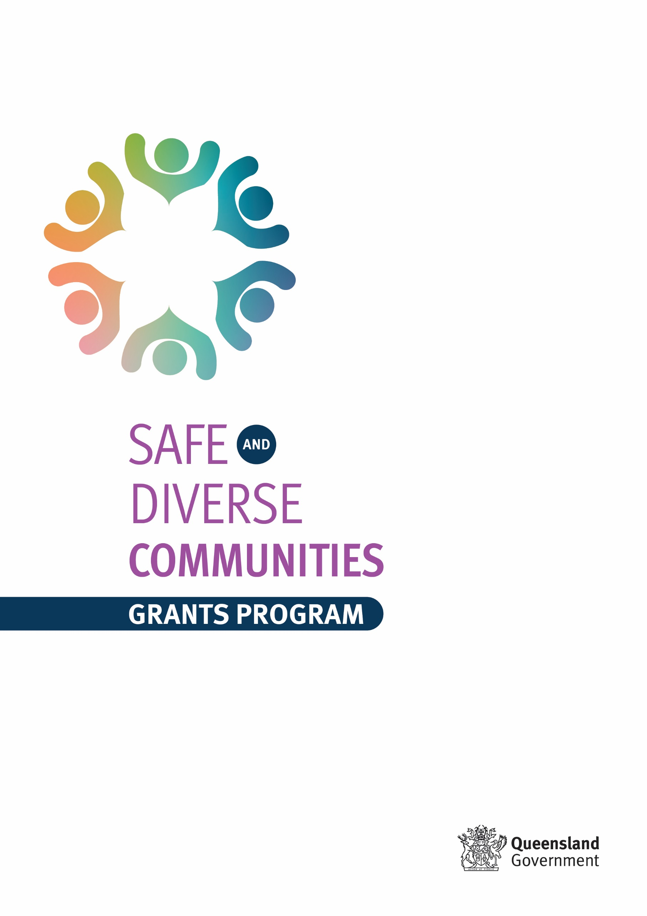

2023-24 Grant information and application guidelines
Table of Contents
Purpose of the grants 2
Objective of grant program 2
Funding available 2
Target group 3
How to apply 3
How to apply: selection process 4
How the selection process will work 4
STEP ONE – SUBMIT YOUR ONLINE APPLICATION FORM 5
STEP TWO – PANEL EVALUATION AND DELEGATE APPROVAL 6
Eligibility Criteria 6
How eligibility will be assessed: 7
What projects will not be funded 7
What you will be required to do if you are successful applicants 7
Important budget information 8
Timeframes 8
Contact details 8

Safe and Diverse Communities grants program: Domestic and family violence prevention in culturally and linguistically diverse communities
The Queensland Government has committed additional funding of $6 million over four years to support the prevention of domestic and family violence in culturally and linguistically diverse communities. $1 million of this funding is committed to facilitating partnerships in culturally and linguistically diverse communities through a grant program. This $1 million will be available over four years, with $250,000 available each year of the grant program.

Purpose of the grants
The purpose of this grant program is to support targeted, community led projects to increase the capability of culturally and linguistically diverse communities to recognise, respond to and prevent domestic and family violence across Queensland. The grants aim to create meaningful partnerships and engagement with people from culturally and linguistically diverse backgrounds to take proactive steps in improving women’s safety and through awareness and prevention initiatives to address domestic and family violence.

Objective of grant program
Funding will be made available to support initiatives addressing the following priority issues:
- awareness raising of domestic and family violence and its impacts, how to recognise it and appropriately refer;
- initiatives that support primary prevention;
- engagement with cultural leaders to support them in developing their understanding of domestic and family violence;
- initiatives that target the prevention of domestic and family violence in culturally and linguistically diverse communities;
- initiatives that reduce domestic and family violence reoffending, including working with perpetrators and/or with victim-survivors;
- initiatives that target awareness raising and prevention of non-physical forms of abuse.

Funding available
$1 million has been committed over 4 years to facilitate partnerships in the prevention of domestic and family violence in culturally and linguistically diverse communities in Queensland. In 2021 and 2022, the total investment committed was $250,000 per round.

The Department of Justice and Attorney-General plans to run an enhanced Safe and Diverse Communities Grant round in 2023-24, with a total funding pool of $850,000 available for this year. With this enhancement, organisations and community groups will be able to apply for grants of up to $25,000 and $150,000 per initiative.

These grants will be dispersed in a tiered approach:

- Small grants up to $25,000 – to support small, targeted local community led projects in culturally and linguistically diverse communities to recognise, respond to and raise awareness of domestic and family violence, and provide better support for victim-survivors of domestic and family violence in culturally and linguistically diverse communities; and

- Larger grants up to $150,000 – to support a small number of larger projects in culturally and linguistically diverse communities which aim to drive cultural change in enhancing response to, prevention, awareness and recognition of, and/or support for those impacted by, domestic and family violence. Funded projects are expected to contribute to sustained community impact beyond the grant's expiration. This must involve the development of training programs / resources / materials tailored to address the priority issue/s under ‘Objective of grant program’. We encourage innovative approaches that foster long-term positive change and empower communities to address and combat domestic and family violence effectively.

Target group
This grant program aims to target culturally and linguistically diverse communities. This includes people from migrant or refugee backgrounds, as well as people who are born in Queensland and who self-identify as being from culturally and linguistically diverse backgrounds. This applies to groups and individuals who differ according to religion, language and ethnicity and whose ancestry is other than Aboriginal or Torres Strait Islander, Anglo Saxon or Anglo Celtic.

How to apply
All applications must be submitted electronically through SmartyGrants at https://justiceqld.smartygrants.com.au/applicant/login. SmartyGrants can be accessed on any web browser.

Please note:
- A separate application must be submitted for each proposed project. Successful organisations will only be awarded one grant.
- Late applications will not be accepted.
- Email or posted applications will not be accepted, they must be completed in SmartyGrants.
- Applications that are incomplete or have not properly been submitted through SmartyGrants, after the closing date, will not be assessed.
- All sections of the form must be completed.
- Ensure you save the form regularly.
- Keep your answers concise by observing the word or time limit for each selection criterion.
- Applicants may attach letters from collaborative partners that state how their organisation supports the work you hope to undertake through this grant.
- Applicants may quote or summarise other documents within the response to a selection criterion. Please do not attach the whole document.
- Note this funding application form is for one event/project/activity only. A separate application form must be completed for each event/project/activity for which funding is sought. Organisations will only be awarded one grant.
- Successful applicants may be offered full or partial grant funding.
- Press submit upon completion, and ensure you receive an acknowledgement email.
- Applications involving more than one organisation should be made jointly. For joint applications between more than one organisation, a lead must be identified.

How to apply: selection process
This grant program will be administered through a two-step selection process.

How the selection process will work

STEP ONE – SUBMIT YOUR ONLINE APPLICATION FORM
The initial step will involve your organisation completing an online application form on SmartyGrants. This online application form will ask you to answer Selection Criteria as outlined below for each grant amount.
Tier 1 – Small grants of up to $25,000
Selection Criteria
- Describe your initiative and how it addresses the priority issue/s under ‘Objective of grant program’
- Tell us about what community group you are targeting (and why), and what existing connections, partnerships, networks and/or alliances you have within the targeted community that you will be utilising for this project
- Present a plan for the project including details of proposed methods of promotion for the project
- Present a budget that is complete, realistic, provides value for money and clearly outlines how the grant funding will be spent
- Demonstrate capacity and experience to manage and deliver the event or activity (including planning, implementation, and evaluation of its success)

Tier 2 – Large grants of up to $150,000
Selection Criteria
- Describe your initiative and how it addresses the priority issue/s under ‘Objective of grant program’
- Tell us about how the planned project will contribute to sustained community impact beyond the grant’s expiration. The project must involve the development of training programs / resources / materials tailored to address the priority issue/s under ‘Objective of grant program’
- Tell us about what community group you are targeting (and why), and what existing connections, partnerships, networks and/or alliances you have within the targeted community that you will be utilising for this project
- Present a plan for the project including details of proposed methods of promotion for the project
- Present a budget that is complete, realistic, provides value for money and clearly outlines how the grant funding will be spent
- Demonstrate capacity and experience to manage and deliver the event or activity (including planning, implementation, and evaluation of its success)
Once you have completed this application by the due date 5pm Friday, 15 March 2024, all applications will be assessed against the Eligibility Criteria (see below).
Once the Eligibility Criteria assessment is completed, a list of eligible applications will be progressed to the panel evaluation stage.

STEP TWO – PANEL EVALUATION AND DELEGATE APPROVAL
- The panel will individually score each response to the Selection Criteria (see above) for eligible applications.
- The panel will then meet for a final panel evaluation. Applicants may be invited to meet with the panel – face to face or via another means preferred by the applicant – should any clarifications be required in relation to the information provided by offerors in their submissions.
- Recommended applications will be forwarded to the departmental delegate for approval to form contracts.
- All applicants will be notified of the outcome of the panel evaluation.

Eligibility Criteria
Applicants must:
- Be a not for profit legal entity, or
- Be a local government entity, or
- Have an auspice agreement with any of the above entities.

Additionally, applicants must:
- Have current Public Liability Insurance of a minimum $10 million; AND
- Have no outstanding financial accountability, service delivery or other performance issues by any Queensland Government agency that would impact on the delivery of your grant activity/initiative; AND
- Be established and currently operational in Queensland

Initiatives must:
- Be completed by 31 January 2025;
- Be delivered in Queensland; AND
- Support the purpose of this grant program

How eligibility will be assessed:
You will be required to complete an application form through SmartyGrants. In SmartyGrants, you will need to:
- Provide an Australian Business Number (ABN);
- Confirm that you are a not-for-profit agency, and provide a copy of your government issued certification of incorporation or other incorporation documentation (e.g. a constitutions), to demonstrate that you are a not for profit organisation;
- Confirm that you have or that you will obtain Public Liability Insurance ensuring your public liability insurance must be for a minimum of $10 million;
- Confirm that you have no outstanding financial accountability, service delivery or other performance issues that would impact on the delivery of your grant activity/initiative; AND
- Confirm that you are established in Queensland. Your head office can be in another state but you are required to have an established office or facility in Queensland.

The Department of Justice and Attorney-General may contact you during the assessment process to request:
- A copy of your most recent Audited Financial Statement,
- Further details to be submitted, or
- Clarification of the information provided.

What projects will not be funded
The following will not receive funding through these grants:
- Projects where the applicant does not meet the eligibility criteria.
- Projects that do not meet the grant purpose.
- Projects involving travel outside Queensland or involving overseas people visiting Queensland.
- Projects that are political in nature or are held for political purposes.
- Commercial or fundraising activities.
- Projects where more than 20 per cent of funds are allocated to administrative costs.
- Projects where more than 10 per cent of funds are allocated to purchase of assets.
- Projects where grant funds are allocated to acquittal, auditing or reporting costs or existing debt.
- Loan repayments, purchase of gifts or prizes, or fees associated with an auspice agreement.

What you will be required to do if you are a successful applicant
If your application for this grant program is successful, we will require you to:
- Enter into a service agreement/contract with the Department of Justice and Attorney-General before receiving the grant funding.
- Provide a certificate of currency for insurance prior to funds being released. At a minimum, applicants must hold public liability insurance to the value of at least $10 million.
- Acknowledge the Queensland Government as a supporter on any printed or promotional material relating to the project or activity, including websites.
- Following the delivery of the funded project, complete an activity report outlining the project and outcomes achieved, AND
- comply with the Community Services Act 2007.

Please also refer to the fact sheet What is expected of an organisation if they are successful in this grant program available on the Department of Justice and Attorney-General’s initiatives page on Safe and Diverse Communities grant program.

Successful suppliers may be required to work with an external contractor engaged by the department, to assist in the development of an ongoing monitoring and evaluation framework to guide future investment.

Important budget information
When developing the budget for your initiative consider the following:
- the minimum one-off grant amount available is $10,000 and the maximum one-off grant amount available is $150,000.
- there are conditions on the maximum allocation of funds to particular items, such as administrative salaries or purchase of assets (see What Projects Will Not Be Funded).
- successful applications may not receive the requested level of funding. Funding allocations will be based on merit, how strongly each application addresses the funding objectives and criteria, the applicant organisation’s capacity to plan and deliver the proposed event, geographic and demographic spread of available funds, contributions committed by an applicant organisation and/or level of funding obtained from other sources, as well as justification of budget items.

Timeframes
Date | Action / Notes
2 February 2024 | Applications open
15 March 2024 | Applications close 5pm – late applications will not be accepted.  Any queries to be submitted to DJAG by 13 March 2024
By 3 April 2024 | Eligibility review, initial online assessment
By 26 April 2024 | Final panel assessment, briefing/approval process
By 3 May 2024 | Announcement of grant outcomes
Mid-late May 2024 | Initiatives have started
February 2025 | All initiatives have been delivered, reporting due in SmartyGrants

Contact details
All enquiries regarding the Safe and Diverse Communities Grants Program 2023 should be directed to the Sector Investment, Women’s Safety and Violence Prevention team between 9am to 5pm, Monday to Friday (excluding public holidays). Enquiries regarding applications are to be made no later than 5pm Wednesday 13 March 2024 so that we can respond to your question before the grant round closes.
Phone: 1800 177 577 or Email: SafeandDiverseGrantPrg@justice.qld.gov.au.
Translation services may be available for this grant program. If you require translation services, please contact 1800 177 577.
Contact officers cannot provide advice on individual applications.

Definitions of key terms
Administrative costs: relates to the administration of your business/organisation. Examples of administration costs would be someone employed to answer the phones, completing business as usual requests such as reporting or data collection. Within your grant application you are only allowed to allocate 20% of your budget towards administrative costs.
Auspice: to ‘auspice’ means to provide support, sponsorship or guidance.
Auspicee: the group (usually a smaller group or organisation) requiring support.
Auspicor/auspice organisation: An auspicor or auspice organisation will make funds available to a smaller organisation or community groups to meet the grant program's financial and legal requirements. This will include taking responsibility to:
- sign your contract with the Department of Justice and Attorney-General
- take legal and financial responsibility of the grant on your organisation’s behalf
- receive and distribute grant funds under the grant agreement
- ensure all grant activities or events are completed
Auspice agreement: An auspice agreement provides an outline of the services and support the auspice organisation will contribute to the activity. This is usually when a larger organisation partners with a smaller organisation to fund a grant activity or event. The larger organisation is known as the auspice organisation.
Certificate of incorporation: is a legal document relating to the company, business, or organisation’s format. This is usually a state government issued certificate to the organisation. The information in the certificate can include the type of entity you are e.g., not-for-profit, confirm the name of your organisation, legal address etc.
Culturally and linguistically diverse: term ‘culturally diverse’ to refer to people with a non-Anglo cultural background. This definition refers to all individuals with non-Anglo-Celtic cultural background, where Anglo-Celtic refers to cultural backgrounds that are English, Scottish, Welsh and Irish. This applies to groups and individuals who differ according to religion, language and ethnicity and whose ancestry is other than Aboriginal or Torres Strait Islander, Anglo Saxon or Anglo Celtic.
Local government: is a council that assists in the administration of a particular county or district, with representative elected by those who live there.
Not for profit: a not-for-profit is an organisation that does not operate for profit, personal gain or other benefit of particular people.
Primary prevention: primary prevention within the prevention of domestic and family violence seeks to reduce the overall likelihood that someone will experience violence or use violence by ensuring that the violence is less likely to occur such as education and awareness programs.
Public liability insurance: public liability insurance protects your organisation or community group financially if someone attending your grant activity or event is injured.
Purchase of assets: Assets include physical or non-physical items with a useful life of more than 12 months, and where the value can reasonably be expected to decline over time. Assets may include computers, cameras, audio visual equipment, electric tools, furniture and motor vehicles. This grant program focuses on community engagement therefore applicants can only allocate 10% of the budget towards the purchase of assets.

