Domestic and family violence services
Regulatory Framework

July 2021

Contents

Introduction 3
Purpose 4
Objectives of the Regulatory Framework 4
Background 4
DFV Practice Standards, Principles and Guidance 4
Summary of Practice Principles and Standards 5
Policy and legislative context 5
Relevant theoretical frameworks 6
Approach 7
Service delivery context 8
Compliance and service requirements 8
Criteria and suggested evidence 8
Compliance and non-conformance 9
Relevant links 9
Glossary 10

Introduction
Domestic and family violence (DFV) is a significant problem impacting many women, children, families, and communities across Australia.
People who work in the DFV sector are critical to delivering quality services to victims experiencing violence (including children) and perpetrators. Supporting workers to develop their skills, knowledge and capabilities is an important element of service quality and improvement.
The Queensland Government funds more than 100 specialist DFV services. These funded services are expected to meet a minimum standard of service delivery as set out by the Practice principles and standards and guidance (Practice Standards).
This document sets out the mechanism of the Regulatory Framework and how it monitors the compliance of DFV funded services with the Practice Standards. Queensland Government funded DFV services are contractually required to comply with the Practice Standards from 1 January 2021 and the Regulatory Framework by 1 January 2022.
The DFV specific criteria and evidence within the Regulatory Framework were developed and reviewed with the specific input of technical experts in auditing human services organisations, certification bodies, peak bodies and key stakeholders within the DFV sector to ensure that it is fit for purpose.

Purpose
The Regulatory Framework provides a mechanism to ensure a high standard of service delivery across DFV services that demonstrates compliance with the Practice Standards. The Regulatory Framework is operationalised through the Human Services Quality Framework (HSQF), the Queensland Government’s monitoring and compliance framework in place for all funded human services organisations, including DFV specialist services.
This DFV practice-specific component within the HSQF aims to promote practice consistency and continuous improvement across the sector to improve victim safety, perpetrator accountability and service integration across Queensland. Improving service consistency sets a baseline for service delivery and works towards the goal that all victims and perpetrators are provided with the same quality of service, no matter where they are in Queensland. The Regulatory Framework achieves this by highlighting good practice and using the audit process to identify areas for improvement, as well as to provide early warning of any potential issues.

Objectives of the Regulatory Framework
The key objectives of the Regulatory Framework are:
- providing an effective system for monitoring compliance with the Practice Standards, while minimising administrative burden on the sector
- promoting practice consistency across the sector
- encouraging continuous improvement in service delivery, particularly regarding victim safety, perpetrator accountability and service integration across the sector
- ensuring accessibility of DFV services for the full range of clients, in recognition of the diversity of the Queensland community
  - promoting greater accountability, transparency and integration of services based on client needs.

Background

DFV Practice Standards, Principles and Guidance
The Practice Standards were developed to ensure clients receive the same quality of service regardless of where they live in the state. The Practice Standards emphasise that the safety of the persons experiencing violence, identified as the victim, is paramount, and perpetrators must be held to account for their actions. All services, regardless of whether they work with victims or perpetrators, have a role to play in achieving these objectives. The Practice Standards seek to support the work of funded services by ensuring that they have the flexibility and autonomy to innovate and use their expertise to deliver services.
The Practice Standards draw on practices and procedures that have been developed over decades by specialist DFV services, women’s services, and other agencies involved in working with people who use and experience violence. The Practice Standards are aligned with broader strategies aimed at reducing DFV and complement, rather than supersede, other standards and frameworks, including the National Outcome Standards for Perpetrator Interventions and the HSQF.

Overview of the Structure of the Practice Standards
•
Principles
The seven principles clearly outline what all clients—victims and perpetrators—should be able to expect from DFV services in Queensland, in terms of services delivered and outcomes achieved
•
Standards
The standards outline a consistent approach to responding to DFV for all service sectors
- These are the elements that must be in place in order to give effect to the principles
Guidance
•
•
The guidance translates the standards into practice
It highlights activities and examples of practice that allow staff to meet each standard and bring the standards to life in their daily practice
- The practice guidance is not exhaustive and further examples of the practice expected of workers may be identified across the sector

Summary of Practice Principles and Standards
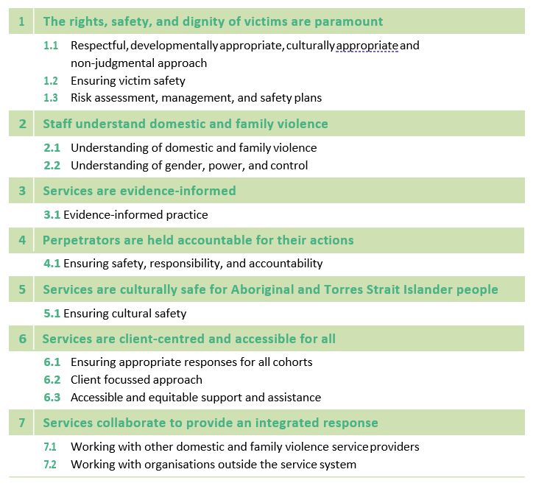

Policy and legislative context
There are a number of policies, strategies and bodies of legislation in place at both the national and state level that are relevant to, and have directly informed the Practice Standards, and subsequently the Regulatory Framework.
These include:
- Queensland’s Domestic and Family Violence Prevention Strategy 2016-2026
- Human Services Quality Framework
- Domestic and Family Violence Protection Act 2012
- Child Protection Act 1999 and Child Protection Reform Amendment Act 2017
- Human Rights Act 2019 – notably in relation to section 28 related to the Cultural Rights of Aboriginal and Torres Strait Islander Peoples.

Relevant theoretical frameworks
The Practice Standards are informed by a range of theoretical frameworks that underpin good practice in responding to the needs of both victims and perpetrators of violence. Victim safety is at the core of DFV practice and service delivery, which is embodied through embedding a gendered lens of DFV and cultural safety principles in governance, policy, and practice
Gendered understanding of DFV
A gendered understanding considers DFV to be both a manifestation and driver of unequal power relations between men and women and sees reducing gender inequality as central to addressing violence against women and children. It also acknowledges the concept of intersectionality, meaning that victims experience and understand violence in different ways based on intersecting experiences with other forms of disadvantage, for instance related to race, class, level of ability and sexuality.3
Cultural safety
Principle 5 of the Practice Standards relates specifically to ensuring that services are culturally safe for Aboriginal and Torres Strait Islander people. Ensuring that culturally safe practice, beliefs and understanding is embedded in all levels of an organisation from governance through to policy and demonstrated in practice is crucial. Cultural safety includes having a deep and nuanced understanding of the harms of colonisation and its connection to intergenerational trauma experienced by Aboriginal and Torres Strait Islander Peoples. Culturally safe practice requires services to work respectfully with First Nations Peoples and take responsibility for delivering services that respect and uphold local protocols, kinship relationships, and connection to community, country and culture.
Additional theoretical frameworks
Common to all of these theoretical frameworks is the importance of a trauma-informed response for victims, which is critical for appropriately responding to the unique and often complex nature of trauma as a result of coercion and controlling tactics. The following are other identified frameworks that relate to DFV service delivery:
  - a social justice framework that aims to improve the safety, wellbeing and social justice outcomes for victims (both adults and children)
  - a human rights-based framework that aims to empower victims to know and claim their rights as well as increasing the accountability of perpetrators who violate those rights
  - a psychosocial perspective that considers the influence that psychological factors such as mental health conditions and drug and alcohol abuse as well as a person’s social circumstances have on their wellbeing and actions
  - an understanding of systems theory that considers the intersection of the influences of multiple interrelated systems on behaviour.

Approach

The Practice Standards and Regulatory Framework set out a consistent approach for responding to DFV throughout the service system, ensuring the focus of intervention and support remains on the safety of the victims and the accountability of perpetrators. They also ensure all professionals involved in identifying and responding to DFV are approaching their victims’ safety and needs consistently, regardless of their background or an organisation’s culture.
The approach includes the Practice Standards at the core, centred on victim safety, perpetrator accountability and culturally safe and inclusive practice. Implementation and monitoring of these standards occurs through a range of mechanisms, including funding agreements, contract management and the Regulatory Framework. This is supported through services’ governance, core values and structure, and by partnering with the community to deliver high quality services that are connected, safe and inclusive.
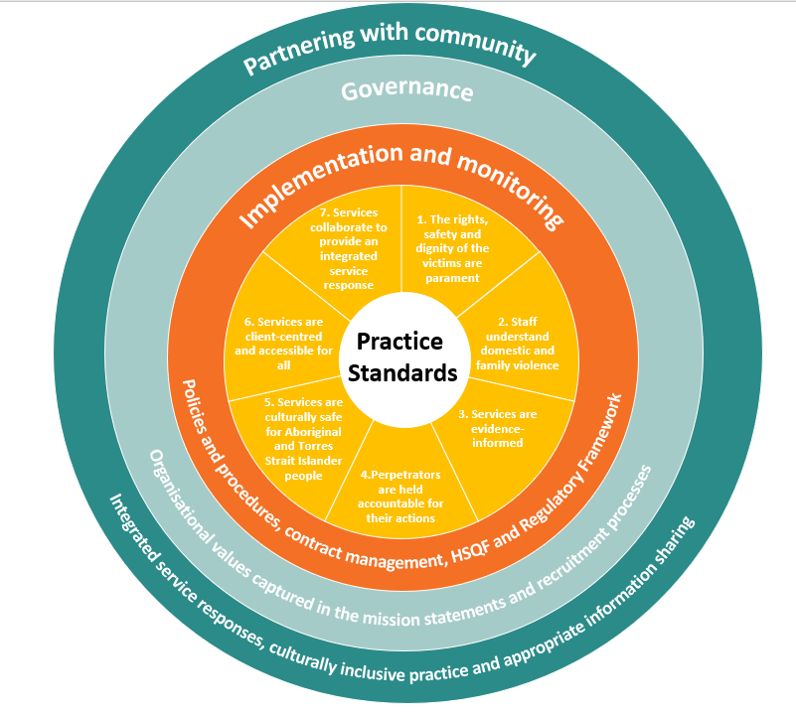

Inspiration drawn from the NSQHS Standards User guide for Aboriginal and Torres Strait Islander Health

Service delivery context
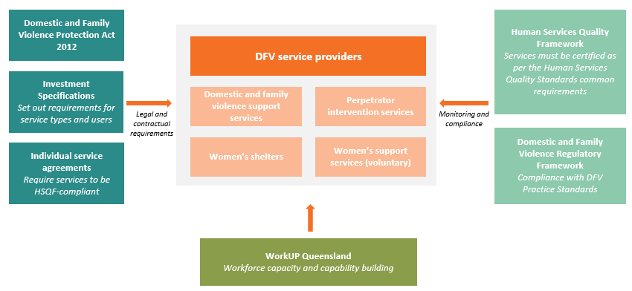
The Queensland Government funds a range of service providers to deliver services under the umbrella of DFV service delivery. This broad range of service types provided to victims and perpetrators includes perpetrator interventions, women’s shelters and crisis accommodation, centre and court-based support, DFV counselling, Aboriginal and Torres Strait Islander specific services and local DFV service systems. The scope of funded service types is outlined in the departmental Domestic and Family Violence Support Services Investment Specification. All funded services are overseen through contract management as well as regular auditing of service delivery through the HSQF.

Compliance and service requirements
The Regulatory Framework is operationalised through the Human Services Quality Framework (HSQF). There are no additional audit processes created by the Practices Standards or Regulatory Framework.

Criteria and suggested evidence
As part of the Regulatory Framework, DFV-specific criteria, designed to measure implementation of the Practice Standards, has been embedded in the HSQF user guide. The user guide sets out what services must demonstrate, and what evidence they could provide, to support an auditor to assess their DFV service delivery. The criteria and evidence are identifiable by the DFV icon within the HSQF user guide.
DFV services seeking and/or maintaining HSQF certification must demonstrate all common requirements for all indicators as outlined in the HSQF user guide, as well as the DFV specific requirements, in order to meet the Human Services Quality Standards. In the HSQF user guide, these requirements are identifiable by the following icons:
HSQF Common requirements | +  Domestic and Family Violence

The criteria and suggested evidence are not intended to be restrictive or prescriptive, rather, they seek to identify the ‘what’ of good practice, rather than ‘how’ services should be delivered. The criteria identify the elements within the Practice Standards that are associated with best practice. The suggested evidence within the Regulatory Framework has been developed to assist practitioners, services and auditors to identify what best practice may look like in DFV service delivery. It is important to note that the evidence is not a ‘check list’ of what services should be delivering or have in place, but a series of examples of what may help demonstrate that services are meeting the criteria.

Compliance and non-conformance
After the compliance date of 1 January 2022, all funded services will be assessed against the new DFV-specific criteria in their next scheduled (and future) HSQF audits. The outcomes of a HSQF audit are provided in an audit report, which provides an assessment of whether an organisation has the systems and practices in place to ensure effective implementation of the Human Services Quality Standards. The outcomes of an HSQF audit are detailed in the HSQF framework and can include the following:
- Conformity
- Observation
- Nonconformity (NC)
- Major Nonconformity (MNC)
- Notifiable Issue.

Where non-conformities or notifiable issues are raised, these will be documented in the audit report and an associated corrective action plan. The certification body and organisation will work together to develop an action plan to address the requirements and for the corrective actions to be reviewed within required timeframes. Services are able to dispute an audit outcome through the existing HSQF process outlined in the HSQF Framework Document.
Auditors have a significant role to play in the ongoing function of the Regulatory Framework. Auditors are required to either undertake DFV specific training or engage a technical expert to support their assessment of DFV practice. This is to ensure that certifying bodies and auditors have the specific skills and training to meaningfully and appropriately assess DFV practice as part of HSQF audits.

Relevant links
- Not Now, Not Ever: Putting an End to Domestic and Family Violence in Queensland
- Queensland Domestic and family violence prevention strategy 2016-26
- Domestic and Family Violence Practice principles, standards and guidance
- Human Services Quality Framework
  - Scheme Rules Part 1
  - Scheme Rules Part 2
  - Human Services Quality Framework user guide
  - HSQF Framework Document
  - HSQF Audits and Notifiable Issues Factsheet

Glossary

Please note that a full glossary is included in the HSQF Regulatory Framework supplement document
Term Definition
Conformity The requirements of a standard, or element associated with a standard such as an indicator, are met. Human Services Scheme Part 1, 3 – Definitions page 6-7
Continuous improvement A continuous improvement framework supports the participation of people who use services in quality improvement.
Cultural Safety Cultural Safety is multifaceted and imbedded and driven by governance and management structures so that it informs the physical environment and ensures appropriate service delivery. Cultural Safety is determined by Aboriginal and Torres Strait Islander people and connects to creating environments where Aboriginal and Torres Strait Islander Peoples feel safe, there’s no challenge to their identity and their needs can be met. It underpins the physical environment, language, social structures, symbolic actions, sharing power, and developing knowledge, understanding and learning. Cultural Safety is the responsibility of all individuals, services and organisations cultivated by an understanding and acknowledgement of past injustices and working towards a process of respect and recognition of cultural differences, by acknowledging that Aboriginal and Torres Strait Islander Peoples are the First Nations Peoples.
Domestic and family violence As defined by the Domestic and Family Violence Protection Act 2012, domestic violence means behaviour by a person towards another person in a relevant relationship that: (a) is physically or sexually abusive; or (b) is emotionally or psychologically abusive; or (c) is economically abusive; or
(d) is threatening; or (e) is coercive; or (f) in any other way controls or dominates and causes fear.
HSQF The Human Services Quality Framework (HSQF) is a system for assessing and improving the quality of human services. The HSQF is designed to increase administrative efficiency and enable service providers to focus their resources on service provision and continued quality improvement.
Intersectionality Intersectionality is an analytical framework for understanding how aspects of a person's social and political identities combine to create different modes of discrimination and privilege. Examples of these aspects are gender, caste, sex, race, class, sexuality, religion, disability, physical appearance, and height.
Intervention The response provided by services.
LGBTIQ+ Throughout the practice standards, the terms sexual orientation, gender diversity, gender identity, and LGBTIQ+ are used interchangeably to refer to the wide range of diverse sexual orientations, gender identities, and intersex variations that exist among the Queensland community. The acronym LGBTIQ+ stands for lesbian, gay, bisexual, transgender, intersex and queer/ questioning, and the + represents other identities not captured in the letters of the acronym.
Major nonconformity The requirements of a standard, or an element associated with a standard such as an indicator, are not met, or the outcome is ineffective. Human Services Quality Framework Scheme Part 1, 3 – Definitions page 6-7. In addition, a major nonconformity will be raised where the following occurs (and this is sometimes referred to as a technical major nonconformity): Human Services Scheme Part 2 – P2_7.4.11
- Three or more nonconforming indicators in the same standard, or
- Three or more nonconforming standards overall.
Nonconformity The requirements of a standard, or element associated with a standard such as an indicator, are not fully met, or the outcome is only partly effective – organisations have 12 months from written notification to close out an NC Human Services Scheme Part 1, 3 – Definitions page 6-7
Notifiable issue In addition during an audit, if an auditor becomes aware of a serious concern (for example evidence or allegations that an organisation is failing to meet key legislative safeguards: significant harm to a person accessing a service including abuse, safety or wellbeing; financial impropriety including potential insolvency and/or professional misconduct), they are required to refer the matter as a Notifiable Issue to the HSQF team (for investigation by the relevant funding department). Further information is available in the HSQF Audits and Notifiable Issues factsheet on the HSQF website
Observation Opportunities for continuous improvement or guidance for the organisation on areas for potential system deficiencies that may need to be reviewed to prevent problems occurring in the future. Observations should be considered by the organisation although action on observations is not mandatory. Observations may also be positive findings (noteworthy features) that are included and reported by the auditor. Human Services Scheme Part 1, P1_7.4.16, page 14.
Perpetrator Person who uses domestic and family violence. The term is used as it is consistent with the principle of placing responsibility for violence with those who use violence. While domestic and family violence is primarily perpetrated by men against women, we acknowledge that perpetrators can be any gender. This is an overarching term used within the sector, however, may not always be culturally appropriate. Communities may identify alternative terms when speaking with or about the person who is using violence.
Practice standards Practice standards outline what is required for effective, professional and accountable practice, generally for a specific profession (such as social workers and psychiatrists) or for a specific workforce (such as mental health workers and child protection caseworkers).
Service The program, intervention, or activity provided by an organisation.
Victim A person who has experienced domestic and family violence. This term is inclusive of all ages, including children, young people, and older people. While DFV is primarily perpetrated by men against women, we recognise that victims can be any gender.
We recognise that not every person who has experienced or is experiencing domestic and family violence identifies with this term. Domestic and family violence is only one part of a victim’s life and it does not define who they are.

- Weaver, L. (2008). Facilitating Change in Men Who Are Violent towards Women: Considering the ethics and efficacy of a person-centered approach, Person Centered and Experiential Psychotherapies, 7: 3, 173-184.
- Child Protection Act 1999 (Qld) s.187.
- Cattaneo, L. B., & Goodman, L. A. (2015). What is empowerment anyway? A model for domestic violence practice, research, and evaluation. Psychology of Violence, 5(1), 84.
- The State of Queensland (Department of Child Safety, Youth and Women), Domestic and Family Violence Information Sharing Guidelines, 2017, p.10. This definition does not provide an exhaustive list of the prescribed entities in Queensland. A more comprehensive list of prescribed entities is provided in the Domestic and family violence information sharing guidelines. Note that the definition of prescribed entities is different under the Child Protection and Domestic and Family Violence legislation. For example, specialist providers are included as a prescribed entity under the Child Protection Act 1999 under the Domestic and Family Violence Protection Act 2012, prescribed entities do not include ‘specialist service providers’.

