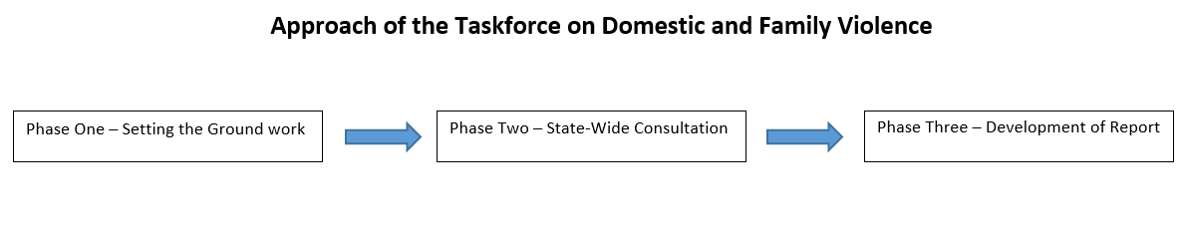

**Phase One – Setting the groundwork**

This included surveys, the Chair’s preliminary community tour and the launch of final Terms of Reference, Taskforce membership and a speaker event.

|  |  |
| --- | --- |
| Chair’s Community Consultations  (August, September 2014) | The Chair visited Beenleigh, Cairns, Torres Strait, Doomadgee, Aurukun and Mount Isa and spoke with police, communities, justice/courts, health, education, service providers, advocates, community leaders, special interest groups and those affected by domestic and family violence to build a context for the work of the Taskforce and inform the Terms of Reference. |
| Community Attitudes Survey  (Online from  10 August - 3 September 2014) | Designed to canvass community awareness and attitudes to domestic and family violence. 897 responses were received. A summary of findings is at Appendix 3. |
| Survey on draft terms of reference  (Online from 10 August to  3 September 2014) | Designed to seek feedback on draft Terms of Reference. 64 responses were received. Assisted in development of final Terms of Reference. |
| Launch  (10 September 2014) | The Taskforce formally launched on  10 September 2014. Membership of the Taskforce and Terms of Reference announced.  Included an event for 50 guests. Facilitated by Professor Carol Dickenson, Senior Deputy Vice-Chancellor of Queensland University of Technology with speeches from:   * Ms Diane Mangan, DV Connect * Ms Sonia Anderson, Advocate * Ms Wendy Reid, CEO Challenge * Professor Heather Douglas, University of Queensland * Mr Ian Stewart, Police Commissioner |

**Phase Two – State-wide consultation**

The Taskforce has focused on Queenslanders views on how to eliminate domestic and family violence. Many courageous people have shared their stories and we have challenged the broader community to raise innovative, fresh ideas.

During the past five and a half months the review has been assisted by:

* 961 completed surveys
* 185 written submissions
* 367 groups from across the state engaging with Taskforce members
* 457 people attending events hosted by the Taskforce
* 164 people participating in focus groups.

Thousands of Queenslanders have participated actively throughout the review. Contributions showcase Queensland’s diversity, with input coming from a wide range of groups and locations.

|  |  |
| --- | --- |
| Share your story  (Between 15 September and  20 October 2014) | The taskforce published ‘Our Journal’, a compilation of personal stories, ideas and experiences about domestic and family violence. 53 contributions were received from members of the public. |
| Formal submissions  (Between 15 September and  1 December 2014) | Designed to seek expert input on matters covered by the Terms of Reference. 132 formal submissions were received. A summary can be found in Chapter 3. |
| General input | An email and postal address were promoted to receive general enquiries, feedback and requests for the Taskforce. 217 enquiries were received. |
| Summits | Two summits were held in Brisbane and Townsville on 27 October 2014 and 5 November 2014 to generate robust discussion on three themes: attitudes and culture, integrated responses and justice responses. A summary is included in Chapter 3. |
| Individual/Group Meetings | A targeted series of smaller consultation meetings were scheduled to engage with individuals and groups on a more personal basis. |
| White Ribbon Day breakfast  (25 November 2014) | The Taskforce hosted a White Ribbon Day breakfast for 200 to highlight the key role of men in preventing violence against women facilitated by Ms Kay McGrath with speakers:   * Mr Ben Ikin – White Ribbon Day Ambassador, and former rugby league player * Mr Leigh Matthews - White Ribbon Day Ambassador, former Australian Football League player and coach * Mr Joe Rea – General Manager Boyne Smelters Limited * Mr George Theo – CEO Unitywater |
| Focus Groups  (December 2014 and January 2015) | Were conducted by an independent research agency to seek the views of socio-demographic groups in the community who would not usually engage in the issue to provide qualitative input on community attitudes on domestic and family violence. A summary is included in Chapter 3 and the report is at Attachment 4. |
| Queensland Government | Sought information from state government agencies through Director-Generals in relation to each relevant agency’s response to domestic and family violence. 19 responses were received. |
| Roundtables  (January, February 2015) | Convened with representatives of:   * Indian community * Muslim community * African community * Indigenous community * Those with disabilities |

**Phase Three – Development of final report**

This took an incremental approach and included the following activities:

* *Our Journal* – A collection of personal thoughts about domestic violence identified key issues in service delivery, cross jurisdictional issues and creative solutions
* Analysis of formal submissions providing an evidence base for recommendations
* Consultation with experts e.g. Crown Law for advice on the intersection of the Magistrates and Family Court processes.