**Safer Bruce 2030 Action Plan**

Overseen by the Bruce Highway Trust Advisory Council

**Copyright information**

© State of Queensland (Department of Transport and Main Roads) 2024

The Queensland Government is committed to providing accessible services to Queenslanders of all cultural and linguistic backgrounds. If you have difficulty understanding this publication and need a translator, please call the Translating and Interpreting Service (TIS National) on 13 14 50 and ask them to telephone the Queensland Department of Transport and Main Roads on 13 74 68.

**Disclaimer**

While every care has been taken in preparing this publication, the State of Queensland accepts no responsibility for decisions or actions taken as a result of any data, information, statement or advice, expressed or implied, contained within. To the best of our knowledge, the content was correct at the time of publishing.

Artwork: ‘Travelling’ by Gilimbaa.

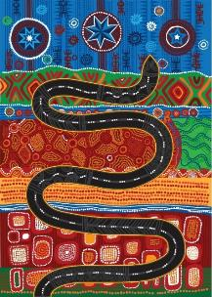

The Department of Transport and Main Roads (TMR) respectfully acknowledges the Traditional Owners and Custodians of the land and waterways. We pay respect to their Elders past, present and emerging. TMR recognises those whose ongoing effort to protect and promote Aboriginal and Torres Strait Islander cultures will leave a lasting legacy for future First Nations people.

Cover image: Caloundra Road to Sunshine Motorway, upgraded highway and new western service road looking north at the Mooloolah River (September 2021).

Contents

Foreword 2

About the Bruce Highway Trust Advisory Council 6

Snapshot of the Bruce Highway 7

The Bruce Highway 8

Purpose 10

Link to road safety strategies 10

The journey so far 13

Developing the plan 14

Safer Bruce 2030 Action Plan 17

Safe roads and roadsides 19

Safe speeds 21

Safe vehicles 22

Safe road users 25

Beyond 2030 27

# Foreword

## Mr Peter Garske

The Queensland Government established the Bruce Highway Trust Advisory Council (BHTAC) as part of the *Future-Proofing the Bruce Policy 2017*. Within this policy, the government tasked the BHTAC with aligning investment decision-making to three key objectives: **to unlock economic growth, build flood resilience and improve safety**.

Under the *A Real Bruce Plan 2020* policy, BHTAC members were also tasked to oversee development of a *Safer Bruce 2030 Action Plan* to help achieve the Queensland Government’s ambitious target of reducing the rate of fatalities along the Bruce Highway by 60 per cent by 2030. In order to deliver on these objectives and this target, the BHTAC is pleased to present this *Safer Bruce 2030 Action Plan* for government consideration.

All 16 BHTAC members—experts from the heavy vehicle, motoring, tourism, local government and agricultural industries and regional representatives who reside along the Bruce Highway, north of Gympie—are passionate about road safety and have worked hard to ensure the *Safer Bruce 2030 Action Plan* addresses the issues and concerns of road users. Comprehensive customer research was conducted to understand how motorists used the Bruce Highway, what is working well and to identify those sections along the highway that should be prioritised for safety improvements.

The findings from the customer research were considered alongside technical analysis, leveraging the knowledge of TMR safety subject matter experts. Using all of this data and information, BHTAC members have received advice on the effectiveness and benefits of appropriate safety treatments during the development of this *Safer Bruce 2030 Action Plan*.

Some of the life-saving investments outlined in this Bruce Highway *Safer Bruce 2030 Action Plan* include:

* completing Wide Centre Line Treatment (WCLT) and Audio Tactile Line Marking (ATLM)
* widening narrow bridges
* developing a fatigue management strategy to look at upgrading and building new rest areas for heavy vehicle drivers and other road users to better manage fatigue
* adding more overtaking lanes
* upgrading intersections
* completing ring roads around major centres to separate local traffic from through traffic
* embracing new technologies both on the road and within vehicles to save lives and prevent serious injury.

The BHTAC acknowledges that road safety is everybody’s responsibility and encourages all road users to remember the fatal five – speeding, drink and drug driving, fatigue, seatbelt use and distraction – when driving along the Bruce Highway.

This *Safer Bruce 2030 Action Plan* should be considered alongside the companion *15-year Vision and Action Plan for the Bruce Highway*, development of which was also overseen by the BHTAC.

The BHTAC members are proud to deliver and endorse this *Safer Bruce 2030 Action Plan* on behalf of the Queensland community and all Bruce Highway road users.

On behalf of the Deputy Chair, Barbara Madden and BHTAC members, I recommend this *Safer Bruce 2030 Action Plan* for government consideration.



**Mr Peter Garske,**  
Chair, Bruce Highway Trust Advisory Council.

## The Honourable Steven Miles MP and The Honourable Bart Mellish MP

As part of the Queensland Government’s 2017 *Future-proofing the Bruce* policy to unlock economic growth, build flood resilience and improve safety along the Bruce Highway, we established the Bruce Highway Trust Advisory Council (BHTAC) to oversee the development of the *15-year Vision and Action Plans for the Bruce Highway*.

The 2020 *A Real Bruce Plan* policy also required BHTAC to oversee the development of a *Safer Bruce 2030 Action Plan* and set an ambitious target to achieve a 60 per cent reduction in the rate of fatalities by 2030, saving on average 13 lives every year on the highway.

As a government, we are serious about reducing road fatalities and trauma. We know every crash, injury and fatality on a Queensland road has a ripple effect that impacts individuals, families and communities.

This *Safer Bruce 2030 Action Plan* contains targeted safety works aligned with the Safe System approach to improve safety along the entire Bruce Highway between Brisbane and Cairns.

Chaired by Peter Garske and supported by Deputy Chair Barbara Madden, BHTAC includes representatives from the Local Government Association of Queensland, Royal Automobile Club of Queensland, Queensland Farmers’ Federation, Queensland Trucking Association, Queensland Tourism Industry Council, Transport Workers Union, the Department of Transport and Main Roads and the Department of Infrastructure, Transport, Regional Development, Communications and the Arts.

Under our 2020 *A Real Bruce Plan* policy, BHTAC membership was expanded to include six regionally based members, who are road users and road safety and regional development experts from along the Bruce Highway, north of Gympie.

The *National Road Safety Strategy 2021-2030*, supported by the *Queensland’s Road Safety Strategy 2022-31*, sets out guiding principles to reduce fatal and serious injury crashes on Queensland roads. This includes the ambitious national vision of realising zero road deaths and serious injuries by 2050.

The *Safer Bruce 2030 Action Plan* builds on the safety outcomes being achieved as part of the jointly-funded Bruce Highway Upgrade Program (2013–14 to 2027–28).

The Queensland Government is pleased to release the *Safer Bruce 2030 Action Plan*.

We acknowledge and thank BHTAC Chair, Peter Garske, Deputy Chair, Barbara Madden and all BHTAC members for rising to the challenge and identifying infrastructure and innovative solutions that can make the Bruce Highway safer for all road users.



**The Honourable Steven Miles MP**,  
Premier



**The Honourable Bart Mellish MP**,  
Minister for Transport and Main Roads and Minister for Digital Services

# About the Bruce Highway Trust Advisory Council

As part of its ongoing commitment to the Bruce Highway, the Queensland Government’s *Future-Proofing the Bruce* 2017 policy established the Bruce Highway Trust Advisory Council (BHTAC). The role of BHTAC was to oversee the development of a Bruce Highway 15-year Vision and three, rolling five-year Action Plans, based on an annual remit of $1 billion per annum 80:20 funding arrangement with the Australian Government. The Vision and the Action Plans deliver on three key objectives: to **unlock economic growth, build flood resilience** and **improve safety**.

In 2020, with the release of the *A Real Bruce Plan,* the Queensland Government tasked the BHTAC to also oversee the development of a companion *Safer Bruce 2030 Action Plan* with an ambitious target of reducing the rate of fatalities along the Bruce Highway by 60 per cent by 2030.

The BHTAC brings together all levels of government and leaders of Queensland’s peak transport and industry bodies and regional representation of road users, road safety and regional development experts from along the Bruce Highway, north of Gympie, to provide a state-wide perspective of Bruce Highway upgrade needs*.*

The BHTAC is supported by a Technical Working Group established within the Department of Transport and Main Roads (TMR) comprised of technical and subject-matter experts.

**Bruce Highway Trust Advisory Council Membership**

* Chair, Peter Garske
* Deputy Chair, Barbara Madden

**Ex officio members**

* Chief Executive Officer, Local Government Association of Queensland (LGAQ)
* Group Chief Executive Officer, Royal Automobile Club of Queensland (RACQ)
* Chief Executive Officer, Queensland Farmers’ Federation (QFF)
* Chief Executive Officer, Queensland Trucking Association (QTA)
* Chief Executive Officer, Queensland Tourism Industry Council (QTIC)
* Branch Secretary, Transport Workers Union Queensland (TWU)
* Director-General, Department of Transport and Main Roads (TMR)
* First Assistant Secretary. Department of Infrastructure, Transport, Regional Development, Communications and the Arts (DITRDCA)

**Regional members**

* Anita Mumford
* Brian Hughes
* Elise Pearson
* Julie Boyd
* Robert Dorgelo
* Tania Dennis

# Snapshot of the Bruce Highway

The Bruce Highway is Queensland’s longest road, stretching 1673 kilometres from Brisbane in the south of the state, to Cairns in the north. The Bruce Highway joins coastal population centres, directly and through connecting roads to Brisbane, Moreton Bay, the Sunshine Coast, Gympie, Maryborough, Bundaberg, Gladstone, Rockhampton, Mackay, Townsville and Cairns.

Key functions of the Bruce Highway include:

* providing connectivity to 11 coastal trading ports, and between key economic areas of the state, such as the Atherton Tablelands, Bowen Basin, and the South and North Burnett regions
* providing an inter and intra-regional connection for medium and long-haul freight and passenger movements, including the National Land Transport Network freight routes to and from Queensland’s capital city Brisbane and beyond
* providing access to Queensland’s natural attractions, including the Great Barrier Reef, beaches, resorts and tropical rainforests and supporting the ‘drive tourism’ economy
* providing connectivity for regional centres in and around Cairns, Townsville, Mackay and Rockhampton to essential businesses, health and educational services
* connecting the Wide Bay and Sunshine Coast regions to Brisbane in the south.
* **1673 kilometers long**   
  Queensland’s longest road connecting people and freight between Brisbane and Cairns and a vital part of the National Land Transport Network
* **Services 62 percent of Queensland's population**   
  Including 18 local government areas and equating to 3.21 million people, and expected to reach 4.13 million people by 2041
* **Carries around 20 million tonnes of freight every year**   
  Supporting major industries, including agriculture, resources, construction, manufacturing and services with connections to 11 coastal trading ports
* **Drives tourism**   
  Is a major route providing access to Queensland’s natural attractions, including the Great Barrier Reef, beaches and tropical rainforests

# The Bruce Highway

More than half of Queensland’s population lives and works along Queensland’s coastline, with the Bruce Highway providing the primary north-south road connection.

* 144 kilometre Brisbane–Gympie
* Dual carriageway
* Motorway standard
* High traffic volumes
* Urban traffic patterns
* 465 kilometre Gympie–Rockhampton
* Dual carriageway in sections
* Wide centre lines
* Heavy vehicles >20 per cent
* 334 kilometre Rockhampton–Mackay
* Single carriageway
* Dual carriageway – provincial cities
* 377 kilometre Mackay–Townsville
* Single carriageways
* Dual carriageway – provincial cities
* Wide centre lines
* 353 kilometre Townsville–Cairns
* Single carriageway
* Dual carriageway – provincial cities
* Wide centre lines

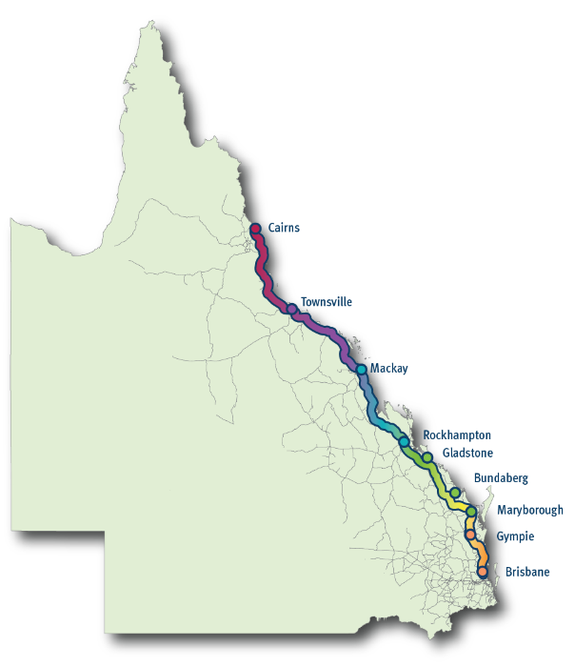

Caption 1: The various sections of the Bruce Highway.

# Purpose

The Bruce Highway stretches 1673 kilometres linking coastal towns and cities from Brisbane in the south of the state to Cairns in the north. The highway forms part of the National Land Transport Network and the National Key Freight Route.

Through its movement of people and freight, the Bruce Highway helps drive the economy, including the tourism, resources and agriculture industries. Being such a significant road corridor, unfortunately, many lives have been changed by devastating injuries and loss of life, due to road incidents, significantly impacting families, friends and colleagues, as well as first responders.

In 2020, the Queensland Government tasked the BHTAC to oversee the development of a safety plan that would see substantial safety outcomes within 10 years, by setting the ambitious target to drive a 60 per cent reduction in the rate of fatalities by 2030.

Overseen by the BHTAC, this *Safer Bruce 2030 Action Plan* provides for road infrastructure upgrades to build a safer Bruce Highway. In addition to infrastructure upgrades, this plan will consider complementary initiatives, including technology advancements and influencing driver behaviour to deliver safety benefits. These actions will strive to achieve the target and the ultimate vision of zero road deaths and serious injuries in this corridor.

The *Safer Bruce 2030 Action Plan* is a companion document to the *15-year Vision and Action Plans for the Bruce Highway* which aims to unlock economic growth, build flood resilience and improve safety, the development of which is also being overseen by the BHTAC.

# Link to road safety strategies

The *Safer Bruce 2030 Action Plan* is guided by the *National Road Safety Strategy 2021–2030*, the *Queensland Road Safety Strategy 2022–2031* and supporting action plans.

Using the internationally recognised Safe System approach and the *Queensland model for road safety*, the *Queensland Road Safety Strategy 2022–2031* and supporting action plans provide for engagement with a broader set of stakeholders, including those outside the traditional transport sector. The model uses four key pathways to organise priorities, being roads and roadsides, places and spaces, communities and individuals. See **Figure 1** for a simplified diagram of the alignment of national and state road safety frameworks, strategies and plans.

The *Safer Bruce 2030 Action Plan* is informed by the ‘movement and place’ and ‘health and behaviour’ concepts of the *Queensland model for road safety* and outlines the key actions to be delivered against the four Safe System elements, including safe roads and roadsides, safe speeds, safe vehicles and safe road users. See **Figure 2** on page 10for the *Safe System model* and the *Queensland model for road safety (Queensland Road Safety Strategy 2022–2031).*

Figure 1: Alignment of national and state road safety frameworks, strategies and plans.

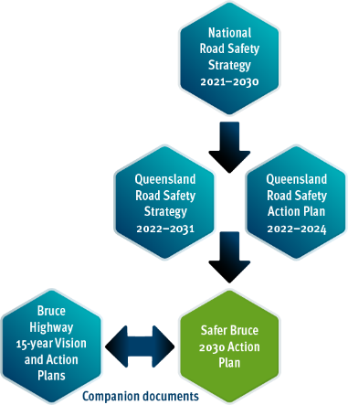

## Safety models

Figure 2: Safe System model and the Queensland model for road safety   
(Queensland Road Safety Strategy 2022–2031).

Safe system model outlining human tolerance of crash impacts.

Queensland model for road safety between movement and place and health and behaviour.

# The journey so far

The Bruce Highway’s high traffic volumes, mix of local and highway traffic, as well as long stretches of single-carriageway intersecting with many other roads are all significant factors in the number of serious and fatal crashes being experienced along the corridor.

In response, the Australian and Queensland Governments committed to address major safety issues, along with addressing capacity and flood resilience issues by establishing the Bruce Highway Upgrade Program (BHUP).

Under the BHUP, significant upgrades have been delivered, including major capacity and duplication projects in the Cairns, Townsville, Mackay, Rockhampton and Sunshine Coast regions, plus additional overtaking lanes, intersection upgrades, new bridges, rest areas, roadside hazard removal and town entry treatments – all of which continues to improve road safety.

Innovative engineering standards aimed specifically at reducing the cross-centreline crashes have been installed, with more than 850 kilometres of the Bruce Highway now upgraded with Wide Centre Line Treatment (WCLT: widening of the existing centre line format) and Audio Tactile Line Marking (ATLM). To date, sections of Bruce Highway where these treatments have been installed are achieving reductions in vehicle crashes.

The reduction and then plateauing of fatal crashes over time has been offset by a corresponding increase in crashes resulting in serious injuries. Following the onset of the COVID-19 pandemic in 2020, a notable upward trend has been seen in fatalities on the Bruce Highway, consistent with the rest of the Queensland road network. See figure 3 for fatalities and serious injuries from 2012 onwards along the Bruce Highway.

With more work to do, this *Safer Bruce 2030 Action Plan* outlines targeted safety treatments, and other safety measures, including technology, enforcement, education and behavioural change to improve safety outcomes and help realise the 60 per cent target of reduced fatalities by 2030.

Figure 3: Fatalities and serious injuries from 2012 to 2023 along the Bruce Highway. Note: 2023 serious injury data is until 30 June 2023 (not a full calendar year).

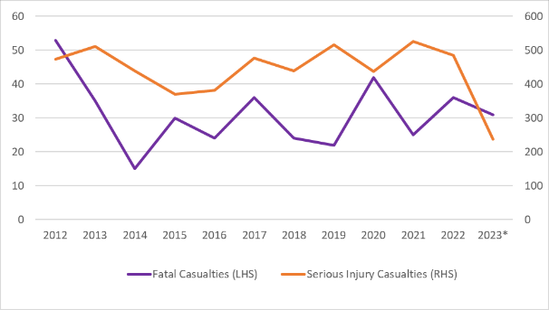

# Developing the plan

## Listening to our customers

With the Bruce Highway between Brisbane and Cairns being an important connection to enable travel to family, friends, healthcare, education and employment, as well as being the workplace for commercial drivers, it was important for the development of this plan that all these customer voices be heard.

Overseen by the BHTAC, a comprehensive program of customer research was undertaken to understand customer perspectives and priorities for the Bruce Highway and how these are changing over time and by location. From analysing hundreds of customer enquiries, submissions and complaints in recent years, to an online survey of nearly 4000 Queenslanders, in-depth interviews and focus groups with representatives of the people and businesses who drive and rely on the Bruce Highway every day, customers shared their experiences, insights and priorities with us.

The research investigated how the three key objectives of unlocking economic growth, building flood resilience and improving safety ranked in importance for the various customer groups.

Focus areas to improve safety were varied, but there were common themes from customers, particularly considering where they lived and travelled. Customers between Brisbane and Gympie identified traffic flow as the main issue to address. North of Gympie and up to Cairns, customers also identified traffic flow, as well as identifying smoother road surfaces, wider bridges, more overtaking lanes and frequent rest stops as key priorities to address safety concerns (Figure 4).

Progressive duplication of the highway, dual carriageways and increased lane capacity in heavily trafficked sections, more overtaking lanes and rest stops and improving the road surface were put forward as solutions to improve traffic flow and safety. Customers also recognised the benefits of the recent WCLT installed along the single carriageway sections of the Bruce Highway. Customers, north of Gympie and up to Cairns, spoke of how the WCLT installed along sections of the Bruce Highway was a practical treatment that gave them a safer sense when driving because there was a visible separation between themselves and on-coming vehicles.

‘Widen narrow bridges, fix bumps in bridges, make sure new or replacement sections of road are done smoother.’ Private citizen

‘It needs more overtaking lanes to help us get around others and them getting around us.’ Heavy vehicle driver

‘Wide Centreline Treatments with Audio Tactile Line Marking should be rolled out as the number 1 priority for the entire length of the highway.’ Private citizen

Figure 4: Major safety concerns expressed by customers by link along the Bruce Highway.

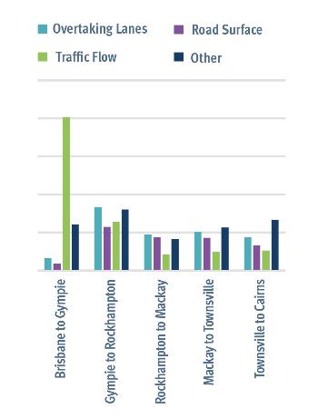

# Developing the plan

## Analysing the data

Drawing on the technical safety expertise from within TMR and oversight and guidance from the BHTAC, interpreting historic crash data was an important part of developing the *Safer Bruce 2030 Action Plan*. Historic crash data, including the types of crashes and the locations where they occurred, was critical to understanding where the greatest safety risks were and informed the most likely treatments to address these risks.

Being the longest road in Queensland, the Bruce Highway takes many forms–from urban motorways with sections between Brisbane and the Sunshine Coast carrying around 165,000 vehicles per day, to rural single carriageways with less than 2600 vehicles daily around St Lawrence, north of Rockhampton.

Approximately 25 per cent of the Bruce Highway is comprised of urban motorway, urban arterial roads (dual and single carriageway) and rural divided carriageway. These sections are generally between Brisbane and the Sunshine Coast and on the approaches to larger regional centres, such as Gympie, Rockhampton, Mackay, Townsville and Cairns. Almost half of all fatal and serious injuries (FSIs) occur along these sections. This is typically due to the high volumes of traffic, increased mix of through-traffic and local traffic and conflict points introduced by intersections with local roads and property accesses. Run-off-road, rear-end and other crashes, such as side-swipes and lane-change type crashes are most common along these sections.

The remaining approximately 75 per cent of the Bruce Highway’s length is comprised of rural, two-lane single carriageway, predominantly with lower traffic volumes (less than 7000 vehicles per day). Run-off-road and head-on crashes are the predominant crash types on these sections of the Bruce Highway, resulting in high severity outcomes. Significantly, due to the long distances travelled between towns and cities, across all FSIs on the Bruce Highway, fatigue and distraction crashes are all too common. Approximately half of FSIs on the Bruce Highway report ‘fatigue’ as a contributing factor.

This *Safer Bruce 2030 Action Plan* takes into account these trends and outlines a number of existing and new actions to make the Bruce Highway a safer corridor for all road users.

# Safer Bruce 2030 Action Plan

## Targets and actions

The *Safer Bruce 2030 Action Plan* is guided by the *Queensland Road Safety Strategy 2022–31* and supporting action plans aligned with the Safe System approach, and is a companion document of the new *15-year Vision and Action Plans for the Bruce Highway*.

## Target

The *Safer Bruce 2030 Action Plan* outlines key actions towards achieving the ambitious target of a 60 per cent reduction in the rate of fatalities by 2030 on the Bruce Highway and, ultimately, zero road deaths and serious injuries by 2050 on the broader road network.

As outlined in the *Queensland Road Safety Strategy 2022–31* and *s*upporting action plans,improving road safety outcomes is a complex challenge requiring infrastructure and non-infrastructure responses. The key actions align with the Queensland Road Safety Strategy’s priorities and supporting action plans. They include Bruce Highway specific responses and actions that are being implemented across the broader Queensland road network relevant to Bruce Highway safety outcomes.

### Safe roads and roadsides actions

1. Continue to deliver the existing Bruce Highway Upgrade Program (2013–14 to 2027–28).
2. Deliver new priorities identified in the new *15-year Vision and Action Plans for the Bruce Highway*, including major capacity upgrades and targeted safety upgrades, such as wide centre line treatments with audio tactile line marking, overtaking lanes, rest areas, intersection upgrades, intelligent transport system technology and other safety treatments.

### Safe speeds actions

1. Support a speed limit hierarchy on the Bruce Highway that promotes the safety of all road users, considering the movement and place functions of the road.
2. Continue enforcement of speed limits, including consideration of future innovative enforcement technologies.
3. Use innovative design and technology to support safer driving behaviour, including at road works on the Bruce Highway.

### Safe vehicles actions

1. Encourage the uptake of safer and smarter new vehicles and develop approaches to reduce the age of the Queensland vehicle fleet.
2. Work with industry and the community to improve the safety of interactions with heavy vehicles and vulnerable road users.

### Safe road users actions

1. Deliver a fatigue management strategy and rest area program as identified in the *15-year Vision and Action Plans for the Bruce Highway*.
2. Use enforcement and innovative approaches and technology to target high-risk driver behaviour.
3. Deliver road safety education, with a particular focus on young people entering the licensing system and novice drivers.

# Safe roads and roadsides

Safe roads and roadsides are designed and built to be more forgiving and account for human error. If a driver makes a mistake, forgiving road infrastructure can significantly reduce the chance that it will result in a fatality or serious injury.

**Key actions to deliver Safe roads and roadsides on the Bruce Highway and broader road network:**

1. Continue to deliver the existing Bruce Highway Upgrade Program (2013–14 to 2027–28)
2. Deliver new priorities identified in the new *15-year Vision and Action Plans for the Bruce Highway*, including major capacity upgrades and targeted safety upgrades, such as wide centre line treatments with audio tactile line marking, overtaking lanes, intersection upgrades, intelligent transport system technology and other safety treatments.

‘…we drove from Brisbane to Cairns in both 2015 and 2016 and experienced the wide centre line treatments. They provided both practical safety enhancement and a perception of a safer road environment. To the point that sections with the unsealed shoulders and no wide centre line feel unsafe.’ Private citizen.

‘…accidents are due to third party erratic and irritated drivers not being able to overtake.’ Transport operator.

## Wide Centre Line Treatment (WCLT) and Audio Tactile Line Marking (ATLM)

By 2030–31, rural highway single carriageway sections of the Bruce Highway will be upgraded to include WCLT and ATLM. WCLT and ATLM are specifically targeted at reducing cross-centreline crashes. WCLT widens the existing centre line format up to one metre apart, giving visible separation between drivers and on-coming vehicles.

## Widening narrow bridges

Along with the WCLT, narrow bridges (less than 8.4 metres wide) within these stretches of single carriageway rural highway will be widened to improve safety for all traffic, particularly heavy vehicles. Wider bridges allow for safer two-way passage across a bridge.

## Priority intersection upgrades

Priority intersection upgrades, including providing turning lanes, signalising and grade-separating intersections are effective treatments to improve the control and flow of vehicles and other road users such as pedestrians and bike riders, to reduce crashes. Safer intersections improve the safety of traffic entering and exiting the highway.

## Additional overtaking lanes

New and upgraded overtaking lanes will support more efficient and safer travel on single carriageway sections. Overtaking lanes are effective at allowing road users to safely overtake slower vehicles and ensure a better road user experience.

## The existing Bruce Highway Upgrade Program (2013–14 to 2027–28), being delivered in partnership with the Australian Government:

**Major Bruce Highway upgrades between Brisbane and Cairns delivered as at 31 December 2023 include:**

* Six-laning between Caloundra Road and the Sunshine Motorway and between Caboolture Bribie Island Road and Steve Irwin Way
* Cooroy to Curra, Sections A, B and C
* Yeppen Flood Plain Upgrade (south of Rockhampton)
* Rockhampton Northern Access Upgrade
* Mackay Ring Road Stage 1
* Sandy Gully Bridge Upgrade, near Bowen
* Haughton River Floodplain Upgrade, midway between Ayr and Townsville
* Townsville Ring Road – Stages 4 and 5
* Cattle and Francis Creek Upgrade, south of Ingham
* Cairns Southern Access Corridor – Stages 1, 2, 3 and 4

**Targeted road safety improvements delivered as at 31 December 2023:**

* 239 kilometres of new Wide Centre Line Treatment (WCLT)*
* 98 new overtaking lanes
* 195 protected right-hand turns and 32 signalised intersections
* 120 new bridges
* 35 new and 30 upgraded rest areas
* 479 kilometres of roadside safety barriers
* 72 township entry treatments

* In addition, 667 kilometres of WCLT and 430 kilometres of Audio Tactile Line Marking (ATLM) have been delivered on the Bruce Highway under other programs.

**Planning and delivery of other key major projects and targeted road safety improvements progressing as at 31 December 2023:**

* Smart Motorways (Stage 2) – Pine River to Caloundra
* Six-laning between Caboolture – Bribie Island Road and Steve Irwin Way
* Cooroy to Curra, Section D: Woondum to Curra Tiaro Bypass
* Rockhampton Ring Road
* Gateway Motorway to Dohles Rocks Road
* Dohles Rocks Road to Anzac Avenue upgrade
* Anzac Avenue to Uhlmann Road upgrade
* Cairns Southern Access Corridor – Stages 5 (Foster Road upgrade intersection)
* Tiaro Bypass

# Safe speeds

Speed is a major factor in the likelihood of any road crash. The faster the speed, the less time there is available for a driver to undertake an evasive manoeuvre and the greater the impact force in the event of a crash.

To build a safe road system, speed limits should be set appropriately to allow drivers to respond accordingly to potential risks on the road. This is particularly important in urban areas, where there are more people and more vulnerable road users, such as motorcyclists, bike riders and pedestrians, as well as in high-risk rural locations with multiple at-grade intersections to reduce the chance of serious crashes.

**Key actions to deliver Safe speeds on the Bruce Highway and broader road network:**

1. Support a speed limit hierarchy on the Bruce Highway that promotes the safety of all road users, considering the movement and place functions of the road.
2. Continue enforcement of speed limits, including consideration of future innovative enforcement technologies.
3. Use innovative design and technology to support safer driving behaviour.

‘… use modern smart-motorways technology to assist vehicle drivers to manage their required speed, and have more digital signage assisting with traffic flows.’ Private citizen

## Township Entry Treatments

A Township Entry Treatment is a speed management measure that involves providing new signs and line marking at the point of transition from a high-speed rural environment to a lower speed environment to coincide with entering a township. This treatment encourages drivers to adopt appropriate speed changes, reducing risks to vulnerable road users, such as pedestrians and cyclists and other road users in the town.

## Additional Smart Motorways technology

Smart Motorways treatments apply a range of integrated technologies to monitor vehicle flows, detect incidents and provide real-time vehicle management responses, such as varying the speed limit to improve traffic flow and safety. Intelligent Transport System (ITS) infrastructure, including Closed-Circuit TV Television (CCTV), flood warning systems, electronic signage, real-time ramp signalling and vehicle detection systems, improves safety outcomes.

The current Bruce Highway Upgrade Program is delivering additional Smart Motorways technology along a 60-kilometre section of the Bruce Highway between Pine River and Caloundra Road to assist in reducing stop-start travel, improving safety and delivering more reliable travel times.

# Safe vehicles

Existing and emerging vehicle safety innovative technologies, such as collision warnings and avoidance, fatigue assistance, braking stability and speed alerts will greatly improve road safety in Queensland.

Over time, the introduction of safer vehicles and new technology has greatly reduced the number of road fatalities in Queensland. As represented below and outlined in the *Queensland Road Safety Strategy 2022–31*, the introduction of seat belts in 1969, for example, saw the beginning of a steep decline in road fatalities. It is anticipated that new technologies designed to improve driver and passenger safety will have similar positive results.

**Key actions to deliver Safer vehicles on the Bruce Highway and broader road network:**

1. Encourage the uptake of safer and smarter new vehicles and develop approaches to reduce the age of the Queensland vehicle fleet.
2. Work with industry and the community to improve the safety of interactions with heavy vehicles and vulnerable road users.

‘…as a daily user, safety on the highway is paramount for me.’ Private citizen

Figure 5: Road fatalities per 100,000 population in Queensland between 1969–2023.

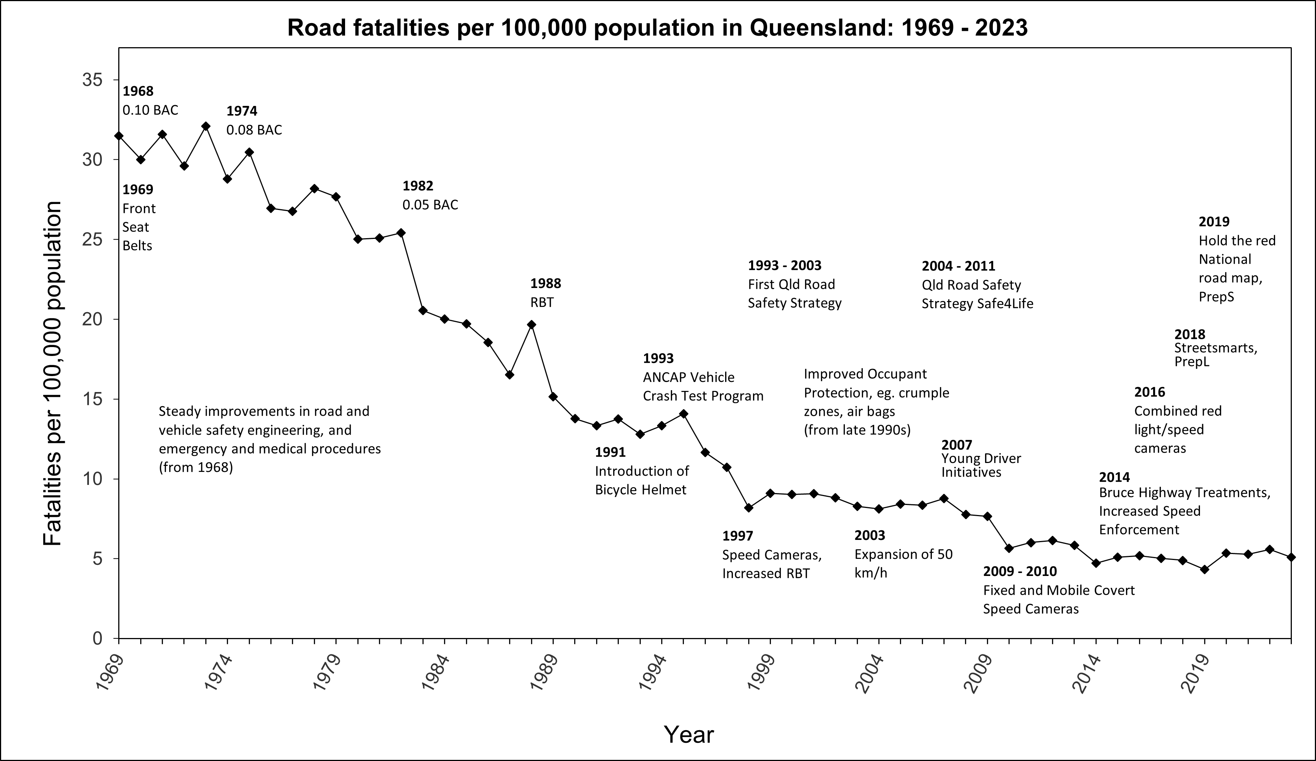

## Case study

### Cooperative and Automated Vehicle Initiative

TMR’s Cooperative and Automated Vehicle Initiative (CAVI) supports Queensland’s vision of zero deaths and serious injuries on the state’s road network. CAVI delivered Australia’s largest Cooperative Intelligent Transport Systems (C-ITS) pilot–the Ipswich Connected Vehicle Pilot which ran from September 2020–2021. The European compliant technology enables vehicles to communicate to other connected vehicles, roadside infrastructure and centralised traffic management systems to share awareness messages. This equipment generated real-time driver warnings to conditions, such as upcoming red lights, road works, road hazards, congestion and presence of pedestrians at intersections, allowing the project team to test how these warnings affect driver behaviour and offer safety benefits.

The technology has now been installed at 66 intersections across Queensland, including 37 intersections along the Bruce Highway, between the Sunshine Coast and Cairns. This will give road users the chance to experience the service in Queensland before it appears in commercially available vehicles. The C-ITS upgrades to the Bruce Highway intersections are jointly-funded by the Queensland and Australian governments.

# Safe road users

While improvements to road infrastructure and safe roadsides are critical to helping reduce serious injuries and fatalities, there are other road safety programs and behavioural change initiatives outlined in the *Queensland Road Safety Strategy 2022–31* that will help to achieve our safety target for the Bruce Highway.

Proactive education campaigns to encourage safer road use will continue on the state and national front. These programs aim to improve road safety by impacting the attitudes and behaviours of Queenslanders through strategic, targeted campaigns and activities that encourage safer road use. Of particular focus is reducing high-risk driving behaviours, such as speeding, drink or drug driving, distracted driving, driving while fatigued and not wearing a seatbelt.

Queensland has been a leader in adopting new technologies and introducing tougher fines to make roads safer for all users. Enforcement initiatives, including the roll-out of world-leading cameras that detect whether a driver is using their mobile phone illegally or wearing a seatbelt incorrectly or not at all, as well as behavioural and cultural change programs, improve road safety outcomes.

**Key actions to deliver Safer road users on the Bruce Highway and broader road network:**

1. Deliver a fatigue management strategy and rest area program as identified in the *15-year Vision and Action Plans for the Bruce Highway*.
2. Use enforcement and innovative approaches and technology to target high-risk driving behaviour.
3. Deliver road safety education, with a particular focus on young people entering the licensing system and novice drivers.

‘More rest stops would be good, even if they’re pit stops where you can pull in quickly to use the bathroom or make a phone call.’ Caravanner/campervanner

‘Rest areas have snowball effects of increasing the safety of drivers which then influences drivers’ ability meet schedules.’ Transport operator

## Fatigue management strategy, including a rest area program

The new *15-year Vision and Action Plans for the Bruce Highway* recommends the development of a dedicated fatigue management strategy. Giving drivers more opportunities to rest, revive and manage fatigue, rest areas prevent crashes associated with drowsiness and/or distraction. The strategy would detail new and upgrades to existing rest area facilities for heavy vehicles and other road users at priority sites between Brisbane and Cairns.

## Case study

### Bruce Highway rest area trial for heavy vehicles

In November 2020, a rest area management pilot project was initiated on the Bruce Highway at the Ogmore heavy vehicle rest area (south of St Lawrence). The project trialled ITS technology to reduce fatigue-related crashes on Queensland’s roads. Heavy vehicle drivers are provided with real-time information about the availability of rest areas, allowing them to better plan their journeys and rest breaks.

Based on the trial’s success at Ogmore, upgrades at five additional rest areas on the Bruce Highway at Christmas Creek, Helens Hill, Miriam Vale, Waverley Creek and Gin Gin were completed during 2021.

The rest area upgrades include:

* advanced information roadside warning signs approximately 10 kilometres ahead of the rest area to provide information on parking availability in real-time
* solar-powered lighting and solar and wind power
* CCTV Cameras
* automatic number plate recognition cameras to increase safety and security for drivers at the rest area.

TMR has received positive feedback from heavy vehicle drivers who are currently using the upgraded sites, including feedback that heavy vehicle drivers are:

* using the rest areas more to take a break from driving than before the upgrades
* feeling more secure stopping at these sites to rest as they know there is CCTV installed
* feeling more secure leaving their trailers at the rest areas, if necessary, because of the CCTV
* feeling they have been given priority at these sites over the general travelling public.

# Beyond 2030

The BHTAC has overseen the development of this *Safer Bruce 2030 Action Plan* towards achieving the Queensland Government’s ambitious target of reducing the rate of fatalities along the Bruce Highway by 60 per cent by 2030.

This Action Plan concludes in 2030, however, beyond that, the *15-year Vision and Action Plans for the Bruce Highway*, also overseen by the BHTAC, identifies further priorities to continue significant safety upgrades designed to save lives and prevent serious injuries in this corridor.

Along with influencing positive driver behaviour through education and enforcement, these future safety upgrades will also benefit from even more advances in technology over time.

As part of the *Safer Bruce 2030 Action Plan* and its companion *15-year Vision and Action Plans for the Bruce Highway* documents, the BHTAC recommends periodic reviews of the Action Plans by TMR at every five-year tranche. This will ensure the objectives, costs, scope, assumptions and growth predictions remain relevant.