Retail Shop Leases Act 1994
Lessee Disclosure Statement

The Lessee Disclosure Statement must be given to the lessor at least seven days before the lessee enters into a retail shop lease (section 22A Retail Shop Leases Act 1994).
Name of lessee:
Name of lessor:
Address of retail shop:
Department of Customer Services, Open Data and Small and Family Business

To the Lessee
Before signing a retail shop lease, or any associated document, you should ensure that you fully understand your rights and obligations under all of the relevant documents.

The lessor is required to give you a Lessor Disclosure Statement and a draft of the proposed lease at least seven days before you enter into a retail shop lease.

If you are a prospective lessee who currently leases less than five retail shops in Australia, you must give the lessor a Legal Advice Report and a Financial Advice Report before you enter into the lease. The approved forms for the Legal Advice Report and the Financial Advice Report are available at: https://www.publications.qld.gov.au/dataset/lease-forms-under-the-retail-shop-leases-act

In any case, it is recommended that all prospective lessees seek both legal and financial advice about the terms and conditions of the lease and the operation and viability of the proposed business.

Lessee’s Disclosure to the Lessor
Note: Where space is insufficient on this form please attach additional sheets and note the attachment at the relevant item below.

- Lessee’s Business name, ABN and address:
- (If applicable) Lessee’s company name and ACN (If no ACN, please provide sufficient information to identify the corporation)
- Please state the number of other retail shops currently leased by the lessee within Australia:

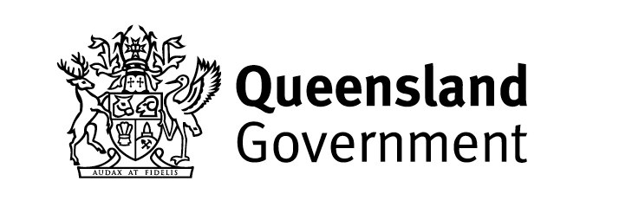

- Does the lessee believe that they will be able to meet all of the financial and other obligations contained in the lease?
Yes  No ➔
4.1 Please detail relevant retail business experience that demonstrates the lessee’s ability to meet the lease obligations:
4.2 Please detail any circumstances or issues known to the lessee that may affect the lessee’s ability to meet the lease obligations:
- Please detail any statements or representations made by the lessor (or the lessor’s agent) that the lessee is relying on in entering into the lease:
Has the lessor given the lessee a Lessor Disclosure Statement and a draft lease?
Yes  No 
Has the lessee given a completed Legal Advice Report and a completed Financial Advice Report to the lessor?
(applicable only if the lessee is currently lessee of less than five retail shops in Australia)
Yes  No  N/A 

Lessee’s Acknowledgement

The lessee acknowledges that:

- the information given in this statement (including any attachments) is correct; and

- apart from the matters detailed at item 5 above, no other material statements or representations have been made by the lessor, or the lessor’s agent, to the lessee regarding the lease or the business to be carried on in or from the retail shop premises.

 |  | / /
Lessee’s signature |  | Date

The Queensland Small Business Commissioner (QSBC) provides mediation and dispute resolution services for retail shop lease disputes under the Retail Shop Leases Act 1994.
Contact: 1300 312 344 https://qsbc.qld.gov.au/leasing-disputes/

© State of Queensland (Department of Customer Services, Open Data and Small and Family Business) 2024
_______________________________________________________________________________________________________________________
_____

